A

**Project Report**

On

**Attendance Management System**



Submitted in partial fulfilment of the requirements for the award of the degree

Of

**BACHELOR OF COMPUTER APPLICATIONS**

**Submitted To:**

Faculty of Computer Science and Applications

Amrapali Institutes of Applied Sciences, Haldwani

**Project Guide: Submitted By:**

Dr. Nitin Deepak Mathur Sir Ms. Meenakshi Tiwari

170610330010

**Amrapali Institutes of Applied Sciences**

**Shiksha Nagar, Haldwani**

**(**Affiliated by Kumaun University, Nainital**)**

**DECLERATION**

I hereby declare that the project report entitled “**ATTENDANCE MANAGEMENT SYSTEM**” submitted by me to **AMRAPALI INSTITUTES OF APPLIED SCIENCES** in partial fulfillment for the award of the degree of **BCA (Bachelor in Computer Applications)** is a record of Bonafede project work carried out by me under the guidance of **Dr. Nitin Deepak Mathur Sir (Associate professor).**

I further declare that the work reported in this project has not been submitted and will not be submitted, either in part or full, for the award of any other degree in this institute or any other institutes or university.

**Ms. Meenakshi Tiwari**

**170610330010**

**ACKNOWLEDGEMENT**

I express my gratitude to my Mentor **Dr. Nitin Deepak Mathur Sir**, giving me opportunity to undertake this project, for helping me whenever I halt and providing me the facilities to do the project successfully.

I owe deep sense of gratitude towards each and every faculty of **Faculty of Technology and Computer Applications** who worked hard and guided me throughout my whole session (2017-2020) which helped me in completing my project sincerely.

My heartful thank to my team Member **Ms. Bhagwati Bora** for helping me in each and every step for completing this project.

Last but not least, I extend my sincere thanks to my family members and my friends for their constant support throughout this project.

**Ms. Meenakshi Tiwari**

**170610330010**

**CERTIFICATE**

This is to certify that the dissertation report entitled **Attendance Management System** is done by **Ms. Meenakshi Tiwari** student of VI Semester. This is an authentic work completed for the partial fulfillment of the requirements for the award of the degree of **Bachelor of Computer Applications** under the guidance of Dr. **Nitin Deepak Mathur Sir**. The matter embodied in this project work has not been submitted earlier for award of any degree to the best of my knowledge and belief.



Ms. Meenakshi Tiwari

**170610330010**

Amrapali Institutes of Applied Sciences

Shiksha Nagar, Haldwani

**TABLE OF CONTENTS**

**CHAPTER CONTENT PAGE NO**

Cover Page 1

Declaration 2

Acknowledgement 3

Self – Certificate 4

Synopsis 6

Chapter 1 Introduction 10

Chapter 2 The Overall Description 12

Chapter 3 System Analysis 16

Chapter 4 System Specification 20

Chapter 5 Software Specification 23

Chapter 6 Design 35

Chapter 7 Database table 48

Chapter 8 System testing 52

Chapter 9 System Implementation and maintenance 60

Chapter 10 Conclusion 62

Chapter 11 Snapshots 69

Chapter 12 Coding 80

Chapter 13 References 216

**SYNOPSIS**

It is a system to maintain and manage the attendance of the students by the teachers in institutes. This system provides the transparency for its user, as they can easily view their attendance from anywhere at any time, which will be provided by the Faculty.

**FEATURE**

Everyone can access the system by using valid ID and Password which will be provided by the Administrator as soon as the user joins. The system has different modules that can be accessed by the user i.e. changing password, viewing own profile, giving feedback, adding Student, Subjects and many more. The system has a responsive behaviour due to which it can be viewed properly on multiple devices.eg- computer, mobile, tab etc

**USER OF SYSTEM**

* **Administrator**
* **Teacher**
* **Student**
* **parent**

**PRESENT STATE**

* Multiple Attendance Management software are developed by different developer before, but this software is developed using different and unique vision.
* Attendance software are not 100% used yet, hence time consumed in accessing records of students
* Manual management of student is big concern.
* Students get details of their attendance after going manually to the individual faculty.
* When attendance is taken manually, it creates problem in updating and deleting.
* No system of parent interaction direct to the institutes, always students are the mediator who can manipulate the messages. if they want, they have to come manually**.**

**AFTER IMPLEMENTNG SOFTWARE**

* Easy to use Graphic User Interface.
* Students can view their attendance in the software and can maintain and improve their attendance accordingly.
* If parent has any query, they can message to the administrator directly and can also update themselves about their ward attendance.
* Every user can view their profile.
* Faculty can mark and update attendance efficiently.
* Attendance report can be generated in pdf format and can be saved as a proof.

**TOOLS AND TECHNOLOGY**

**Tools:**

**Framework**

A framework can be defined as a platform for developing the software applications. it also includes code libraries, compilers and other useful program used in the software development process.

**CodeIgniter 3.1.11 (Ellislab)**

It is an open source **PHP** MVC framework used for the development of web applications rapidly. It provides libraries for connecting to the database and performing operations like managing sessions, uploading files, etc.

**phpMyAdmin (Tobias Ratschiller)**

It is an open source free software, designed to handle the administration and management of MYSQL databases through the graphic user interface written in php. It contains the list of features such as browsing, dropping, creating, altering MYSQL databases, tables and fields.

**Technology:**

**Front-End**

**HTML (Tim Berners-Lee)**

It stands for **Hypertext Markup Language** user to create and structure sections, paragraph, headings, links, button, Images etc. for the web pages and applications. while working with html we use simple code structures (tag and attributes) to mark up a website page.

**CSS (World Wide Web Consortium)**

It stands for **Cascading Style Sheet** which is used to format the layout of webpages. They can be used to define text styles, table sizes, borders and other aspects of webpages. The styling through CSS can be done using **<style>** tag in document or by creating different file and linking them to webpage.

* CSS save time
* Page load faster

**Bootstrap 4**

It is a free front-end framework developed for faster and easier web development. It helps us to make our website **responsive** hence it can easily change and handle its content according to the viewport of the gadgets. Bootstrap includes HTML and CSS based design templates for forms, buttons, tables, navigation, modals, image carousels and many other, as well as optional JavaScript plugins

ADVANTAGE

* Easy to use
* Responsive features
* Browser compatibility

**JavaScript**

It is a client-side scripting language which ids used to program behavior of html and the web.it helps us to change the content of the html element, style, hide the element etc. it can be used inline using <script> tag , by linking the external JavaScript file to the page or within body tag.

**jQuery**

It is a lightweight “write less, do more” JavaScript library which helps us to use the JavaScript much easier on our website. jQuery takes a lot of common tasks that require many lines of JavaScript code to accomplish, and wraps them into methods that you can call with a single line of code.

The jQuery library contains the following features:

* HTML/DOM manipulation
* CSS manipulation
* HTML event methods
* Ajax

**jQuery Ajax**

It stands for Asynchronous JavaScript and XML a combination of browser built in XML http request object; it **is a front-end tool used to communicate with back-end.** it contains various built in method to do so. such as $. ajax (), $. get (), $. post () etc.

**Back-End**

**Php**

It stands for **Hypertext Preprocessor** widely used server-side scripting language, and a powerful toll for making dynamic and interactive webpages. Php files can contain HTML, CSS, JavaScript and php code together inside it.

**SIGNIFICANCE OF PROJECT**

1. Reduce the use of pen and paper.
2. Student can easily be updated which help them to maintain or improve their attendance.
3. Parents can check their child performance and give feedback.
4. Teachers can easily add and update student’s attendance.
5. Multiple users can access to their respective modules using single login panel.

**Chapter 1: Introduction**

**Definition: -**

**Attendance Management System** is a software developed for management of attendance of student by the teachers on the daily basis. It facilitates to access the attendance information of a particular Student in a class. The administrator will provide the separate ID and password for every user which help them to login and access modules. The system will also be helpful in evaluating attendance eligibility criteria of a student. the system provide transparency for its user as they can access their attendance from anywhere. feedback form is available which help us to communicate with the institution.

**Purpose: -**

The main purpose of making an attendance management system is to computerised the traditional way of taking attendance. Faculty take attendance manually which is very time consuming. Updating attendance is also difficult manually hence the software reduces the time and make updating easy and efficient. Report can also be generated in pdf format. The parents of a particular student can also be aware about the attendance of their children.

* Reduce the operational time.
* Attendance can be stored with accuracy
* Reliable
* Data Security

**Scope: -**

The scope of software is the system on which the software is installed, i.e. it will work for the particular institute. Due to its responsive behaviour this software can also be accessed from device having different dimensions other than a desktop. No guest users will be able to work inside the system.

**Overview: -**

**Attendance Management System** basically has two main modules for its proper functioning: -

1. **Administrator**: Admin has right to create new users. Adding subjects, teachers, managing session etc.
2. **User**: User have the right to give attendance, update attendance, generate report etc

**Parent/student**: they have the right to view attendance, view profile, give feedback etc

**Faculty**: they have the right to give attendance, update attendance, view profile etc.

**Chapter 2: The Overall Description**

**Problem Definition: -**

This system developed will reduce the manual work and avoid redundant data. When we take attendance manually the risk of generation of wrong report is maximum. The system can generate report based on the start date and end date. As the attendance is maintained inside the registers so it had been the tough task to maintain and search the student for long time. Instead the software is helpful in maintaining and retrieving information when needed.

**Product Perspective: -**

The product Attendance Management System is a dependent product. We have used the XAMPP as a server and CodeIgniter as a framework to build the application. the product will handle multiple tasks related to the user, better organize the stored information and perform optimal.it will ensure smooth working of these processes.

**Module Description: -**

The system is designed in such a way that only the authorised users should be allowed to access some particular modules. The records should be added and deleted by the administrator. The user should be in control of application not visa versa. The system should be clear, complete and user friendly. (designed by me)

**LOGIN**

This module will work as a main module and help the authenticated user to access the other modules and complete its functioning. the user will give its username and password and according to its status it will move to the respective portal where multiple modules will help him to complete its functioning.

**CHANGE PASSWORD**

This module will help individual to change its previous password with the new password. It is made for the security of user, if the password is misused by anyone it can be change and hence secured.

**MARK ATTENDANCE**

This module will facilitate the faculty to give attendance to the student each day according to their respected subject. As soon as all the details will be provided, on the attendance panel name of the student will be shown and attendance can be added.

**UPDATE ATTENDANCE**

This module will help the individual to update attendance in case if the previous attendance is miswritten or not given to any student.

**VIEW ATTENDANCE**

This module will help us to view the attendance of the student and provide flexibility to them, they can keep watch on their attendance at any time, place. Student can also get detail about the attendance average which help them to maintain their attendance. Report sheet can also be generated from the panel as a proof.

Student can get his attendance directly by providing the start and end date.

Other users have to provide enrolment along with the start and end date to get details of attendance.

**VIEW FEEDBACK**

In module will help us to view the feedback given by the student and parent to the institutes. It will help them to understand the problem of the users and provide them better facility. This option is only available to the administrator and no other user can access it.

**VIEW PROFILE**

This module helps the user to view their own information. Available to everyone except administrator.

Student will able to see their rollno, name, subjects, departments, semester etc.

Faculty will able to see their name, contact, teaching details, email etc.

Parent will be able to see their name, contact, children name etc.

**Product Functions: -**

Our product has two basic modules: -

**Administrator**

He will be working as a super user having all the power and privileges. He will be getting a

Valid ID and Password to access the system and work further.

**Characteristics**

1. Login
2. Manage Session
3. Add/delete the user (Students, Teachers, Parents)
4. Change Password
5. Add subjects
6. View attendance details
7. View feedback
8. Logout

**User**

There are three user which can access to the system and perform required functioning.

**Teacher**

**Characteristics**

* Login through valid ID and password.
* View Profile
* Mark attendance
* Update attendance
* View attendance details
* Generate report
* Logout

**Student**

**Characteristics**

* Login through valid ID and password.
* Change Password
* View profile
* Give Feedback
* View attendance details
* Generate Report in pdf format
* Logout

**Parent**

**Characteristics**

* Login through valid ID and password
* Change Password
* View Profile
* Give Feedback
* View Attendance details
* Generate Report in pdf format
* Logout

**Constraints: -**

Interface is only in English; no other language option is available.

User can only access the module through provided ID and password, no guest user is entertained.

**Assumptions and Dependencies: -**

It is assumed that the software will be used in the Computer that is connected to the LAN of College.

It is assumed that the trusted member of the college will work as an administrator and will be enjoying super user privileges.

The end users of this software will have the basic knowledge of computer system functioning.

Admin should be careful in adding and deleting users as any information knowingly and unknowingly create inconsistency in database.

**Chapter 3 System Analysis**

**Introduction: -**

It is the process of collecting and interpreting facts, identifying problem and breaking it into multiple steps to find the optimal solution. System Development is a systematic process which comprises of multiple phases. It is a technique used to improve system and ensure that all the components of the system work efficiently to accomplish the purpose. A system should be well organized, interacting, interdependent and integrated.

**System Design: -**

It is the process of planning about a new system or changing the existing system by defining its components or modules to satisfy the specific requirements. Before planning you must have the basic knowledge of system functioning and required feature.

The purpose of the System Design process is to provide sufficient detailed data and information about the system and its system elements to enable the implementation consistent with architectural entities as defined in models and views of the system architecture.

System Design focuses on **how to accomplish the objective of the system**.

**Elements of a System**

* **Architecture**- This is the conceptual model that defines the structure, behaviour and more views of a system. We can use flowcharts to represent and illustrate the architecture.
* **Modules -**This are components that handle one specific tasks in a system. A combination of the modules makes up the system.
* **Components -**This provides a particular function or group of related functions. They are made up of modules.
* **Interfaces -**This is the shared boundary across which the components of the system exchange information and relate.
* **Data -**This the management of the information and data flow.

System Analysis and Design (SAD) mainly focuses on −

* Systems
* Processes
* Technology

Stages of system development are as follows:

* Feasibility study

Its main objective is to check whether the proposed system can be developed efficiently, how must cost will be required, sufficient resources, tools and technologies, developer skills etc.

* Planning

Planning involves exact modules that are needed in the system, what will be the step by step procedure to develop the system. Planning for the quality assurance requirements and identification of the risks associated with the project is also done in the planning stage.

* Designing

Once the requirements are understood, the design process take place. It makes use of established patterns for application architecture and software development; various architecture can be used here.

* Coding

Coding for various modules are done inside this phase.

* Testing

Testing is the most important phase of software development. If quality software impossible to deliver without testing. it includes code quality, unit testing, integration testing etc. before deploying it to system.

* Deployment

As soon as the software is developed, it gets deployed and some guidelines are provided to the end user.

* Maintenance

After deployment if any error or problem occurs, further changes are required in the system, then the software will be updated.

**Proposed System: -**

The project aims to develop a software that is reliable, reduce the paper work and save time to generate accurate results from the student’s attendance. The software has one login panel which will redirect to the respected page according to the users. Marking and updating attendance is easy and efficient.

**Advantage of proposed system**

* Relatively fast approach to enter attendance
* Parent interaction
* Generate report in pdf format
* Viewing individual profile
* Show average
* Graphical User Interface

**Feasibility Study: -**

It is defined as an assessment of the practicality of a proposed plan or method. It includes all the relevant factors into account-economic, technical, legal, and scheduling considerations- to ascertain the likelihood of completing the project successfully. These studies are done to discern the pros and cons of undertaking a project before they invest a lot of time and money.

**Items that is needed to be included in feasibility study:**

* Technical considerations
* Marketing strategies
* Required resources
* Project financials

**Goals of feasibility study:**

* Understanding all aspects of a project, concept, or plan.
* While implementing the project whether any potential problem can occur or not.
* Whether the project is worth undertaking.

.**Chapter 4 System Specification**

**HARDWARE REQUIREMENTS**

**RAM (Random Access Memory): -** 4GB

**HARD DISK**: - 1TB

**PROCESSOR**: - Intel(R) Core (TM) i3-7020U CPU @ 2.30GHz

**SOFTWARE REQUIREMENTS**

**OPERATING SYSTEM: -** Window 10

**FRAMEWORK**: - CodeIgniter 3.1.11

**DATABASE: -** phpMyAdmin

**SERVER: -** XAMPP

**FRONT DESIGN: - CSS**, Bootstrap 4

**FRONT-END LANGUAGE: -** HTML, JavaScript, jQuery(library), ajax(method)

**BACK-END: -** php

**NON-FUNCTIONAL REQUIREMENTS**

The non functional requirements are also called the quality attributes of the software under development. They describe how the system should work.  In the requirement gathering technique the focus is on the functional requirement rather than non-functional requirements. There exists a gap between both types of requirements.

**Some of these are as follows:**

**USABLITY:**

System’s important functions should be prioritized, frequently used functions should be tested properly. Be sure to create a requirement for this.

**RELAIBLITY:**

It is defined as the trust towards the system that is developed after using it for a long time. The bugs present in code, hardware failures and problems can reduce the reliability of software. It is a good idea to also include requirements that make it easier to monitor system performance.

**AVAILABILITY:**

The software will only be available to the authorized users of the colleges. Like administrator to work as a super user, teacher to mark attendance, students and parents to view attendance and generate report.

**SECURITY:**

Security of data is the primary function. The software will be handled by the administrator and authorised users. Only the admin has right to add or delete any details, create username and password, deliver it to users. No guest user can access the system.

**PORTABLITY:**

The software is window-based application and developed in CodeIgniter (MVC architecture PHP Framework) and coded with php extension which is available for UNIX, WINDOWS, MAC OS and OS/2. Hence it is cross platform and operating system independent.

**PERFORMANCE:**

The coding is done for the software in PHP extension. They execute faster as compare to the other scripting language. It is open source hence the software development cost is little less. this produces a stable and robust product.

**DESIGN CONSTRAINTS:**

The login form prevents software from being misused by unauthorized users. Only the authorized user will be granted rights to modify as per requirements. The user should know the programming language very well that is used to develop software.

**FUNCTIONAL REQUIREMENTS**

These are the product features or functions that developers must implement to enable users to accomplish their tasks. So, its important to make them clear, functional requirements describe system behavior under specific condition.

**Use Case Diagram**

**ADMIN STUDENT**

**FACULTY PARENT**

**Chapter 5 Software Specification**

**OPERATING SYSTEM**

**Window 10**

Window 10 is a major version of the Microsoft was released on July 29, 2015. One of the primaries aims of window 10 is to unify the windows experience across multiple devices, such as desktop, tablets, computers and smartphones.

**Features of window 10**

1. **New Start Menu**

Microsoft has brought back the Start Menu. Now, when you click on the Start button at the bottom left of the screen, you get two panels side by side, with the left column showing pinned, recently and most-used apps. You also get a power button at the top for options such as Hibernate, Standby and Shutdown, while the right column features a selection of live tiles that you can customize, resize and reorganize.

2. **Cortana Integration**

Windows 10 will bring Microsoft’s voice-controlled digital assistant Cortana to desktop computers, to make it easier for you to interact with your device without lifting a finger. You will be able to search your hard drive for specific files, pull up photos from specific dates, or launch PowerPoint presentations just by telling your PC to do so. You can even get Cortana to send an email while you’re working on a spreadsheet, making multi-tasking much easier.

3. **Microsoft Edge Web Browser**

Internet Explorer was replaced by Microsoft Edge, which features a new rendering engine called Edge HTML. Edge also integrates with the Cortana Digital Assistant to provide voice control, search, and personalized info to users. Users can also use Edge to annotate web pages, and these annotations are stored on OneDrive and can be used with other users.

4. **Virtual Desktops**

Unless you have a multi-monitor setup it can be easy to run out of screen space. For that reason, Windows 10 provides multiple desktops that you can work in and quickly switch between. The virtual desktops feature in Windows 10 is called “Task View” and is located on the Taskbar. To add a new desktop, all you need to do is click the Plus sign. You create multiple desktops, and switching between them is just a matter of clicking the Task View button again and moving your mouse over the thumbnail of the one you want.

**Framework**

**CodeIgniter**

CodeIgniter is a PHP driven framework, work on MVC architecture containing a grab-bag of libraries, helpers, plug-ins and other resources, that takes care of many of the more complex procedures and functions for which PHP is famous.it simplify PHP syntax, streamline the code underlying your web pages, and -best of all -have you churning out dynamic, interactive, professional websites in no time.

**Feature of CodeIgniter**

**Model-View-Controller based system**

CodeIgniter works behind the idea of Model View Controller (MVC). In MVC, Model refers to data, View refers to the presentation layer and Controller to the application logic. MVC breaking the development process of applications isolates business logic from UI.   Integrating with your own existing scripts it helps developers to build core libraries for the system. CodeIgniter allows its users to follow the MVC route instead of other procedural ways. Using MVC architecture CodeIgniter development can easily build and manage large applications.

**Error Handling**

CodeIgniter development helps you create error-free applications. Providing user-friendly interfaces, it helps you detect the error functions. It has an error-logging class which further provides you the facility to save errors as text files.   Providing an error function – error reporting at the top of your index file it provides you easy detection of errors to give you error    
**Security**

  Another important benefit CodeIgniter framework provides is that it contains many in-built security tools. For securing your web applications the features it includes are – XSS Filtering, CSRF protection, Password handling, and Input data validation. Recommended Reading: Best PHP Frameworks for Start-up Your Business in 2019 CodeIgniter possessing the security features helps you secure from password in many ways. With many default security actions present in the framework it gives you the choice of how and in what level you want to protect your app.

**Simpler and Easy to Use**

  Providing an easy interface CodeIgniter development is simpler in use. Easy to expand, CodeIgniter framework is more reliable, light in weight, and efficient in use. With CodeIgniter framework creating new libraries you can easily change its features. Also, CodeIgniter coding is easier to understand as compared with other frameworks. As per your requirements, you can easily change its features. Sign up for Newsletters Check out our popular newsletters and subscribe   CodeIgniter development provides you the benefit of database abstraction layers. With CodeIgniter, it is easy to modify the database in different ways like adding and removing columns creating new and removing old from tables through its database.

Extremely light weight.

Query building database support

Form and data validation

Session management

**MVC Architecture (MODEL-VIEW-CONTROLLER)**

HTTP REQUEST

DATABASE

**VIEW**

The **model**, which represents data structures. Classes contained within the model tier will contain methods that interact with database.

The **view**, which looks after presentation. A view will normally be a webpage, but can also be a page fragment like a header or footer.

The **controller**, which does most hard work, and is an intermediate between model, the view and other resources needed to run your application.

Separating a project in this manner means each tier does its job extremely efficiently, maintaining its relationship with other tiers yet operating within clearly defined boundaries. It also means multiple views and controllers can interface with the same model, and new or different view and controller can interface with a model without forcing a change in the model design.

**SOME OF THE PRINCIPLE BENEFITS OF CODING IN CODEIGNITER**

* CodeIgniter development provides easy and hassle-free migration from the server hosting to server hosting
* Without affecting the customization, it helps you add new functionalities
* CodeIgniter development provides straightforward solutions for solving errors.
* Structure and development of CodeIgniter development is simple
* CodeIgniter development offers flexibility and easy management
* Provides easy configuration of files
* CodeIgniter development is easy to understand and extend
* It has a large and active user community
* CodeIgniter is easy in handling and customizing
* CodeIgniter framework is good for start-up
* It is light in weight.

**DATABASE**

**PhpMyAdmin**

phpMyAdmin is an open-source software tool introduced on September 9, 1998 which is written in PHP. It is a third-party tool to manage the tables and data inside the database. The main work of phpMyAdmin is to handle the administration of MySQL over the web. We can create, update, drop, delete, import and export MYSQL database tables by using this software. it also supports a wide range of operations like managing databases, relations, tables, columns, indexes, permissions and users.

phpMyAdmin is a GUI-based application which is used to manage MySQL database. We can manually create database and table and execute the query on them. It provides a web- based interface and can run on any server. Since it is web-based, so we can access it from any computer.

**Features of phpMyAdmin**

phpMyAdmin use stored procedure and queries to display multiple results sets.

It can change the changes done on database, views and tables.

It provides the faculty to back up the database into different forms.

**Advantage of phpMyAdmin**

We can easily create, delete and edit the database and can manage all elements using the graphical interface of phpMyAdmin, which is much easier than MYSQL command-line editor.

We can also backup our database and export the data into different formats like xml, csv, sql, pdf, spreadsheet etc.

It can run on any server or any OS as it has a web browser.

**SERVER**

XAMPP

XAMPP is an open source software developed by Apache. It stands for cross-platform Apache server MariaDB, PHP and Perl. XAMPP software package contains Apache distributions Apache server, MariaDB, PHP and Perl. It is a local server which works on your own desktop or laptop computer. The used of XAMPP is to test the clients, your projects and websites before uploading it to the remote web server. This server gives you a suitable environment for testing MYSQL, PHP, Apache and Perl projects o the local computer.

[**Apache**](https://httpd.apache.org/)

Apache server is an open source free software which is initially developed by a group of software developers and now it is maintained by Apache software foundation. Apache HTTP is a remote server(computer) if someone request files, images or documents using their browser they will serve those files to clients using HTTP servers. Mainly hosting companies use this application to create a VPS server and shared hosting for their clients.

[**MYSQL**](https://www.mysql.com/)

MYSQL is an open source software. It is actually a relational database management system (RDBMS). This SQL stands for Structured Query Language. It is the most popular and best RDBMS used for developing a variety of web-based software applications. With the help of MYSQL, it is possible to organize the information, manage, retrieve and update the data whenever you wish to do.

[**PHP**](https://php.net/)

The full form of PHP is Hypertext Pre-processor. It is a server-side scripting language that helps you to create dynamic websites. This language is mainly used to build web-based software applications. What actually happens is, the PHP code will be executed on the server and at the browser side its HTML code will be displayed.

[**Perl**](https://www.perl.org/)

Perl is usually said to be the general-purpose programming language. This Perl language is interpreted and highly dynamic. Actually, this language is used for web development, GUI development, system administration, etc.

**Front-End Design**

**CSS (Cascading Style Sheet)**

**C**ascading **S**tyle **S**heets, fondly referred to as CSS, is a simple design language intended to simplify the process of making web pages presentable. CSS handles the look and feel part of a web page. Using CSS, you can control the colour of the text, the style of fonts, the spacing between paragraphs, how columns are sized and laid out, what background images or colours are used, layout designs, variations in display for different devices and screen sizes as well as a variety of other effects. CSS is easy to learn and understand but it provides powerful control over the presentation of an HTML document. Most commonly, CSS is combined with the mark-up languages HTML or XHTML.

## Advantages of CSS

* **CSS saves time** − You can write CSS once and then reuse same sheet in multiple HTML pages. You can define a style for each HTML element and apply it to as many Web pages as you want.
* **Pages load faster** − If you are using CSS, you do not need to write HTML tag attributes every time. Just write one CSS rule of a tag and apply it to all the occurrences of that tag. So, less code means faster download times.
* **Superior styles to HTML** − CSS have a much wider array of attributes than HTML, so you can give a far better look to your HTML page in comparison to HTML attributes.

**Bootstrap 4**

bootstrap is a framework to help you design websites faster and easier. It includes HTML and CSS based design templates for typography, forms, buttons, tables, navigation, modals, image carousels, etc. it also gives you support for JavaScript plugins. Bootstrap responsive CSS adjusts to phones, tablets, and desktops. Bootstrap is compatible with all modern browsers like chrome, Firefox, internet, Explorer, Safari, Opera. Bootstrap was originally created by a designer and a developer at Twitter in mid-2010. Before being an open-sourced framework, Bootstrap was known as Twitter Blueprint.

You can save a lot of time and effort with Bootstrap. So bookmark this website and continue on.

There are lot more things you can do with Bootstrap.

* You can easily create responsive websites.
* You can quickly create multi-column layout with pre-defined classes.
* You can quickly create different types of form layouts.
* You can quickly create different variation of navigation bar.
* You can easily create components like accordions, modals, etc. without writing any JS code.
* You can easily create dynamic tabs to manage large amount of content.
* You can easily create tooltips and popovers to show hint text.
* You can easily create carousel or image slider to showcase your content.
* You can quickly create different types of alert boxes.

**Some of the advantage of bootstrap are as follows:**

If you have had some experience with any front-end framework, you might be wondering what makes Bootstrap so special. Here are some advantages why one should opt for Bootstrap framework:

* **Save lots of time** — You can save lots of time and efforts using the Bootstrap predefined design templates and classes and concentrate on other development work.
* **Responsive features** — Using Bootstrap you can easily create responsive websites that appear more appropriately on different devices and screen resolutions without any change in mark-up.
* **Consistent design** — All Bootstrap components share the same design templates and styles through a central library, so the design and layout of your web pages will be consistent.
* **Easy to use** — Bootstrap is very easy to use. Anybody with the basic working knowledge of HTML, CSS and JavaScript can start development with Bootstrap.
* **Compatible with browsers** — Bootstrap is created with modern web browsers in mind and it is compatible with all modern browsers such as Chrome, Firefox, Safari, Internet Explorer, etc.
* **Open Source** — And the best part is, it is completely free to download and use.

**FRONT-END LANGUAGE**

**HTML**

**HTML** stands for **Hypertext Mark-up Language**. It allows the user to create and structure sections, paragraphs, headings, links, and blockquotes for web pages and applications.HTML is not a programming language, meaning it doesn’t have the ability to create dynamic functionality. Instead, it makes it possible to organize and format documents, similarly to Microsoft Word.

HTML was invented by [**Tim Berners-Lee**](https://en.wikipedia.org/wiki/Tim_Berners-Lee), a physicist at the CERN research institute in Switzerland. He came up with the idea of an Internet-based hypertext system. Hypertext means a text that contains references (links) to other texts that viewers can access immediately. He published the first version of HTML in 1991, consisting of 18 HTML tags. Since then, each new version of the HTML language came with new tags and attributes (tag modifiers) to the mark-up.

**ADVANTAGE**

* Runs natively in every web browser.
* Open-source and completely free.
* Easily integrable with backend languages such as [**PHP**](https://www.hostinger.com/tutorials/php/) and Node.js.

**DISADVANTAGE**

* Mostly used for static web pages. For dynamic functionality, you may need to use JavaScript or a backend language such as PHP.
* It does not allow the user to implement logic. As a result, all web pages need to be created separately, even if they use the same elements, e.g. headers and footers.

**JAVASCRIPT**

JavaScript is a client-side scripting language that allows you to implement complex features on web pages — every time a web page does more than just sit there and display static information for you to look at — displaying timely content updates, interactive maps, animated 2D/3D graphics, scrolling video jukeboxes, etc. A very common use of JavaScript is to dynamically modify HTML and CSS to update a user interface, via the Document Object Model API (as mentioned above). Note that the code in your web documents is generally loaded and executed in the order it appears on the page. If the JavaScript loads and tries to run before the HTML and CSS it is affecting has been loaded, errors can occur. You will learn ways around this later in the article, in the [Script loading strategies](https://developer.mozilla.org/en-US/docs/Learn/JavaScript/First_steps/What_is_JavaScript#Script_loading_strategies) section.

**Features**

#### 1. Object-Centred Script Language

Object Centred Language features built in the object as Java Script has a window object. Some Common Examples of Object Centred languages are Java Script and Visual Basic etc. The object-centred languages are mostly used for features like Polymorphism which is a quality of taking an object in many forms. [Use of Polymorphism](https://www.educba.com/what-is-polymorphism/) within [object-oriented programming](https://www.educba.com/object-oriented-programming-in-java/) requires whenever we use to represent reference of the parent class to an object of a child class.

#### 2. Client Edge Technology

The client is basically a term used for Web Browser in respective of User. The data on the server gets uploaded by a client which later used by a user in the rendered form. The user gets access to the client through a web browser for surfing and interacting through websites. The client edge technology in Java Script allows the client to have full control over the content which is being updated in servers.

#### 3. Validation of User’s Input

Validation of User’s Input is most commonly known as form validation, it allows users to interact with client through filling forms through web pages. The details in the form need to be correctly filled where [form validation helps](https://www.educba.com/javascript-form-validation/) the client to validate the details entered by the user.

#### Else and IF Statement

IF and Else Statements are used to perform logical operations.

#### 5. Interpreter Centred

Java Script is built with Interpreter Centred which allows the user to get the output without the [use of Compiler](https://www.educba.com/best-c-compilers/). That means the input performed by the user gets rendered directly without the compiling of codes.

#### 6. Ability to Perform in Build Function

Java Script has many In-Built Functions like isNAN(), Number(), parseFloat() and parseInt() etc. [isNAN() Function](https://www.educba.com/isnan-javascript/) is used to identify that input object is correct number format. [parseFloat () function is used](https://www.educba.com/parsefloat-in-javascript/) in the conversion of the object into a number. parseInt () Function is used to analyse strings.

#### 7. Case Sensitive Format

The codes written in Java Script are Case Sensitive which explains that there will be no difference in the output whether the codes are written in Upper Case or Lower-Case Format.

#### 8. Light Weight and delicate

Java Script Features Light Weight and delicate and codes written in JavaScript don’t include variables and uses only objects to perform the operations.

#### 9. Statements Looping

The statement looping is used to perform the same operations repeatedly. In this operation the same set of code run in repeat manner for a specific or unspecific set of time.

#### 10. Handling Events

The Java Script has the ability to control operations updated on servers. This is basically controlling the response on the website when the user tries to perform any operation the server handled by the client like clicking on links and options, interaction response over the website, etc.

**JQUERY (JAVASCRIPT LIBRARY)**

jQuery is a fast, small, cross-platform and feature-rich JavaScript library. It is designed to simplify the client-side scripting of HTML. It makes things like HTML document traversal and manipulation, animation, event handling, and AJAX very simple with an easy-to-use API that works on a lot of different type of browsers.The main purpose of jQuery is to provide an easy way to use JavaScript on your website to make it more interactive and attractive. It is also used to add animation.

**FEATURE**

* **DOM manipulation** − The jQuery made it easy to select DOM elements, negotiate them and modifying their content by using cross-browser open source selector engine called **Sizzle**.
* **Event handling** − The jQuery offers an elegant way to capture a wide variety of events, such as a user clicking on a link, without the need to clutter the HTML code itself with event handlers.
* **AJAX Support** − The jQuery helps you a lot to develop a responsive and feature rich site using AJAX technology.
* **Animations** − The jQuery comes with plenty of built-in animation effects which you can use in your websites.
* **Lightweight** − The jQuery is very lightweight library - about 19KB in size (Minified and zipped).
* **Cross Browser Support** − The jQuery has cross-browser support, and works well in IE 6.0+, FF 2.0+, Safari 3.0+, Chrome and Opera 9.0+
* **Latest Technology** − The jQuery supports CSS3 selectors and basic XPath syntax.

**AJAX (JQUERY METHOD)**

AJAX stands for **A**synchronous **Ja**vaScript and **X**ML. AJAX is a new technique for creating better, faster, and more interactive web applications with the help of XML, HTML, CSS, and Java Script. A front-end tool used to communicate to back-end.

* Ajax uses HTML for content, CSS for presentation, along with Document Object Model and JavaScript for dynamic content display.
* With AJAX, when you hit submit, JavaScript will make a request to the server, interpret the results, and update the current screen. In the purest sense, the user would never know that anything was even transmitted to the server.
* XML is commonly used as the format for receiving server data, although any format, including plain text, can be used.
* AJAX is a web browser technology independent of web server software.
* A user can continue to use the application while the client program requests information from the server in the background.
* Intuitive and natural user interaction. Clicking is not required, mouse movement is a sufficient event trigger.

**Chapter 6 Design**

|  |  |
| --- | --- |
| Task Assigned | |
| 1 | **01** |
| 1-feb-2020 | **2-feb-2020** |
| Dr. Nitin Deepak Mathur | |

|  |  |
| --- | --- |
| Identifying Requirements | |
| 3 | **27** |
| 3-feb-2020 | **30-feb-2020** |
| Ms. Bhagwati Bora | |

**PERT chart [**program evaluation & review technique**]**

|  |  |
| --- | --- |
| Perform System  Analysis | |
| 2 | **27** |
| 3-feb-2020 | **30-feb-2020** |
| Ms. Meenakshi Tiwari | |

|  |  |
| --- | --- |
| Distributed Task  To Individual | |
| 5 | **05** |
| 1-mar-2020 | **5-mar-2020** |
| Ms. Meenakshi Tiwari | |

|  |  |
| --- | --- |
| Perform system  Design | |
| 6 | **35** |
| 11-mar-2020 | **15-apr-2020** |
| Ms. Bhagwati Bora &Ms.  Meenakshi Tiwari | |

|  |  |
| --- | --- |
| Install Resources Required | |
| 4 | **05** |
| 5-mar-2020 | **10-mar-2020** |
| Ms. Bhagwati Bora & Ms.  Meenakshi Tiwari | |

|  |  |
| --- | --- |
| Documentation | |
| 7 | **35** |
| 11-mar-2020 | **15-apr-2020** |
| Ms. Bhagwati Bora & Ms.  Meenakshi Tiwari | |

|  |  |
| --- | --- |
| Develop Modules  Individually | |
| 8 | **50** |
| 15-apr-2020 | **05-jun-2020** |
| Ms. Bhagwati Bora & Ms.  Meenakshi Tiwari | |

|  |  |
| --- | --- |
| Implement Test Cases | |
| 10 | **10** |
| 20-jun-2020 | **29-jun-2020** |
| Ms. Meenakshi Tiwari | |

|  |  |
| --- | --- |
| Integrate Modules | |
| 9 | **15** |
| 05-jun-2020 | **20-jun-2020** |
| Ms. Meenakshi Tiwari | |

|  |  |
| --- | --- |
| System Ready | |
| 11 |  |
| 30-jun-2020 | **30-jun-2020** |
| Ms. Bhagwati Bora & Ms.  Meenakshi Tiwari | |

**Data Flow Diagram:**

1. **Context Diagram**

loginrequest

USER

DATABASE

logout response

1. **1-level DFD**

FACULTY

STUDENT

ADMIN

DATABASE

PARENT

1. **2-level DFD**

**CHANGE PASSWORD**

Username, New-password

ADMIN

PARENT

FACULTY

STUDENT

Password change success

**LOGIN TABLE**

**LOGIN**

Username, Password

PARENT

ADMIN

FACULTY

STUDENT

Access module after checking from table

**LOGIN TABLE**

**MANAGE SESSION**

Session id, start date, end date

ADMIN

Data stored

Session created **SESSION TABLE**

**ADD/DELETE FACULTY**

Faculty details

ADMIN

Details added Data stored

**FACULTY TABLE**

**ADD/ DELETE PARENT**

Parent details

ADMIN

Data stored

Details added **PARENT TABLE**

**ADD STUDENT**

Student details

ADMIN

Data stored

Details added **STUDENT TABLE**

**ADD SUBJECT**

Subject info

ADMIN

Subject added data stored

**SUBJECT TABLE**

**VIEW ATTENDANCE**

Enrollment, Dates Start and End date

STUDENT

ADMIN

View created view created

Enrollment, Dates Enrollment, Dates

FACULTY

TEACHER

View created view created

Data fetched

**ATTENDANCE TABLE**

**VIEW FEEDBACK**

ADMIN

View createdData fetched

**FEEDBACK TABLE**

**MARK / UPDATE ATTENDANCE**

Id, Subject, course, date, remark

FACULTY

Attendance added/updated

Data inserted/updated

**ATTENDANCE TABLE**

**VIEW PROFILE**

enrollmentrequest data **STUDENT TABLE**

STUDENT

create view request data

id **FACULTY TABLE**

FACULTY

create view

id request data

PARENT

create view **PARENT TABLE**

**GIVE FEEDBACK**

Name, feedback

STUDENT

Name, feedback

PARENT

Data inserted

**FEEDBACK TABLE**

**E-R DIAGRAM**

ER diagrams are a visual tool which is helpful to represent the ER model. It was proposed by Peter Chen in 1971 to create a uniform convention which can be used for relational database and network. He aimed to use an ER model as a conceptual modelling approach. An ER model is a design or blueprint of a database that can later be implemented as a database. The main components of E-R model are: entity set and relationship set.

**USAGE OF E-R DIAGRAM**

* **Database design** - Depending on the scale of change, it can be risky to alter a database structure directly in a DBMS. To avoid ruining the data in a production database, it is important to plan out the changes carefully. ERD is a tool that helps. By drawing ER diagrams to visualize database design ideas, you have a chance to identify the mistakes and design flaws, and to make corrections before executing the changes in the database.
* **Database debugging** - To debug database issues can be challenging, especially when the database contains many tables, which require writing complex SQL in getting the information you need. By visualizing a database schema with an ERD, you have a full picture of the entire database schema. You can easily locate entities, view their attributes and identify the relationships they have with others. All these allow you to analyse an existing database and to reveal database problems easier.
* **Database creation and patching** - Visual Paradigm, an ERD tool, supports a database generation tool that can automate the database creation and patching process by means of ER diagrams. So, with this ER Diagram tool, your ER design is no longer just a static diagram but a mirror that reflects truly the physical database structure.
* **Aid in requirements gathering** - Determine the requirements of an information system by drawing a conceptual ERD that depicts the high-level business objects of the system. Such an initial model can also be evolved into a physical database model that aids the creation of a relational database, or aids in the creation of process maps and data flow modes.

**Components of E-R diagram**

* Entities
* Attribute
* Relationships

### **Entity**

An ERD entity is a **definable thing or concept within a system**, such as a person/role (e.g. Student), object (e.g. Invoice), concept (e.g. Profile) or event (e.g. Transaction) (note: In ERD, the term "entity" is often used instead of "table", but they are the same). When determining entities, think of them as nouns. In ER models, an entity is shown as a rounded rectangle, with its name on top and its attributes listed in the body of the entity shape.

### **Entity Attributes**

Also known as a column, an attribute is a **property or characteristic of the entity that holds it**.

An attribute has a name that describes the property and a type that describes the kind of attribute it is, such as varchar for a string, and int for integer. When an ERD is drawn for physical database development, it is important to ensure the use of types that are supported by the target RDBMS.

#### **Primary Key**

Also known as PK, a primary key is a special kind of entity attribute that **uniquely defines a record in a database table**. In other words, there must not be two (or more) records that share the same value for the primary key attribute. The ERD example below shows an entity 'Product' with a primary key attribute 'ID', and a preview of table records in the database. The third record is invalid because the value of ID 'PDT-0002' is already used by another record

#### **Foreign Key**

Also known as FK, a foreign key is a **reference to a primary key in a table**. It is used to identify the relationships between entities. Note that foreign keys need not be unique. Multiple records can share the same values. The ER Diagram example below shows an entity with some columns, among which a foreign key is used in referencing another entity.

### **Relationship**

A relationship between two entities signifies that the **two entities are associated with each other somehow**. For example, a student might enroll in a course. The entity Student is therefore related to Course, and a relationship is presented as a connector connecting between them.

**ATTENDANCE MANAGEMENT SYSTEM**

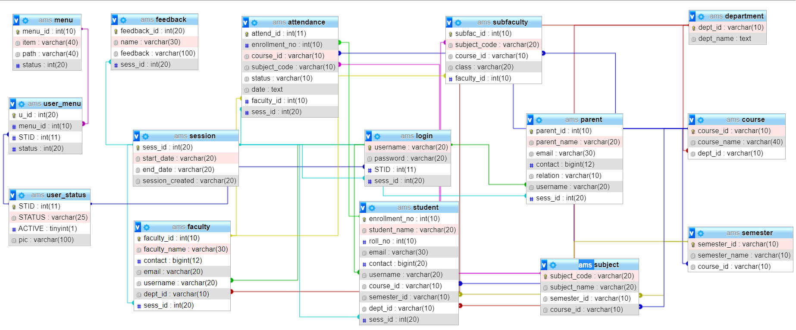

**ADVANTAGE**

* Helps you to define terms related to entity relationship modelling.
* Provide a preview of how all your tables should connect, what fields are going to be on each table.
* ER diagrams are translatable into relational tables which allows you to build databases quickly.
* ER diagrams can be used by database designers as a blueprint for implementing data in specific software applications

**INPUT DESIGN**

Input design is defined as the process of converting user-originated input format to a computer-based format. The computer-based input is called as input form or source document. The input forms are designed using HTML and classes available Bootstrap 4. The collection of input data is considered to be the most important part of the system design. In our project input forms have been used to add students, faculty, parent, subjects, giving feedback, mark attendance etc. it will help us to create the best output.

**Objective of Input Design**

* It must be complete and accurate
* There should not be any inconsistency of data.
* It should be relevant and attractive to the user.
* Input forms must be easy to fill out.

**Designing input form**

* Detailed study of user-originated document.
* Identification of fields whether they are constant or variables
* Designing on the basis of both SRS and user-oriented forms.

**Input media:** keyboard

**Input verification:** if any incorrect data enter into the system, it become costly to make necessary correction. There are numerous methods to verify data. We have used multiple condition using control statement to verify our data before storing it to database wherever required.

**OUTPUT DESIGN**

Computer output is the most important & direct source of information to the user. Output design of the application “**Attendance Management System**” generally refer to the results and information that are generated by the system for end-users. The system is accepted by the user only by the quality of its output. If the output is not of good quality, the user is likely to reject the system. The effective output design is the major criteria for deciding the overall quality of the system. In our project output designs like view attendance, view profile, view feedback, report etc. are made attractive, convenient and informative. Output have been shown using division, tables, etc.

**Advantage**

* It is permanent and portable.
* Its information can’t be changed by user.
* Affordable for many organizations.
* Adjustable according to the Viewport.

**Designing output form**

* Clarity about the information that is to be shown to the end- user.
* Information should be arranged in a proper format.
* Some of the view created are dynamic and change according to the user.

**Output media:** Monitor Screen, printers (for hard copy generation).

**Chapter 7 Database Table**

**HELPING TABLE**

**USER-STATUS TABLE**

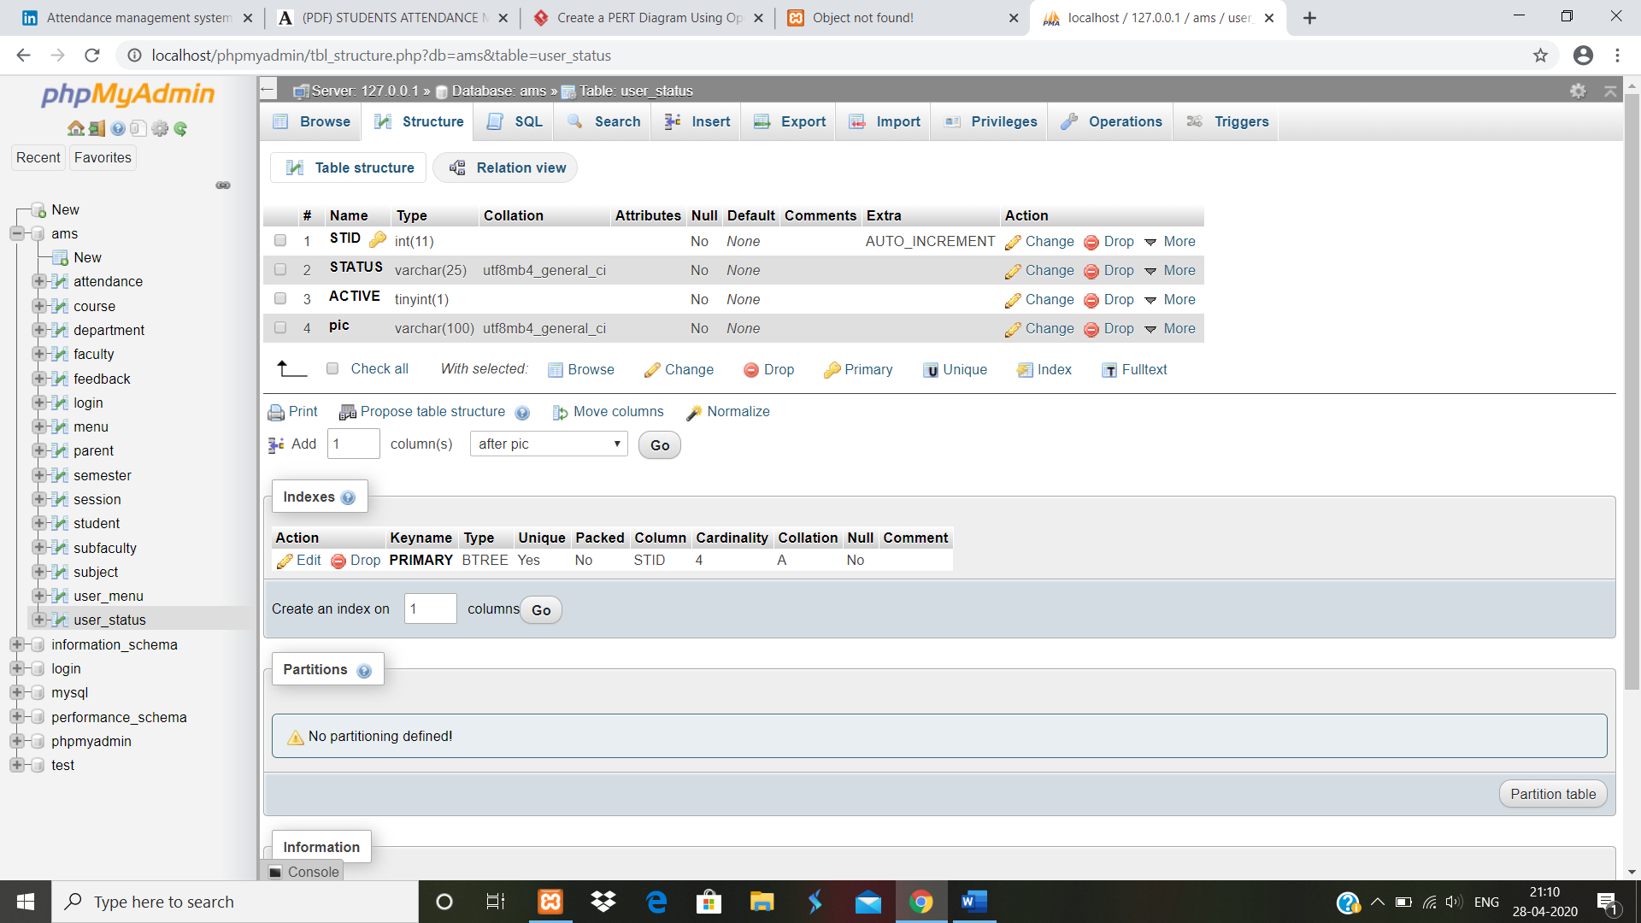

**MENU TABLE**

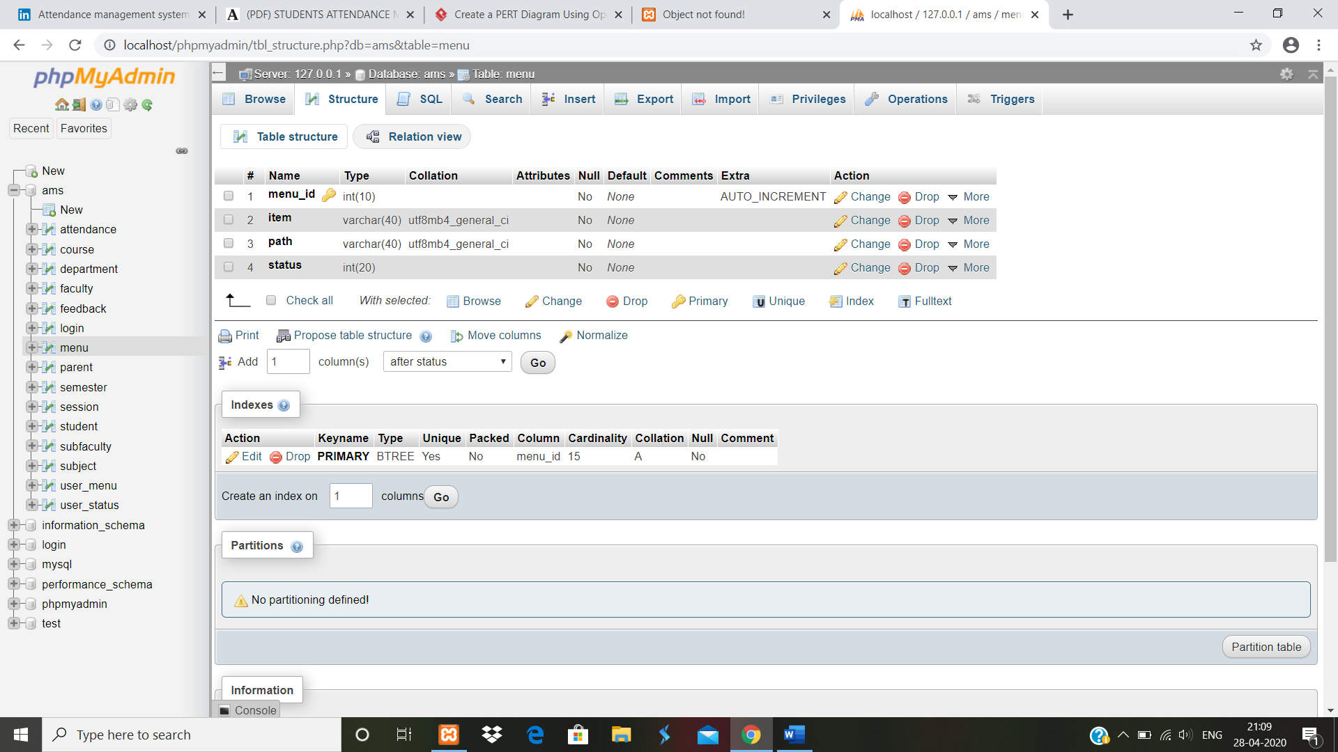

**USER-MENU TABLE**

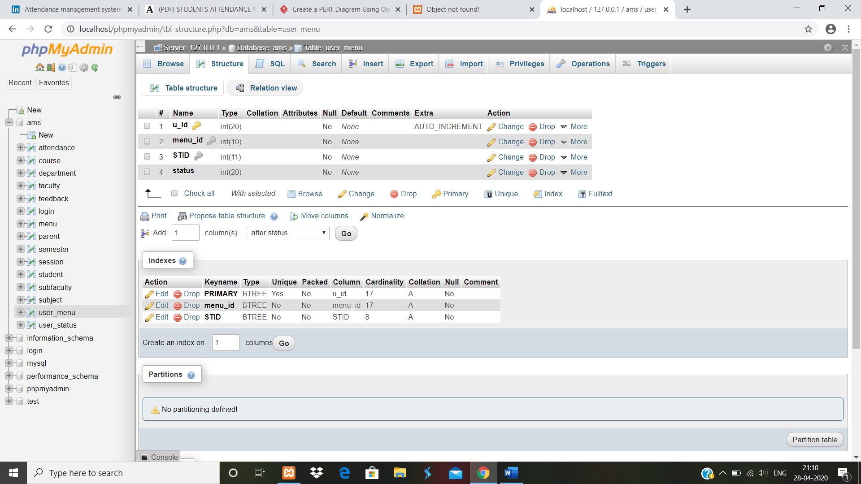

**DEPARTMENT TABLE**

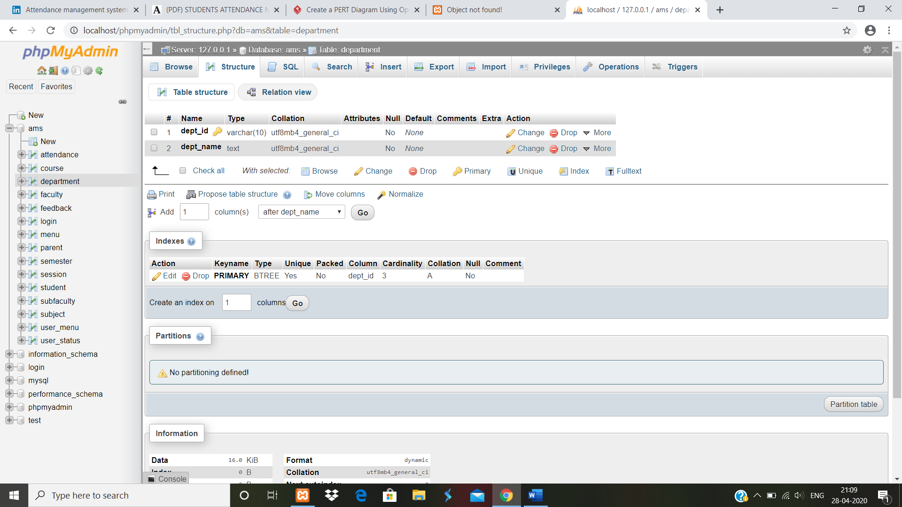

**COURSE TABLE**

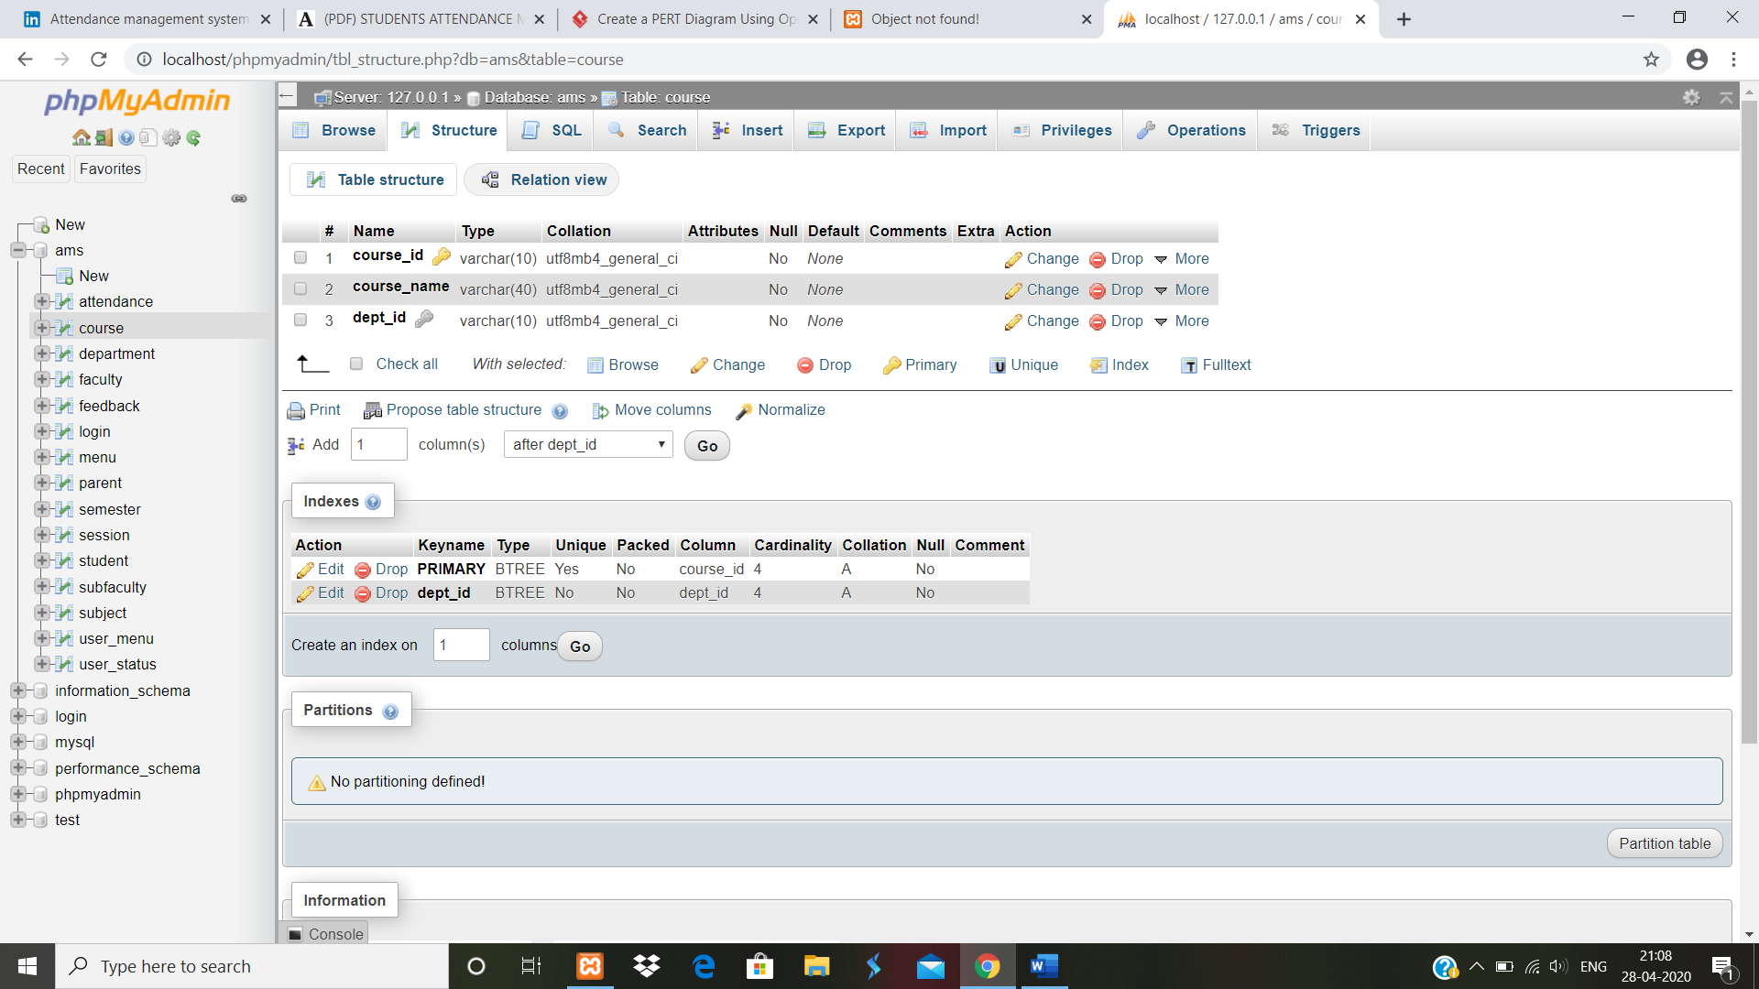

**SEMESTER TABLE**

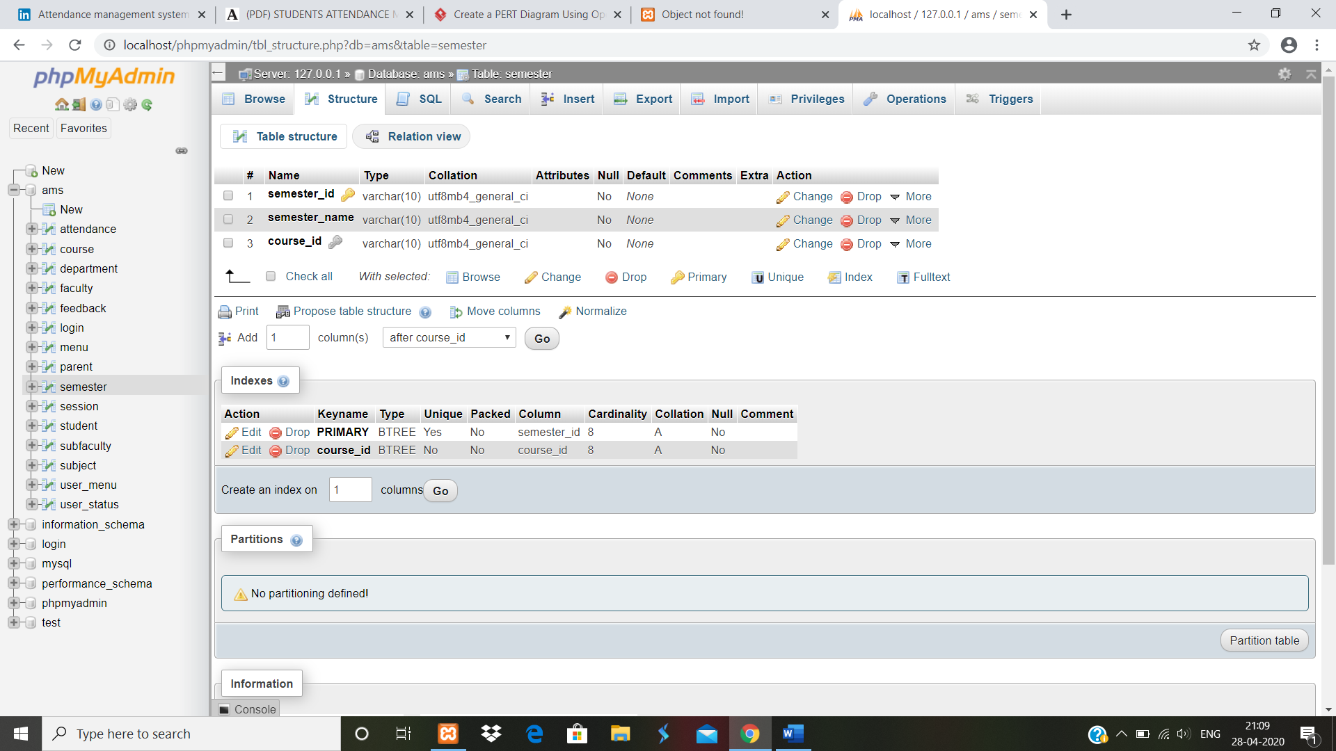

**MAIN TABLE**

**SESSION TABLE**

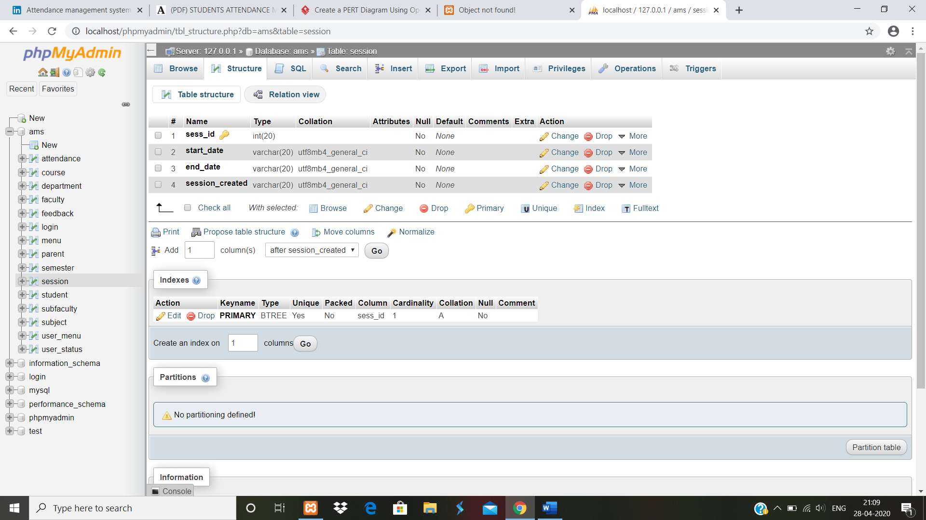

**LOGIN TABLE**

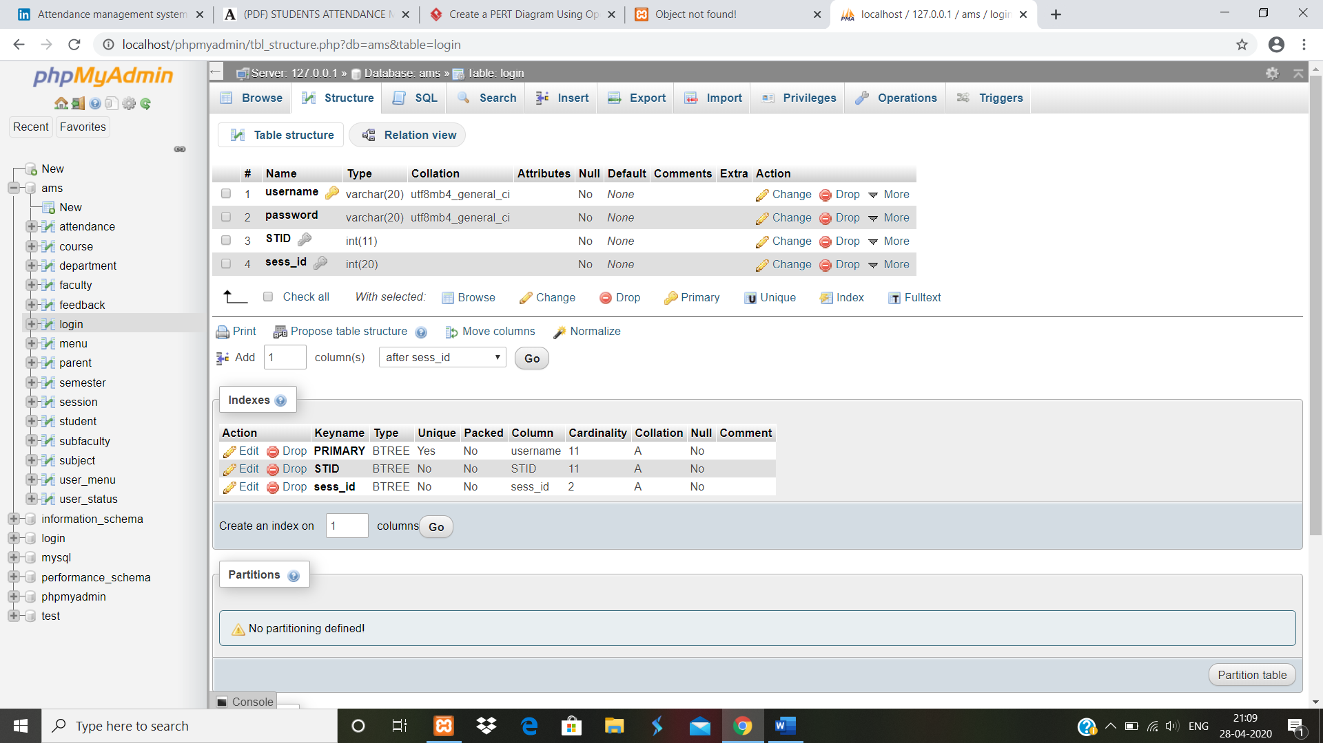

**STUDENT TABLE**

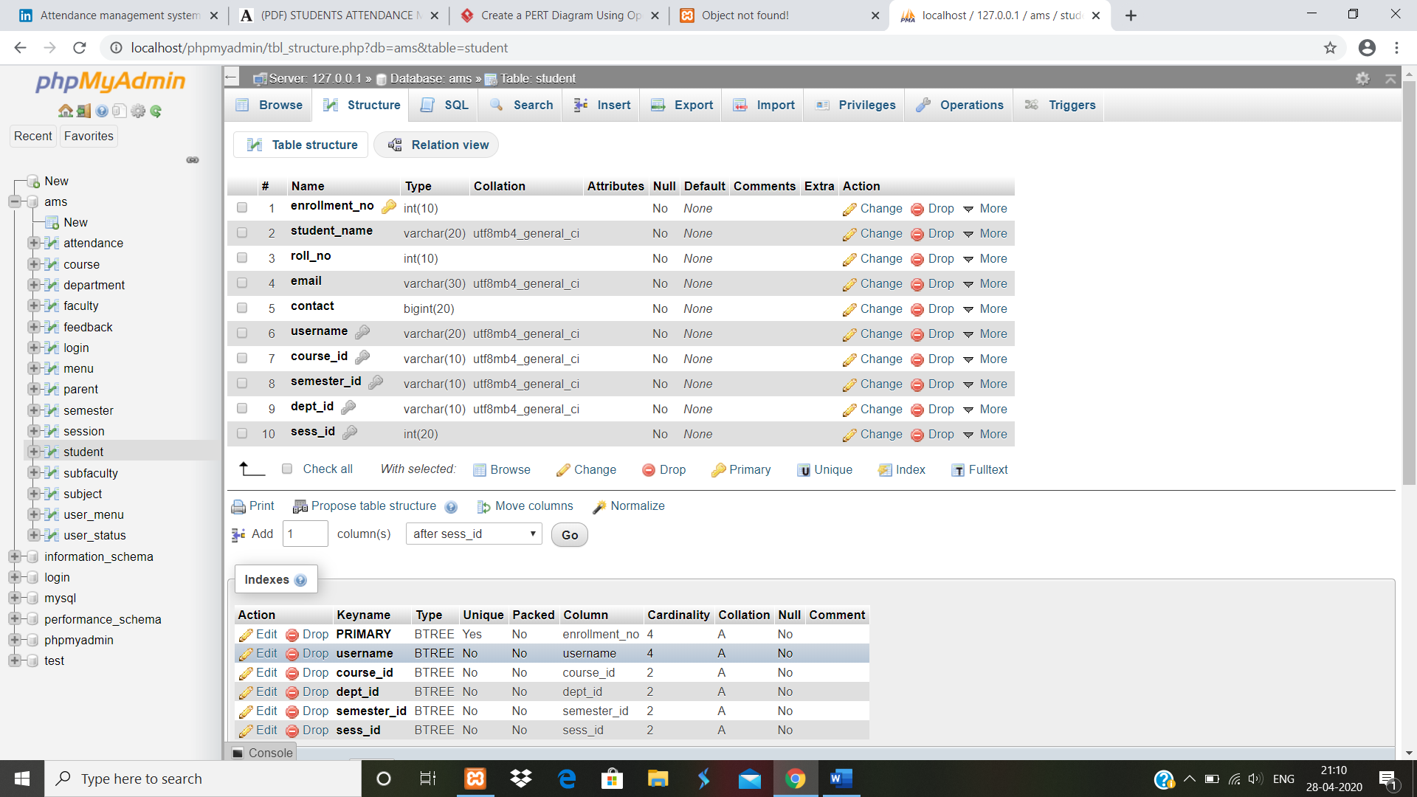

**FACULTY TABLE**

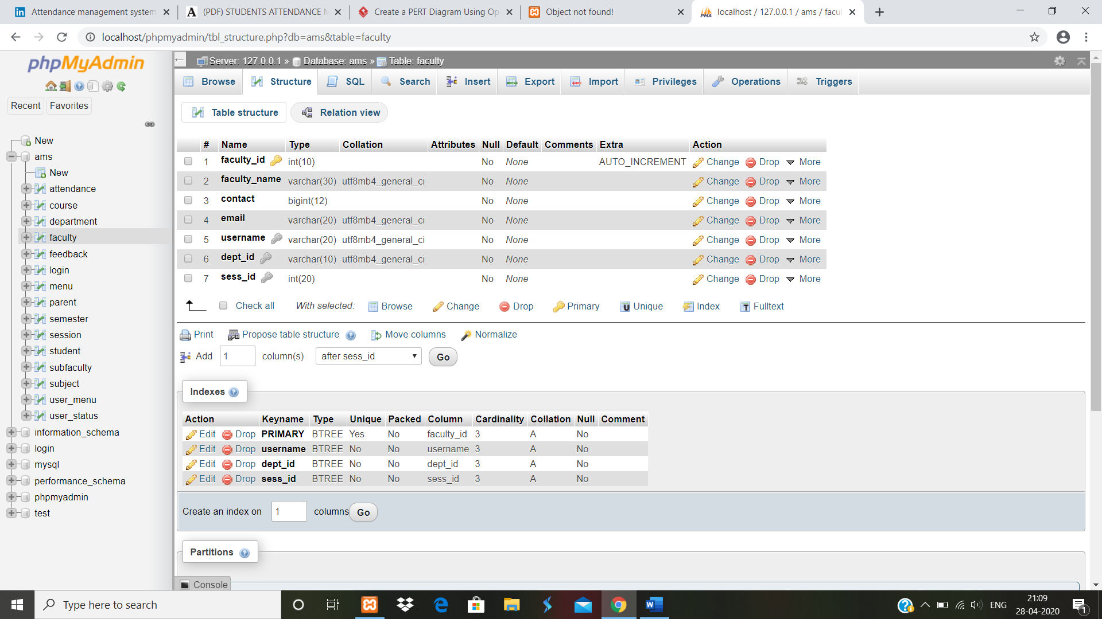

**SUBFACULTY TABLE**

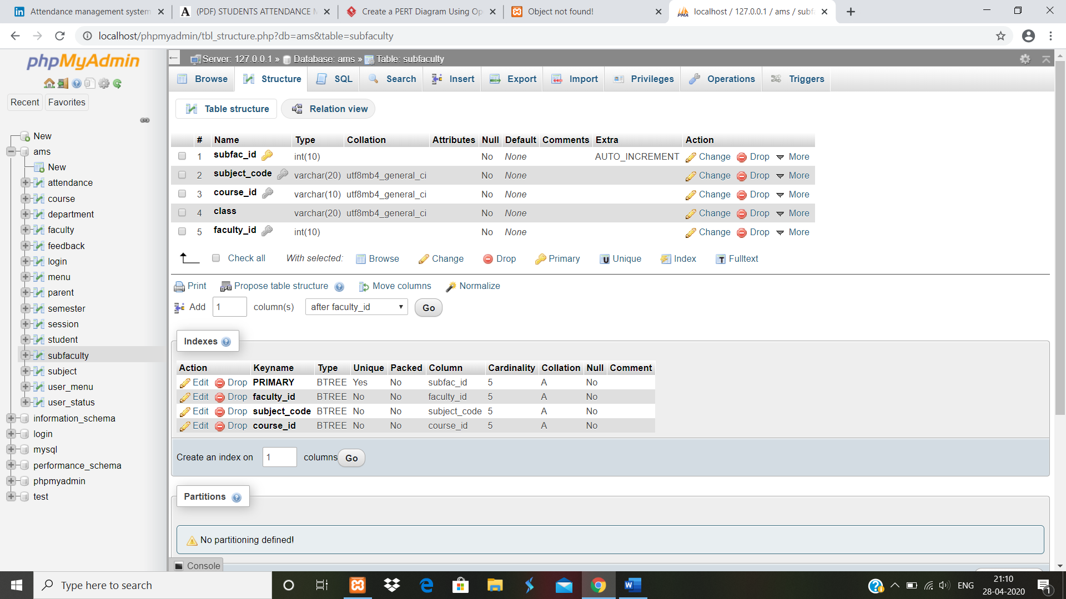

**SUBJECT TABLE**

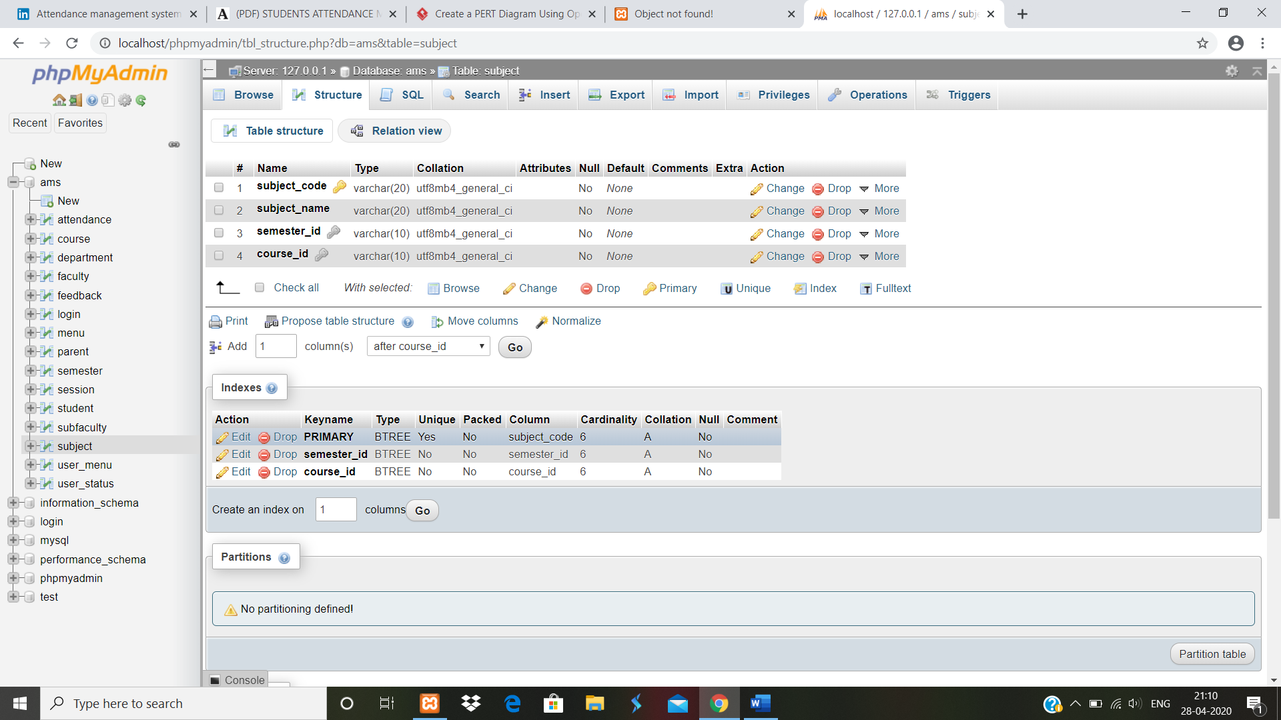

**PARENT TABLE**

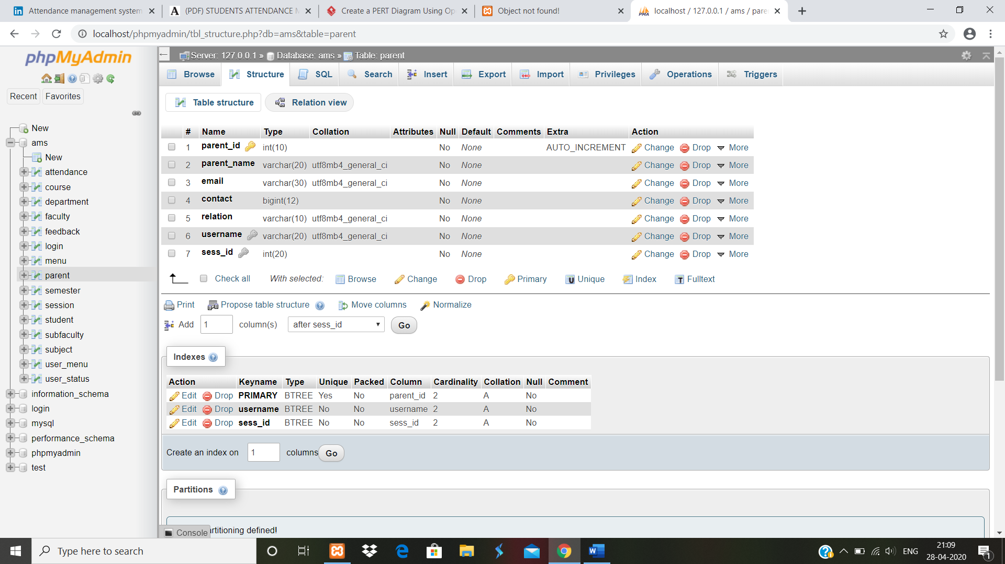

**ATTENDANCE TABLE**

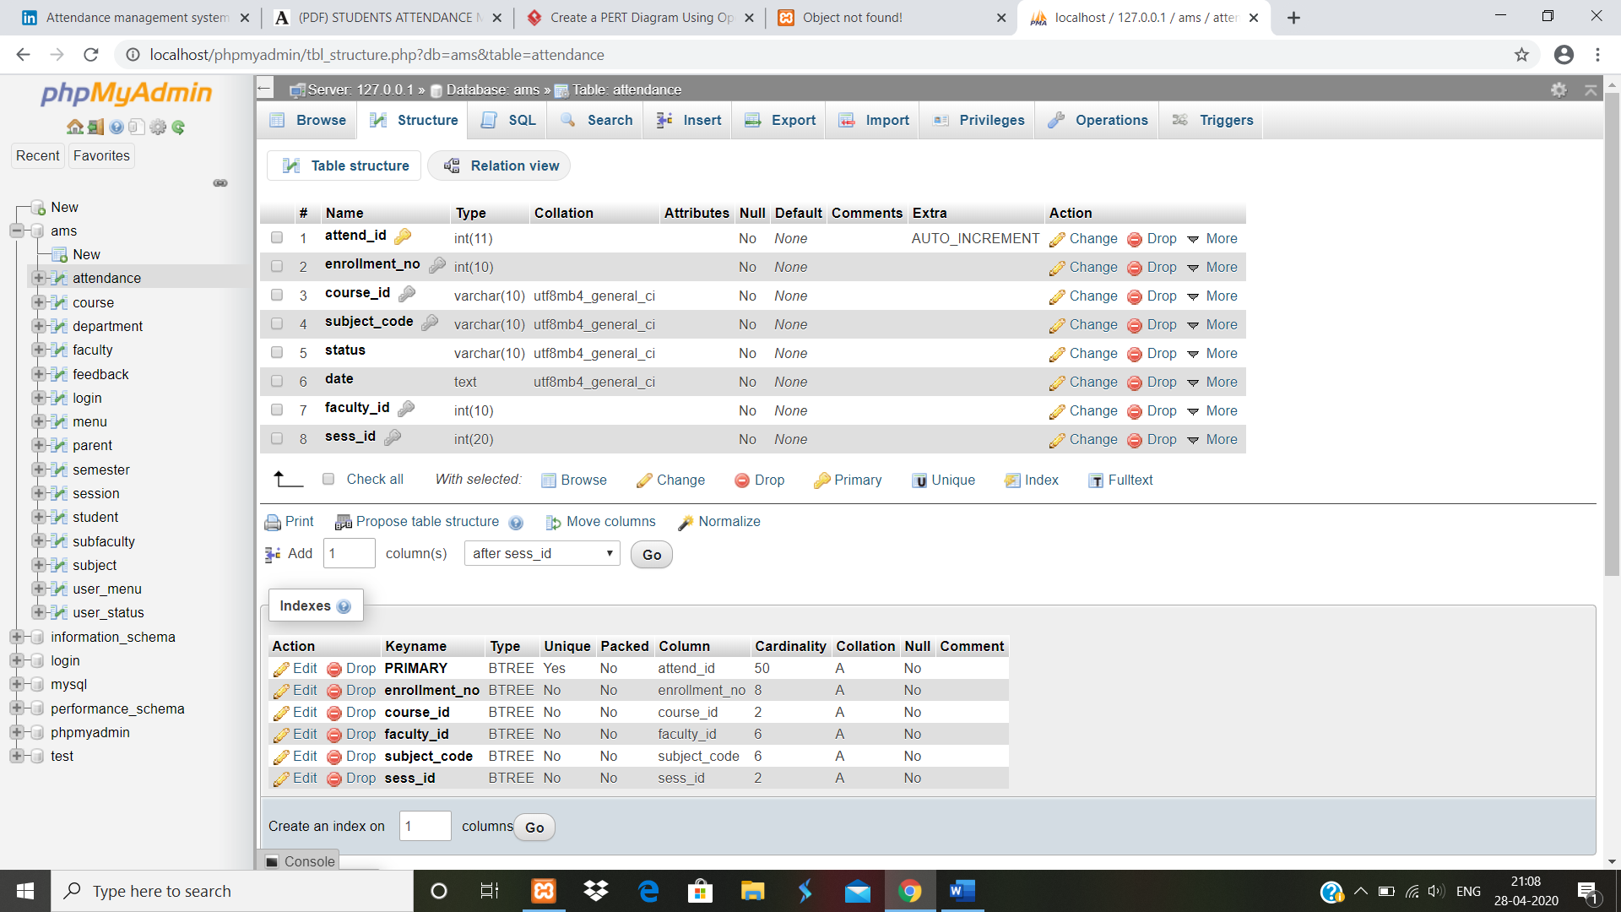

**FEEDBACK TABLE**

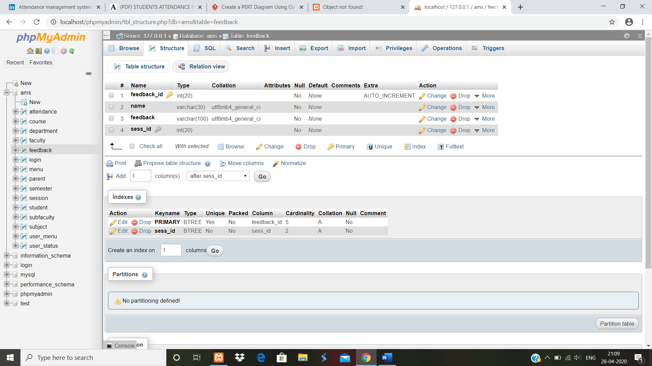

**Chapter 8 System Testing**

System Testing is a level of testing that validates the complete and fully integrated software product. The purpose of a system test is to evaluate the end-to-end system specifications. Usually, the software is only one element of a larger computer -based system. Ultimately the software is interfaced with other software/hardware systems. Our goal is to design a series of test cases that have a high likelihood of finding errors. To uncover the error software techniques are used. these techniques provide systematic guidance for designing test that

* Exercise the internal logic of the software
* Exercise the input and output domains of the program to uncover errors in program function, behavior and performance.

**Software Is Tested from Two Different Perspective:**

**Black Box Testing**

**BLACK BOX TESTING**, also known as Behavioural Testing, is a [software testing method](http://softwaretestingfundamentals.com/software-testing-methods/) in which the internal structure/design/implementation of the item being tested is not known to the tester. These tests can be functional or non-functional, though usually functional. This method is named so because the software program, in the eyes of the tester, is like a black box; inside which one cannot see.

 This method attempts to find errors in the following categories:

* Incorrect or missing functions
* Interface errors
* Errors in data structures or external database access
* Behaviour or performance errors

**Techniques**

**Equivalence Partitioning:**It is a software test design technique that involves dividing input values into valid and invalid partitions and selecting representative values from each partition as test data.

**Boundary Value Analysis**: It is a software test design technique that involves the determination of boundaries for input values and selecting values that are at the boundaries and just inside/ outside of the boundaries as test data.

**Cause-Effect Graphing**:It is a software test design technique that involves identifying the cases (input conditions) and effects (output conditions), producing a Cause-Effect Graph, and generating test cases accordingly.

Advantages

* Tests are done from a user’s point of view and will help in exposing discrepancies in the specifications.
* Tester need not know programming languages or how the software has been implemented.
* Tests can be conducted by a body independent from the developers, allowing for an objective perspective and the avoidance of developer-bias.
* Test cases can be designed as soon as the specifications are complete.

Disadvantages

* Only a small number of possible inputs can be tested and many program paths will be left untested.
* Without clear specifications, which is the situation in many projects, test cases will be difficult to design.
* Tests can be redundant if the software designer/developer has already run a test case.
* Ever wondered why a soothsayer closes the eyes when foretelling events? So is almost the case in Black Box Testing.

**White Box Testing**

**WHITE BOX TESTING**(also known as Clear Box Testing, Open Box Testing, Glass Box Testing, Transparent Box Testing, Code-Based Testing or Structural Testing) is a [software testing method](http://softwaretestingfundamentals.com/software-testing-methods/) in which the internal structure/design/implementation of the item being tested 1is known to the tester. The tester chooses inputs to exercise paths through the code and determines the appropriate outputs. Programming know-how and the implementation knowledge is essential. White box testing is testing beyond the user interface and into the nitty-gritty of a system.

This method is named so because the software program, in the eyes of the tester, is like a white/transparent box; inside which one clearly sees.

A tester, usually a developer as well, studies the implementation code of a certain field on a webpage, determines all legal (valid and invalid) AND illegal inputs and verifies the outputs against the expected outcomes, which is also determined by studying the implementation code.

White Box Testing is like the work of a mechanic who examines the engine to see why the car is not moving.

Advantages

* Testing can be commenced at an earlier stage. One need not wait for the GUI to be available.
* Testing is more thorough, with the possibility of covering most paths.

Disadvantages

* Since tests can be very complex, highly skilled resources are required, with a thorough knowledge of programming and implementation.
* Test script maintenance can be a burden if the implementation changes too frequently.
* Since this method of testing is closely tied to the application being tested, tools to cater to every kind of implementation/platform may not be readily available.

**Testing Methodologies:**

it is defined as strategies and testing types used to certify that the application under test meets client expectations.it includes functional and non- functional testing to validate.

**Unit Testing**

it is a level of software testing where individuals’ units/components of a software are tested. The purpose is to validate that each units of the software performs as designed. A unit is the smallest testable part of any software. It usually has one or few inputs and usually a single output. In programming, a unit may be an individual’s program, functions, procedure etc. In object-oriented programming, the smallest unit is a method, which may belong to a base/ super class, abstract class or derived/ child class. (Some treat a module of an application as a unit. This is to be discouraged as there will probably be many individual units within that module.) Unit testing frameworks, drivers, stubs, and mock/ fake objects are used to assist in unit testing.

**Integration Testing**

It is a level of software testing where individual units are combined and tested as a group. The purpose of this level of testing is to expose faults in the interaction between integrated units. Test drivers and stubs are used to assist in integration testing.

* **integration testing:**Testing performed to expose defects in the interfaces and in the  
  interactions between integrated components or systems. See also component integration  
  testing, system integration testing.
* **component integration testing:**Testing performed to expose defects in the interfaces and  
  interaction between integrated components.
* **system integration testing:**Testing the integration of systems and packages; testing  
  interfaces to external organizations (e.g. Electronic Data Interchange, Internet).

**TEST CASES**

Test case is an object for execution for other modules in the architecture does not represent any interaction by itself. A test case is a set of sequential steps to execute a test operating on a set of predefined inputs to produce certain expected outputs. There are two types of test cases

Manual: test cases are executing manually.

Automatic: test cases are executing manually.

In system testing, test data should cover, the possible values of each parameter based on the requirements. Since testing every value is impractical, a few values should be chosen from equivalence classes. Test cases that check the error conditions are written separately from the functional test cases and should have steps to verify the error messages and logs. If functional test cases are not written then its ok to check for error conditions when performing normal functional test cases.

**TEST CASE**

**Change password form**

|  |  |  |  |  |  |  |  |
| --- | --- | --- | --- | --- | --- | --- | --- |
| S. No | Test Case Name | Case Required | | Step | Expected Result | Actual Result | Status |
| 1 | **Change password** | | **verify whether user exist, if yes change password** | **Enter the username and new password and**  **Click on change button.** | **“Password changed successfully” or username not exist must be displayed.** | **Password changed successfully.** | **Pass** |

**Login Form**

|  |  |  |  |  |  |  |
| --- | --- | --- | --- | --- | --- | --- |
| S. No | Test Case Name | Case Required | Step | Expected Result | Actual Result | Status |
| 1 | **Validate login** | **Verify whether username and password exist, if yes than access modules** | **Enter the username and password and click on button** | **“Login successful” or**  **“error” must be displayed** | **Login successful** | **Pass** |

**Add Faculty form**

|  |  |  |  |  |  |  |
| --- | --- | --- | --- | --- | --- | --- |
| S. No | Test Case name | Case Required | Step | Expected result | Actual result | Status |
| 1 | **Check availability of faculty’s username.** | **To check whether username exist, if yes, the details can’t be added.** | **Fill up all the details of the add faculty form and click on submit button.** | **“faculty added successfully” or “username exist “must be displayed.** | **“Username exist” message displayed.** | **fail** |

**Add Student form**

|  |  |  |  |  |  |  |
| --- | --- | --- | --- | --- | --- | --- |
| S. No | Test Case name | Case Required | Step | Expected result | Actual result | Status |
| 1 | **Check availability of student’s username.** | **To check whether username exist, if yes, the details can’t be added.** | **Fill up all the details of the add student form and click on submit button.** | **“student added successfully” or “username exist “must be displayed.** | **“student added successfully” message displayed.** | **Pass** |

**Add Parent Form**

|  |  |  |  |  |  |  |
| --- | --- | --- | --- | --- | --- | --- |
| S. No | Test Case name | Case Required | Step | Expected result | Actual result | Status |
| 1 | **Check availability of parent’s username.** | **To check whether username exist, if yes, the details can’t be added.** | **Fill up all the details of the add parent form and click on submit button.** | **“parent added successfully” or “username exist”**  **must be displayed.** | **“parent added successfully” message displayed.** | **Pass** |

**View attendance form**

|  |  |  |  |  |  |  |
| --- | --- | --- | --- | --- | --- | --- |
| S. No | Test Case name | Case Required | Step | Expected result | Actual result | Status |
| 1 | **check**  **Valid enrollment** | **To check whether attendance details exist, if yes, the details will be shown in the screen.** | **Fill up all the details asked in the form and click on submit button.** | **“Report will be shown on the screen” or “attendance not exist” must be displayed.** | **Report displayed on the screen.** | **Pass** |

**Manage Session Form**

|  |  |  |  |  |  |  |
| --- | --- | --- | --- | --- | --- | --- |
| S. No | Test Case name | Case Required | Step | Expected result | Actual result | Status |
| 1 | **Check session exist.** | **To check whether session id exist, if yes, then session will not be created.** | **Fill up all the details asked in the form and click on submit button.** | **“session created” or “session already exist” must be displayed.** | **Session already exist is displayed.** | **Fail** |

**Update attendance Form**

|  |  |  |  |  |  |  |
| --- | --- | --- | --- | --- | --- | --- |
| S. No | Test Case name | Case Required | Step | Expected result | Actual result | Status |
| 1 | **Check for update attendance.** | **To check data will be updated.** | **Fill up the detail of the form and click on submit button.** | **“attendance updated” or redirection to the home page.** | **Page redirected to home.** | **fail** |

**Chapter 9 System Implementation and Maintenance**

**Purpose**

System implementation is the important stage of the project when the theoretical design is turned into practical system. The main stages in the implementation are as follows:

Planning

Training

System Testing

Changeover Planning

Planning is the first task in the system implementation. At the time of implementation of any system people from different departments and system analysis involve. They are confirmed to practical problem of controlling various activities of people outside their own data processing departments.

This attendance management system will add the various people involves with the institutes like adding student, adding teachers, add parent and subjects viewing attendance and feedback. Some of the user’s task like viewing profile, generating attendance, giving feedback etc. The report can be generated in pdf format and can be saved.

**Maintenance**

The results obtained from the evaluation process help the organization to determine whether its [information](http://ecomputernotes.com/fundamental/information-technology/what-do-you-mean-by-data-and-information) systems are effective and efficient or otherwise. The process of monitoring, evaluating, and modifying of existing information systems to make required or desirable improvements may be termed as System Maintenance. System maintenance is an ongoing activity, which covers a wide variety of activities, including removing program and design errors, updating documentation and test data and updating user support.

For the purpose of convenience, maintenance may be categorized into three classes, namely:

**Corrective Maintenance**: This type of maintenance implies removing errors in a program, which might have crept in the system due to faulty design or wrong assumptions. Thus, in corrective maintenance, processing or performance failures are repaired.

**Adaptive Maintenance**: In adaptive maintenance, program functions are changed to enable the information system to satisfy the information needs of the user. This type of maintenance may become necessary because of organizational changes which may include:

* change in the organizational procedures.
* Change in organizational objectives, gaols, policies etc.
* Change in forms

**Perfective Maintenance**: Perfective maintenance means adding new programs or modifying the existing programs to enhance the performance of the information system. This type of maintenance undertaken to respond to user’s additional needs which may be due to the changes within or outside of the organization. Outside changes are primarily environmental changes, which may in the absence of system maintenance, render the information system is ineffective.

**LIMITATION OF PROPOSED SYSTEM**

* No feature of database backup is available.
* Details updating feature of users is not available hence it should be added to the database properly.

**Chapter 10 Conclusion**

To conclude, project can work like a component and can access all the database and picks up different functions. It overcome many limitations in the attendance

Easy implementation environment

Generate report

Viewing profile

**SCOPE FOR FUTURE DEVELOPMENT**

the project has very vast scope in the future. The project can be implemented on interact in future. project can be also updated with the new features whenever the requirement of the same arises, as it is flexible in terms of expansion. The proposed software is fully functional, the client can easily manage and run the entire work in a much better, accurate and error free manner.

THE FUTURE SCOPE OF PROJECT

On discontinuing of particular student eliminate potential attendance.

Bar code reader-based attendance system

Individual attendance system with photo using login.

**Chapter 11 Snapshots of System**

**LOGIN PANEL**

**LOGIN PAGE**

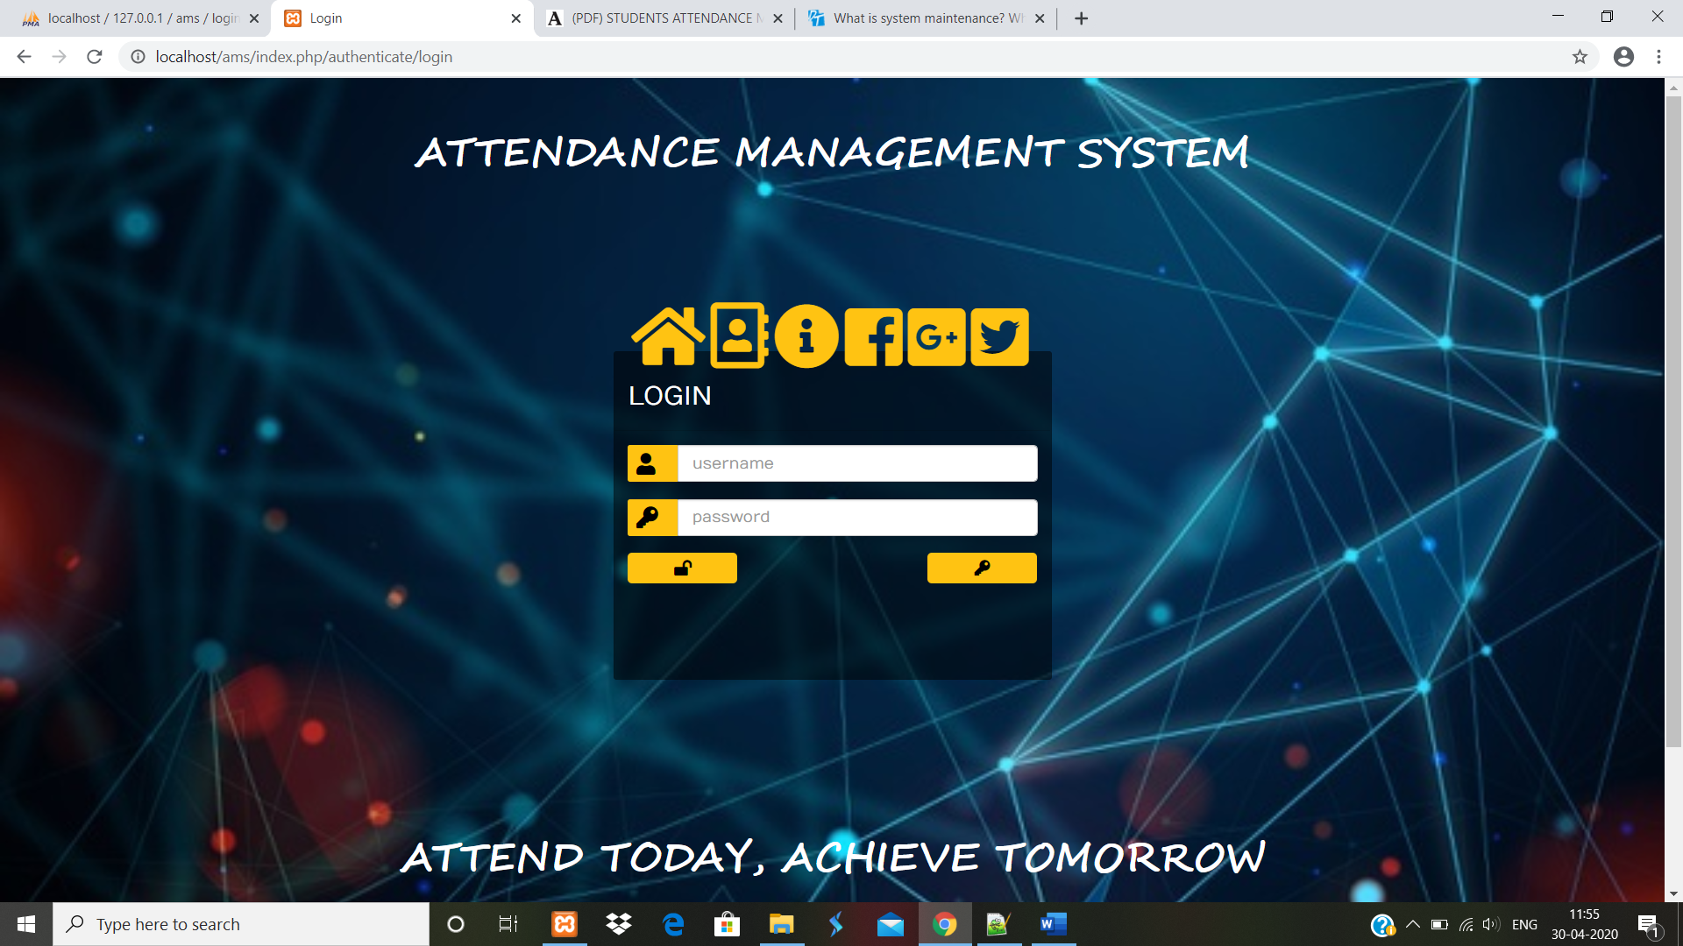

**CHANGE PASSWORD**

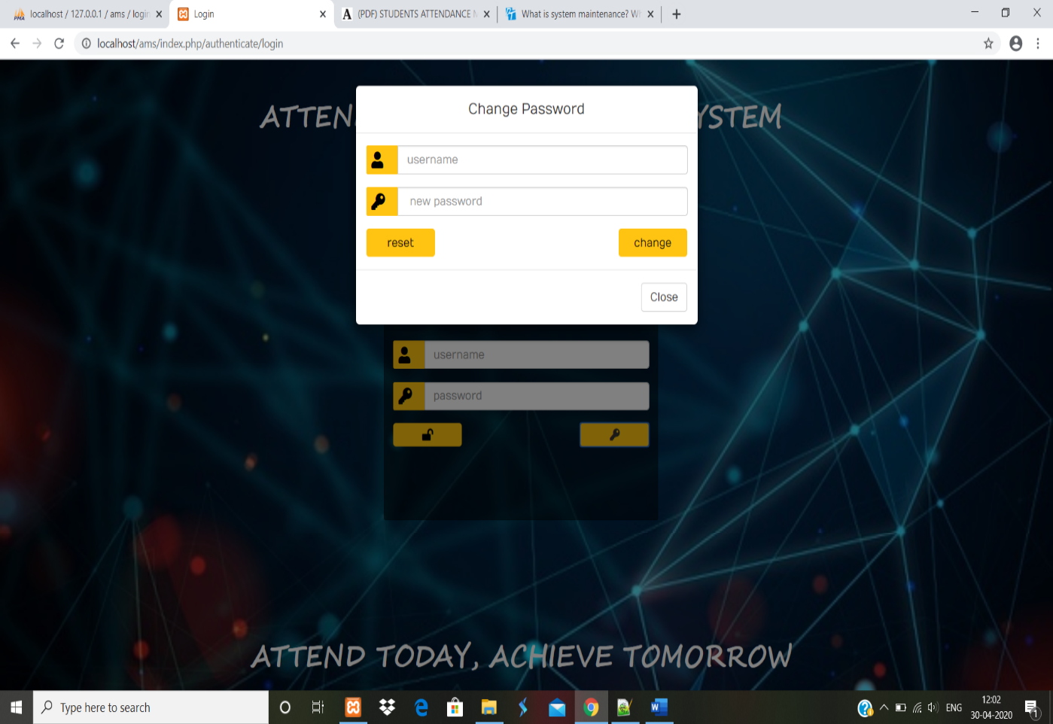

**CONTACT PAGE**

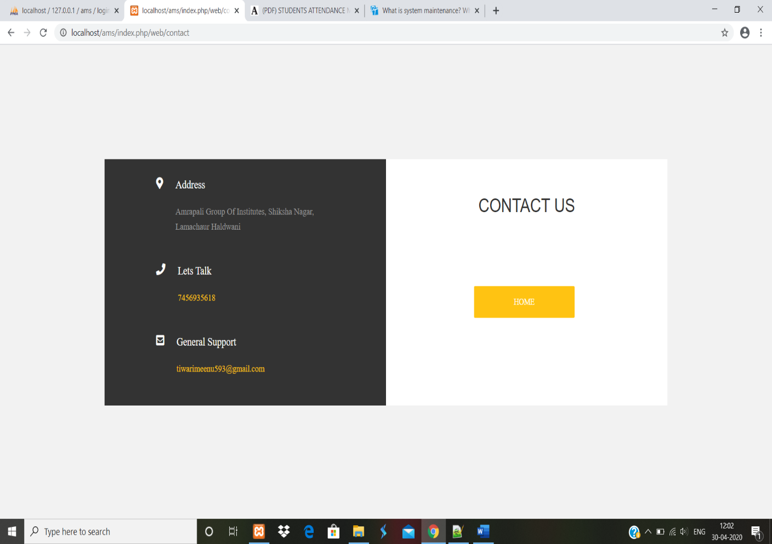

**ADMIN PORTAL**

**ADMIN HOMEPAGE**

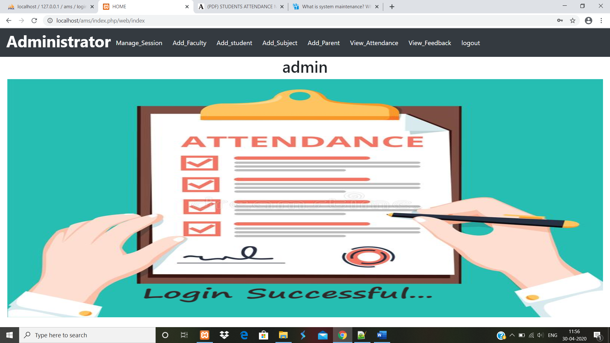

**MANAGE SESSION**

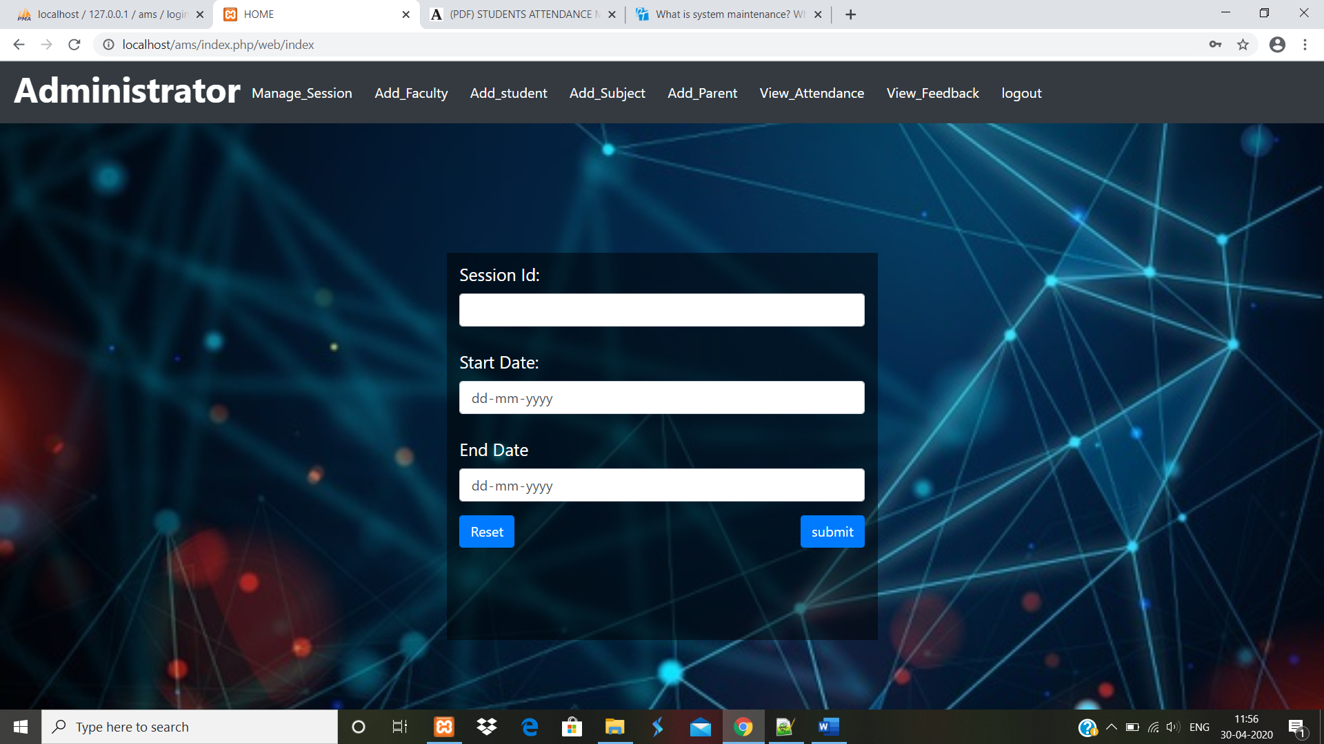

**ADD FACULTY**

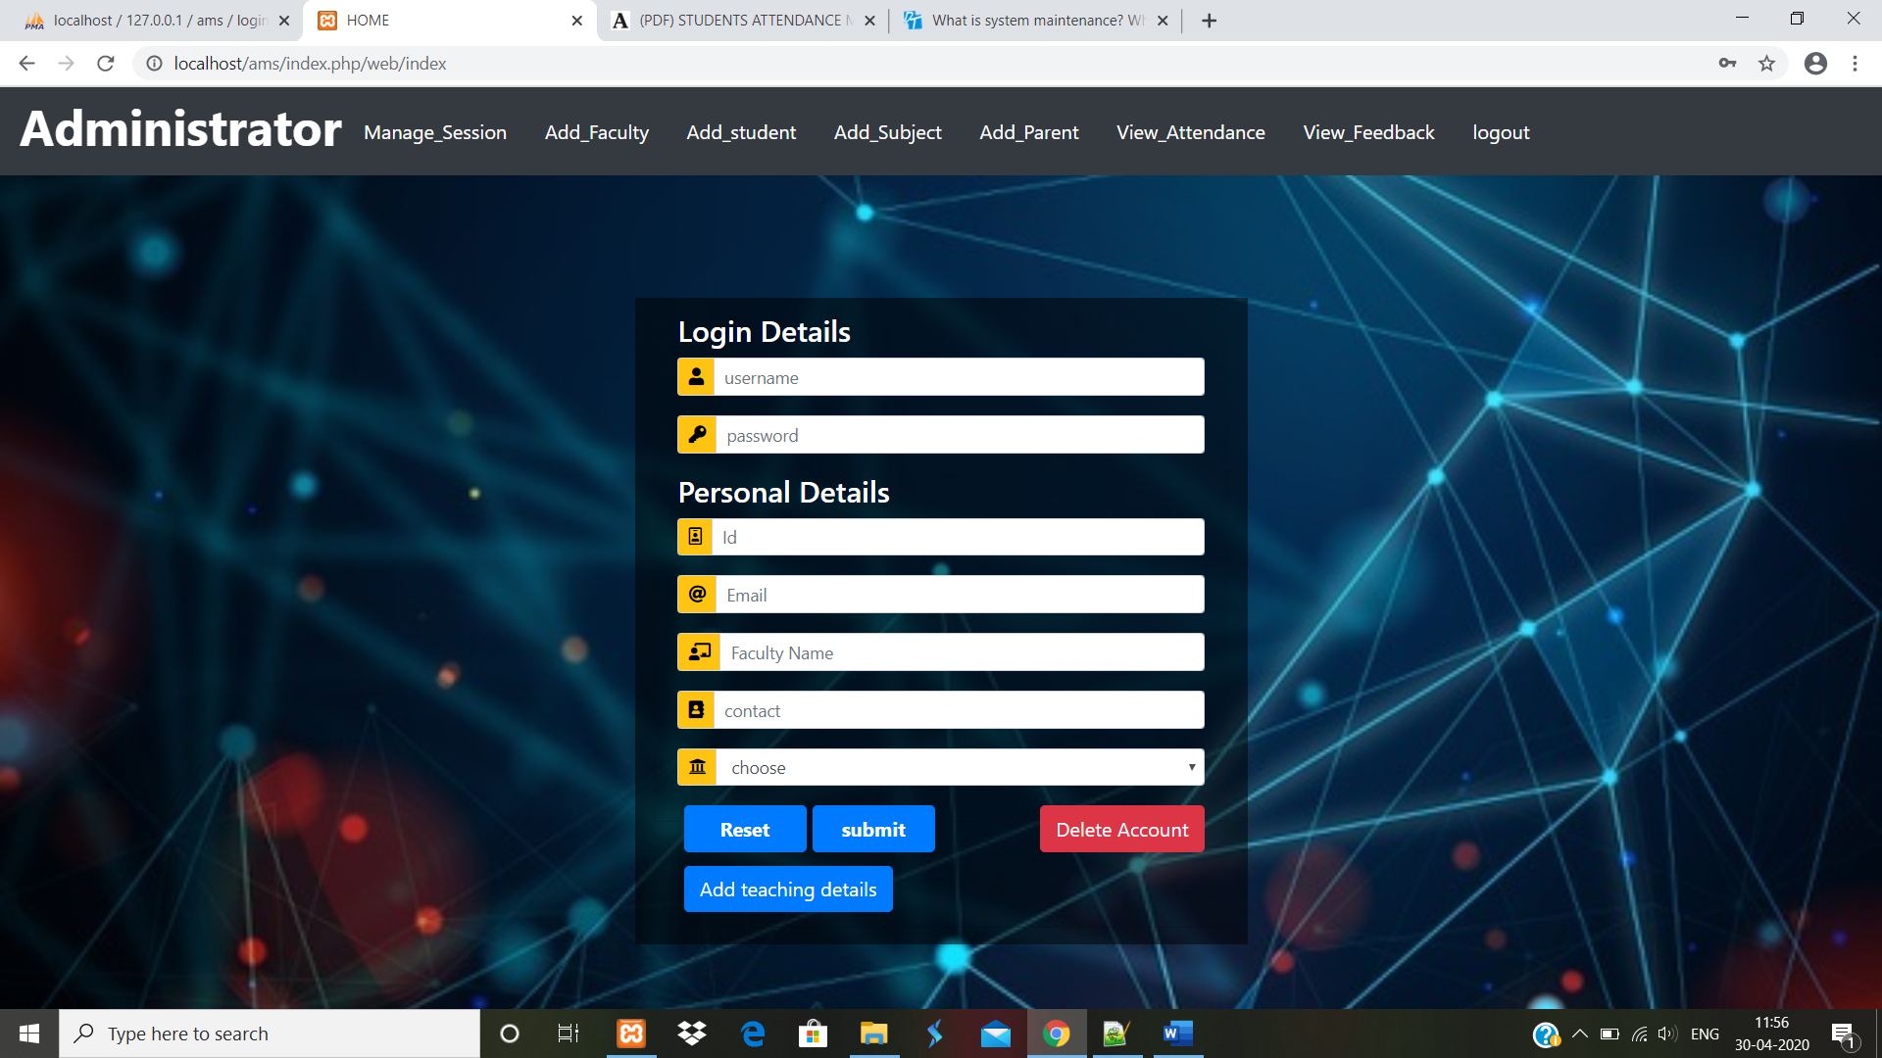

**ADD STUDENT**

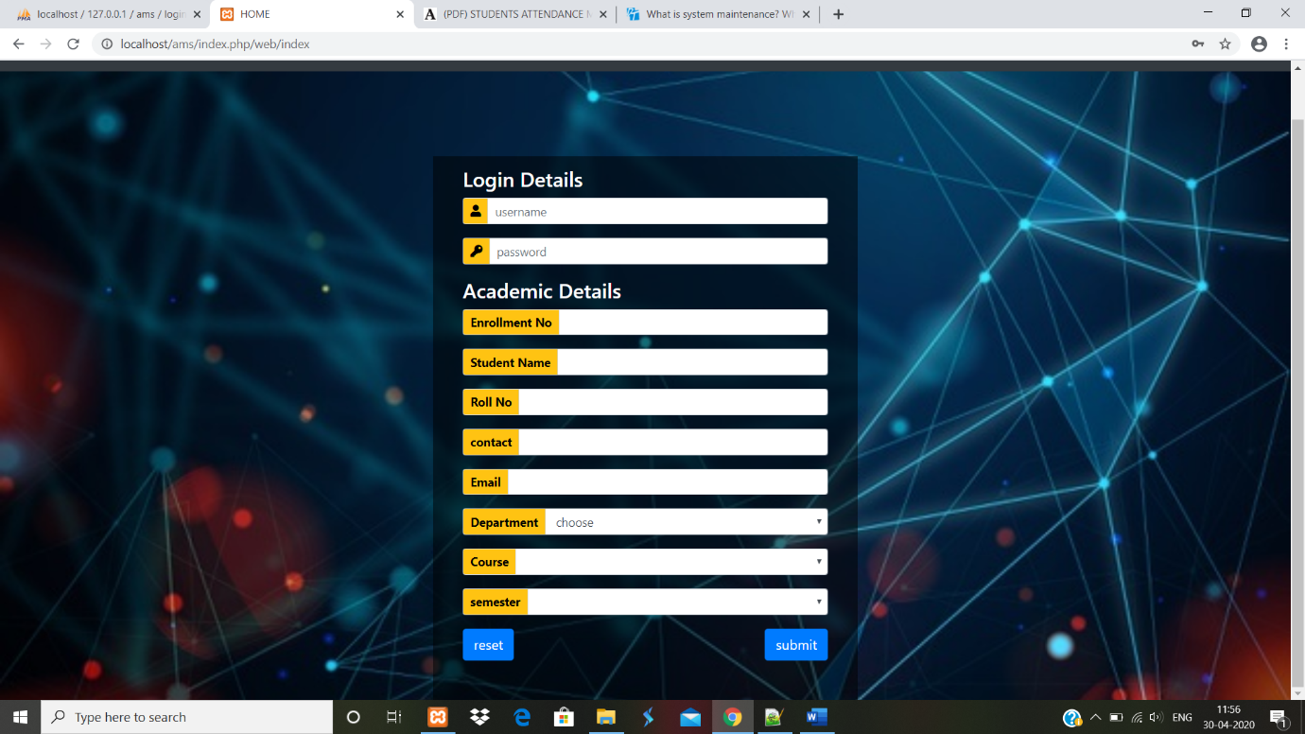

**ADD SUBJECT**

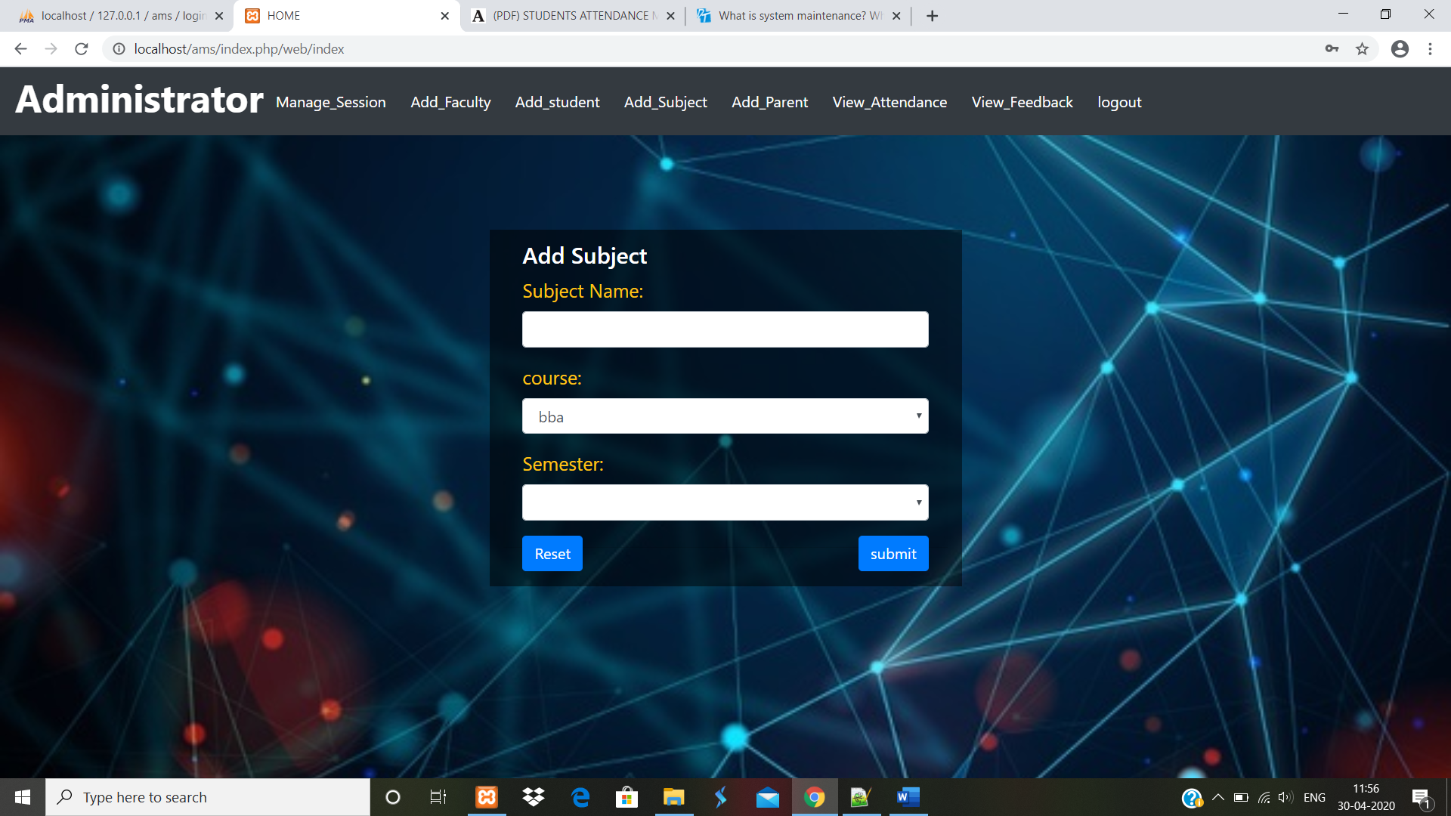

**ADD PARENT**

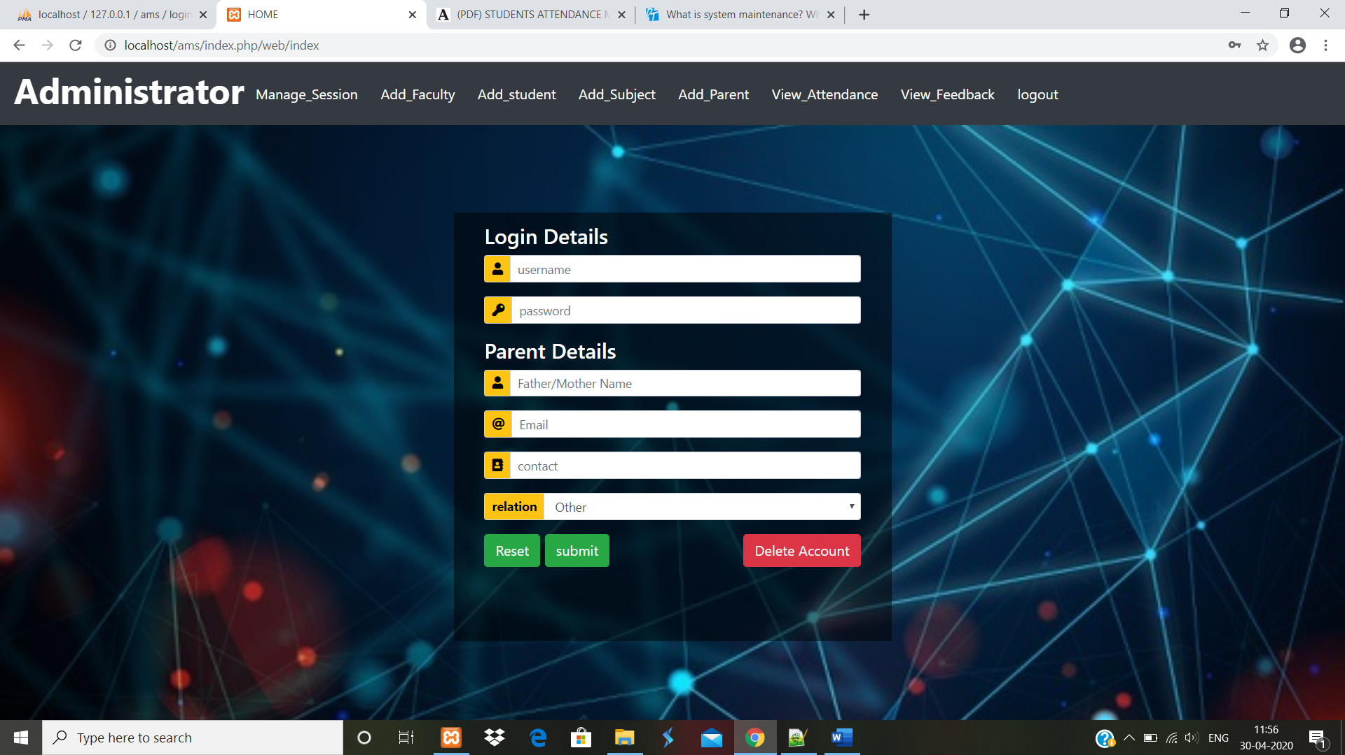

**VIEW ATTENDANCE**

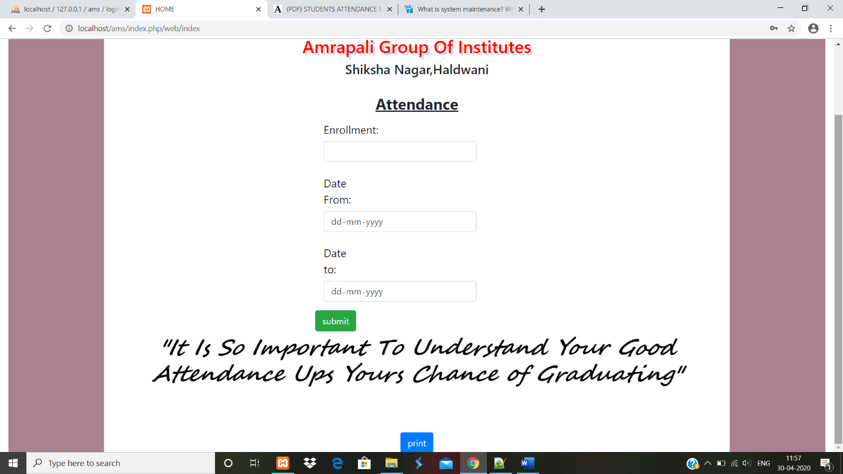

**ATTENDANCE REPORT AFTER FILLING DETAILS**

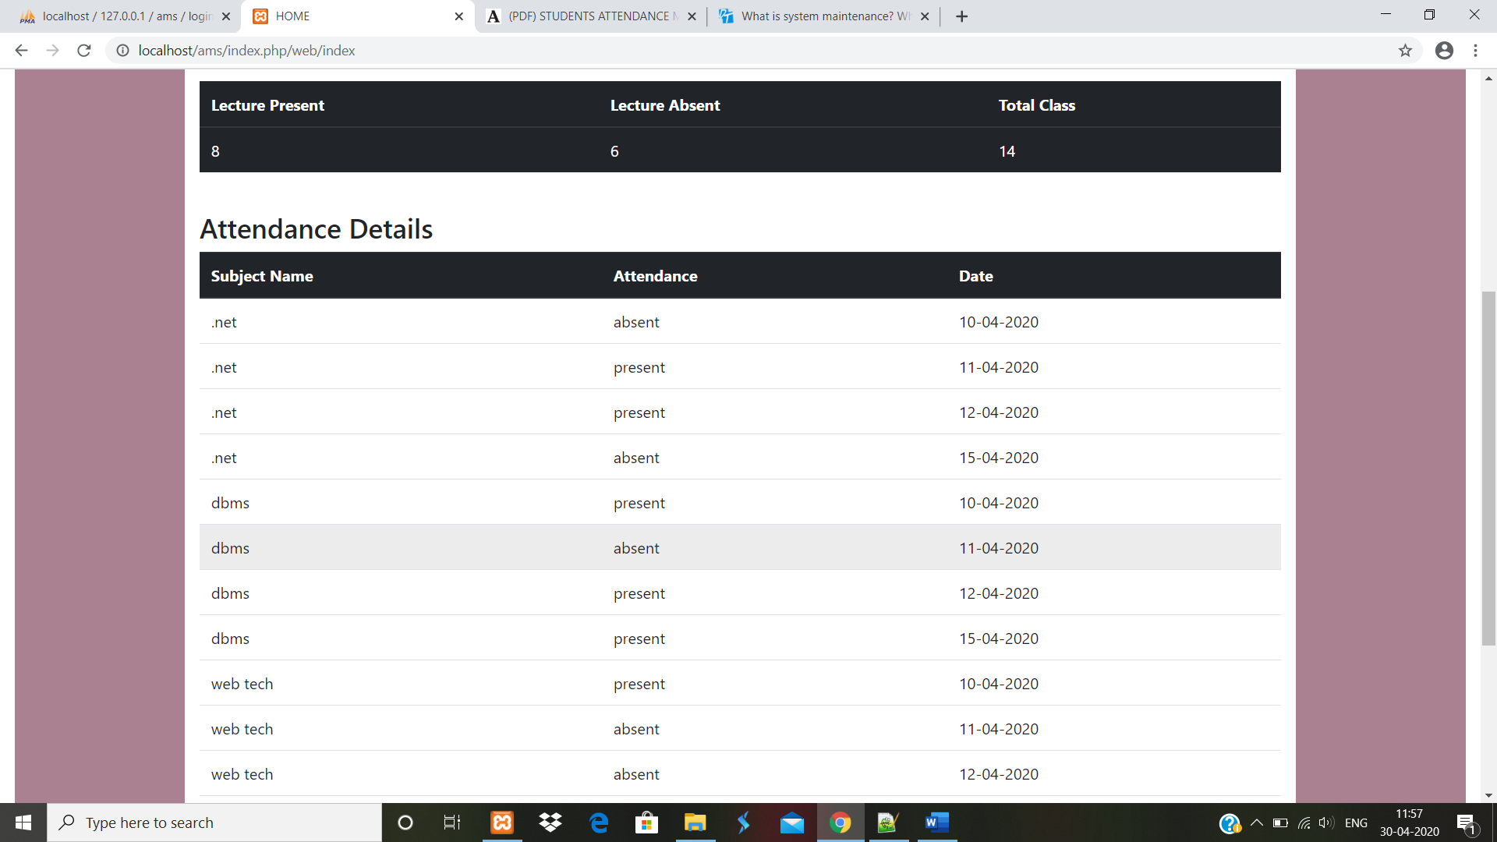

**REPORT GENERATE AS PDF FORMAT**

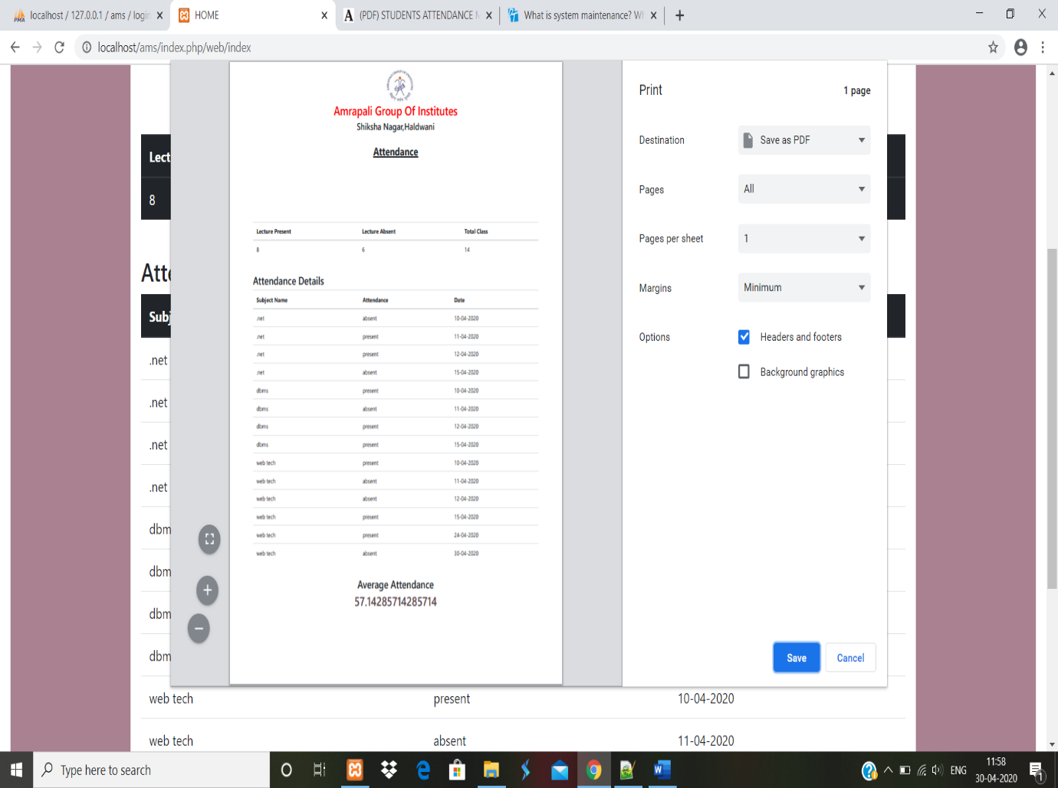

**VIEW FEEDBACK**

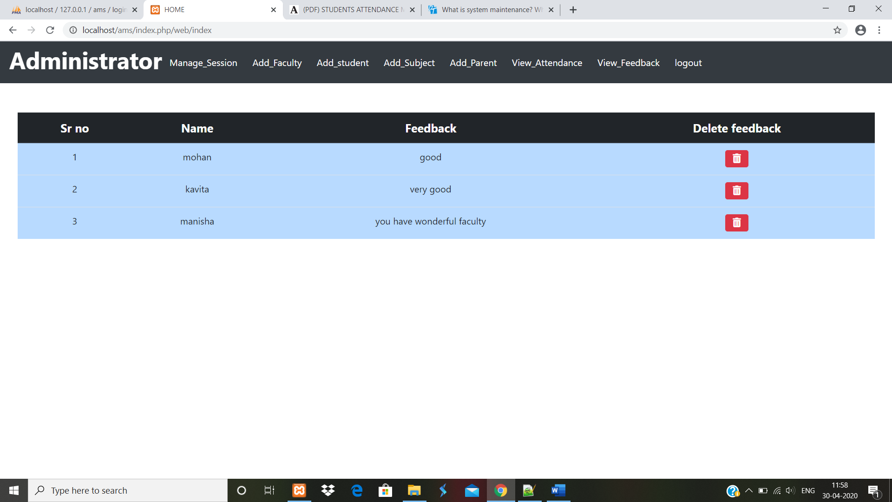**FACULTY PANEL**

**FACULTY HOMEPAGE**

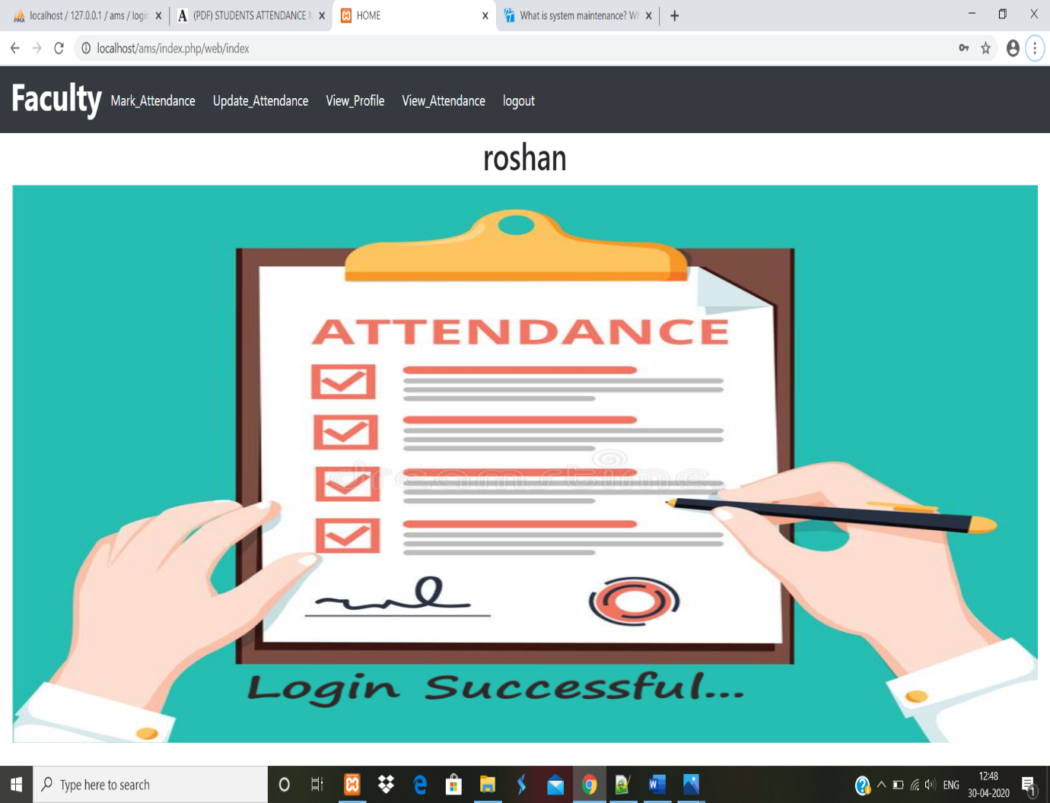

**MARK ATTENDANCE**

**FORM**

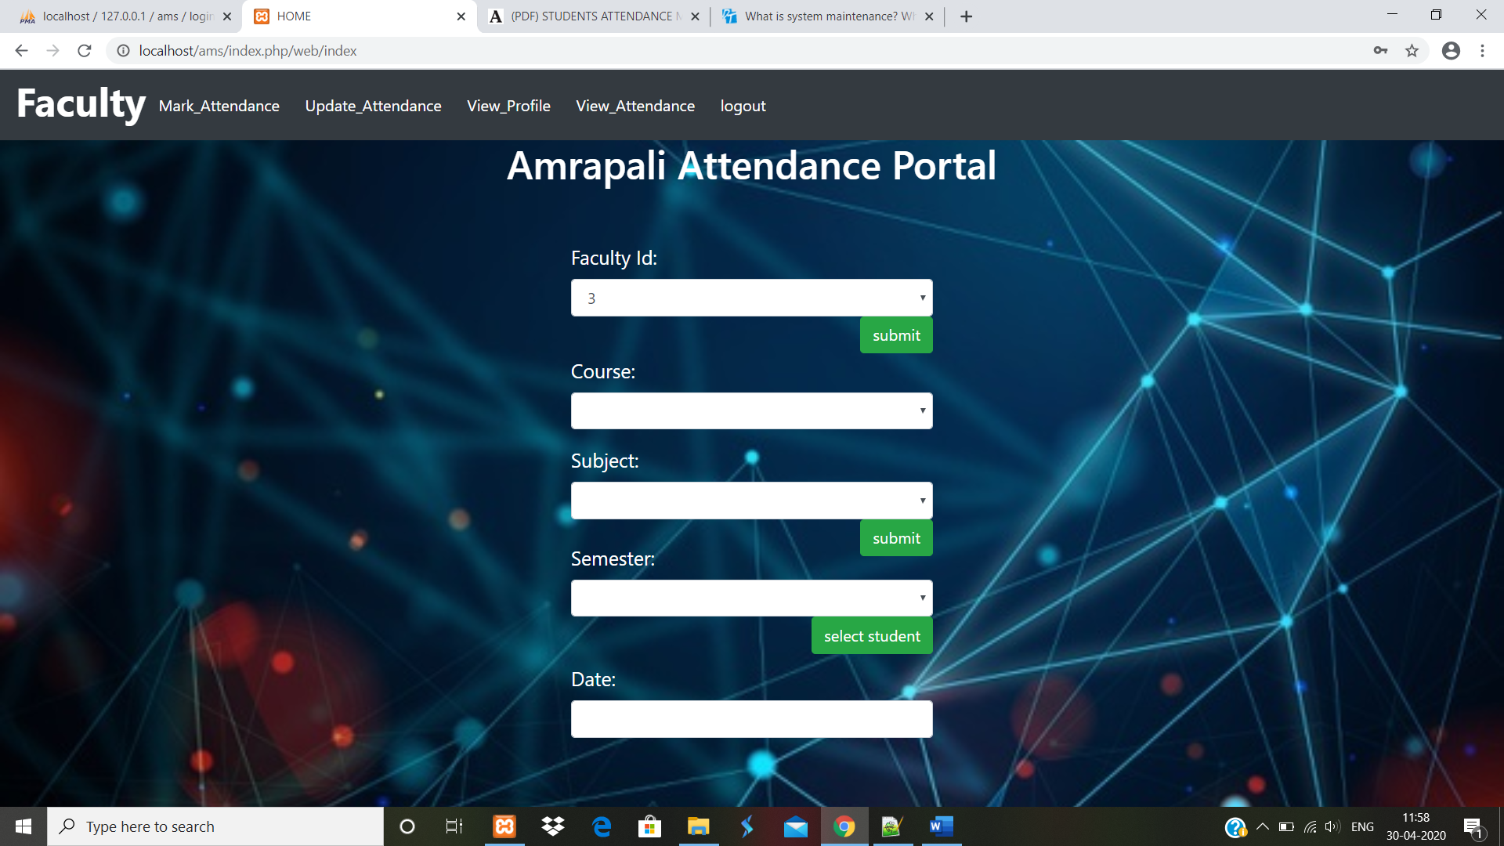

**AFTER FILLING DETAILS**

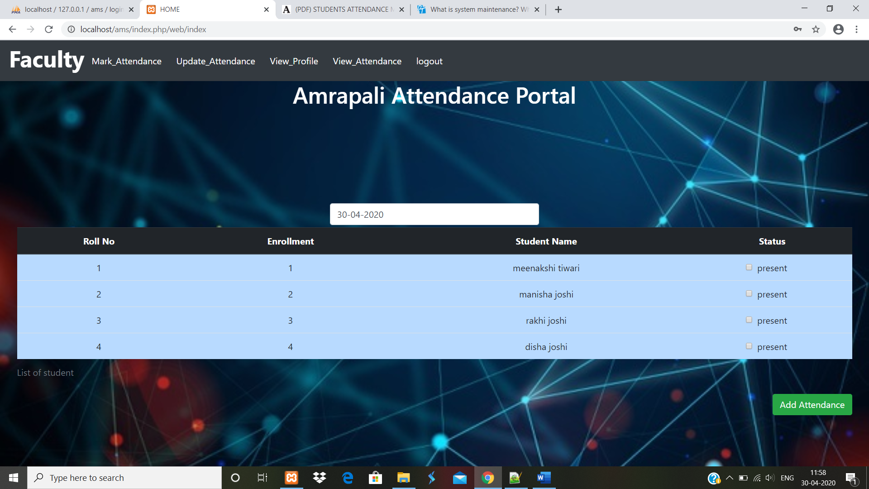

**UPDATE ATTENDANCE**

**FORM**

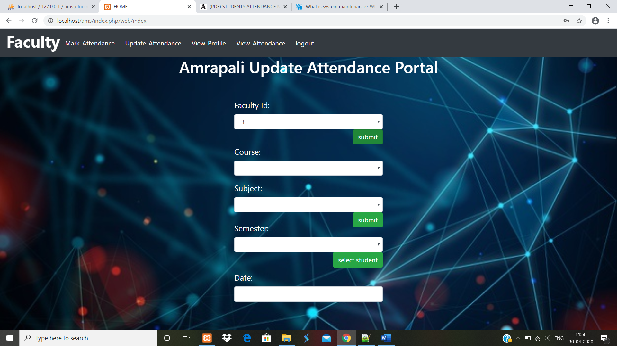

**AFTER FILLING DETAILS**

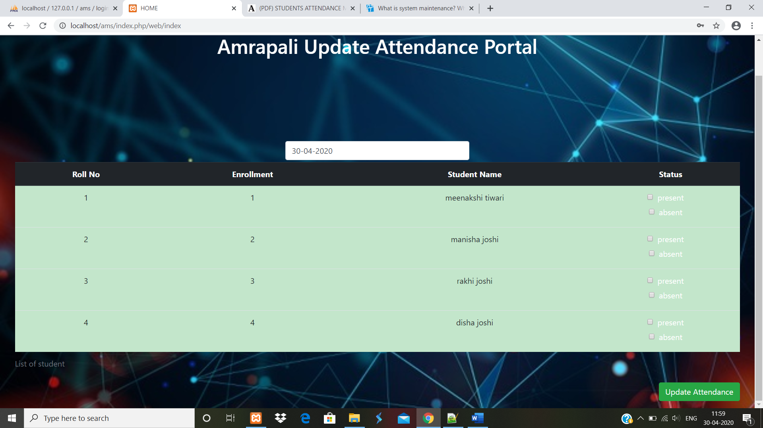

**VIEW PROFILE**



**VIEW ATTENDANCE**



**ATTENDANCE REPORT AFTER FILLING DETAILS**



**REPORT GENERATE AS PDF FORMAT**



**STUDENT PORTAL**

**STUDENT HOMEPAGE**

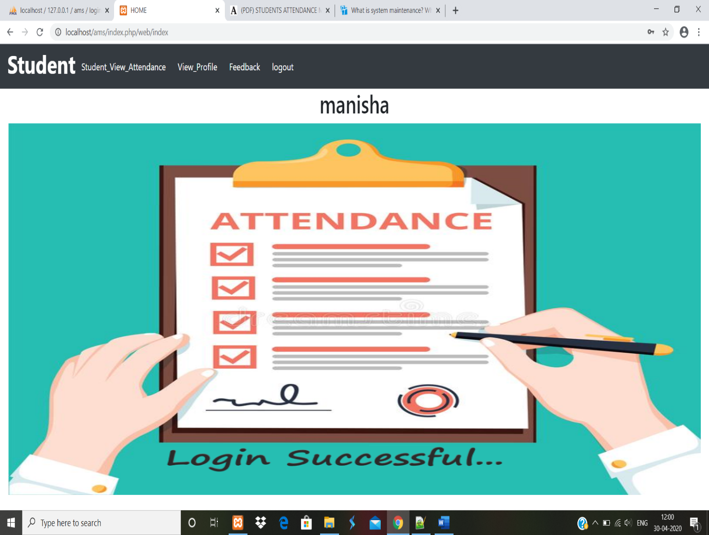

**VIEW ATTENDANCE**

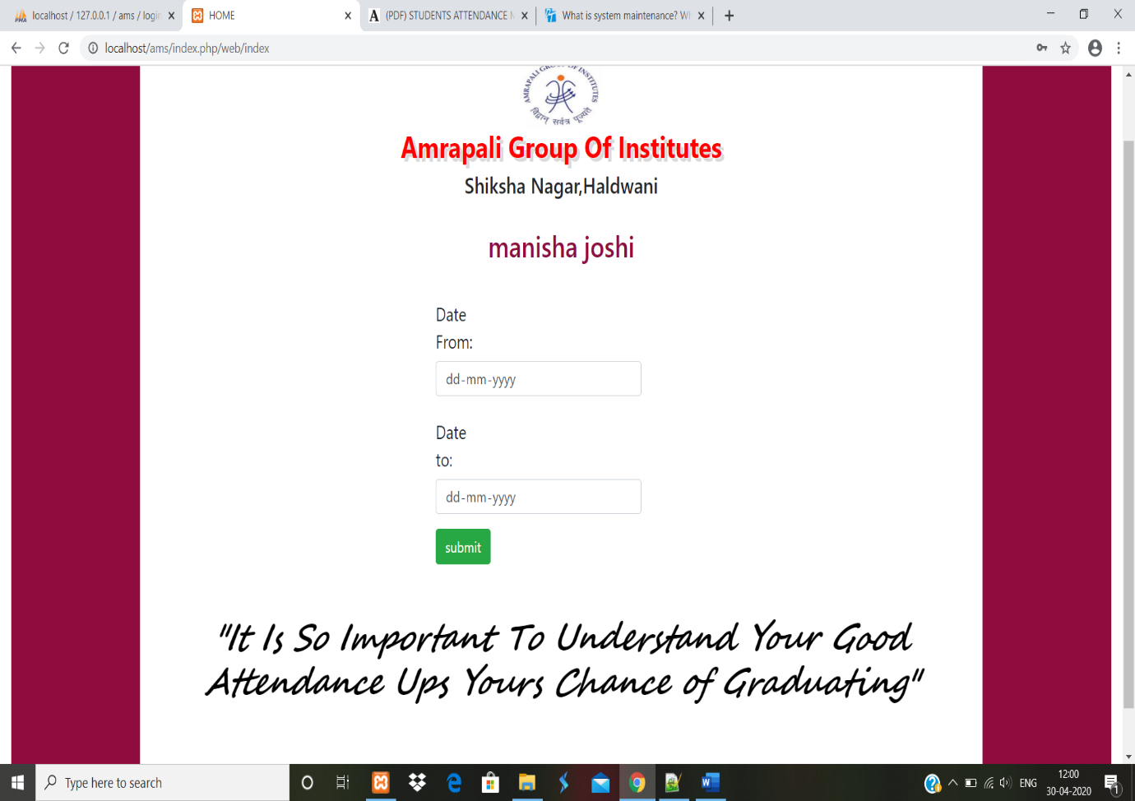

**REPORT AFTER FILLING DETAILS**

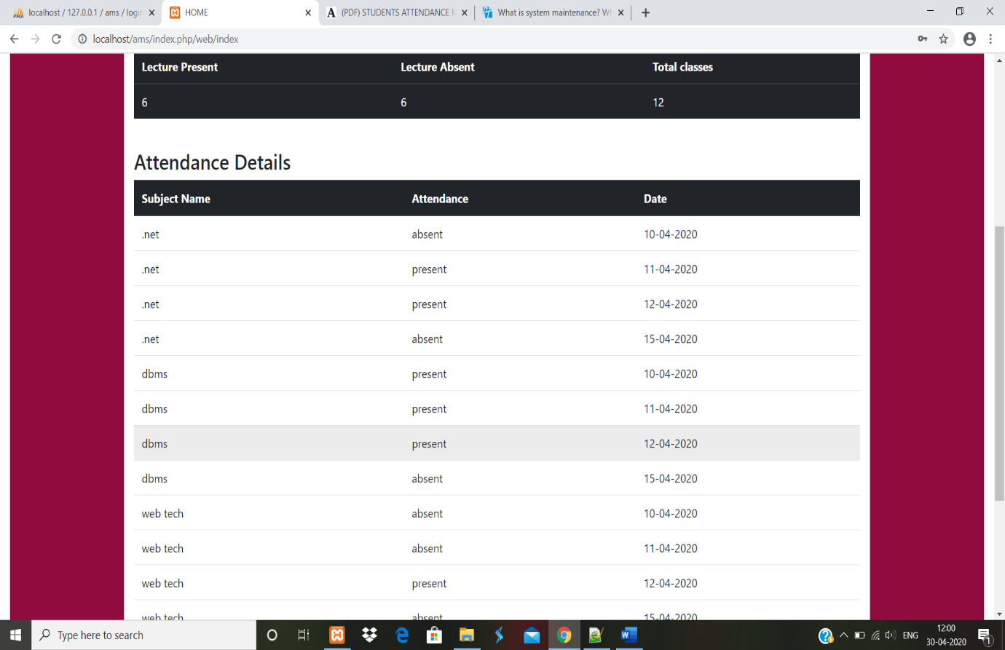

**GENERATE REPORT IN PDF FORMAT**

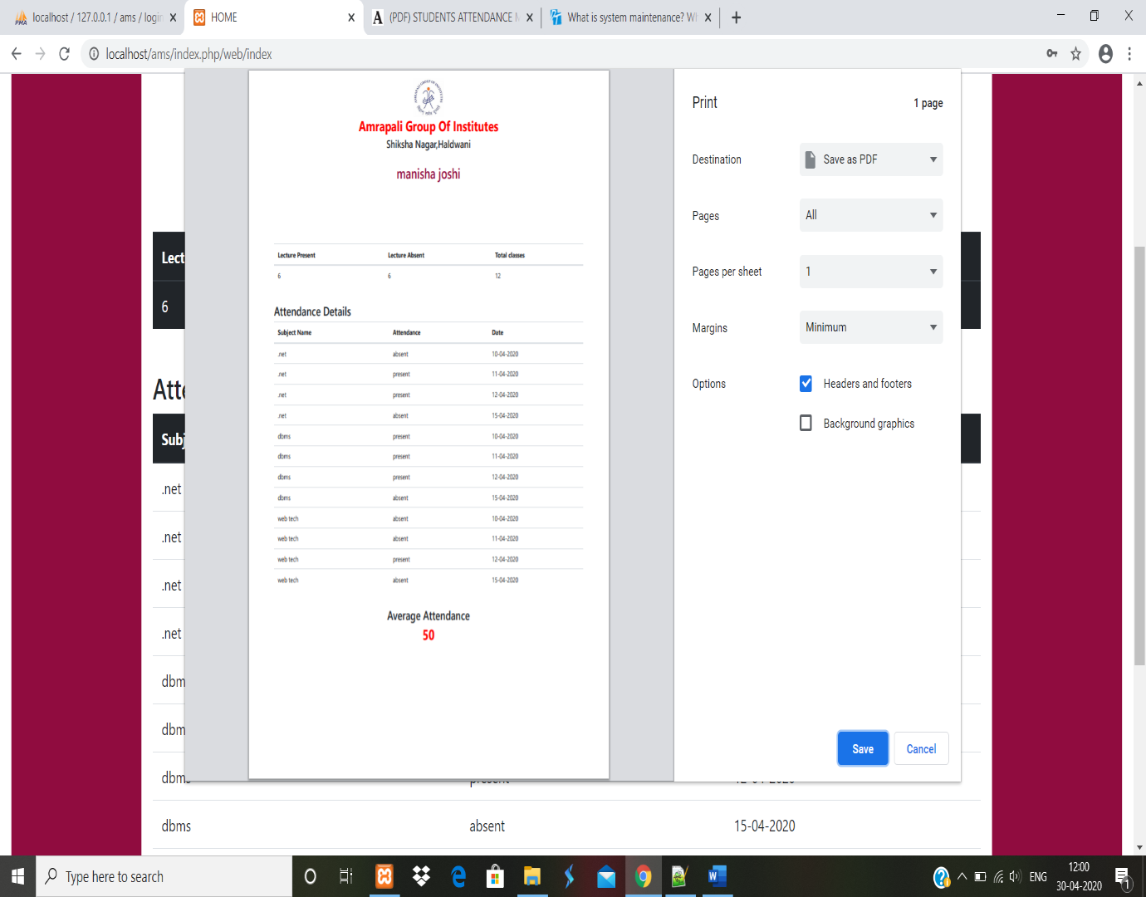

**VIEW PROFILE**

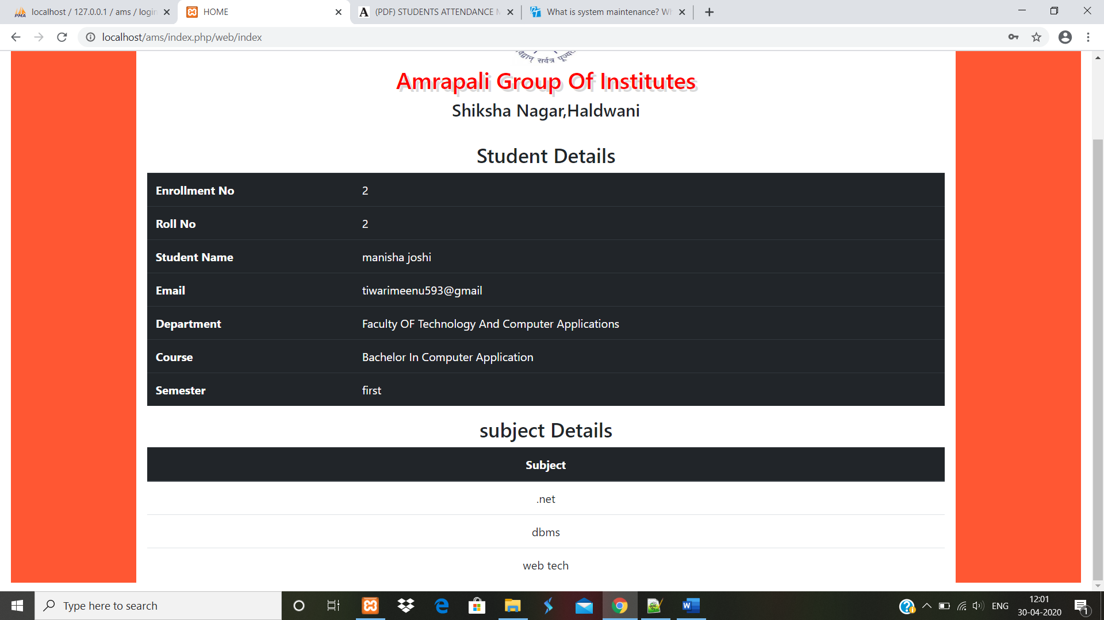

**GIVE FEEDBACK**

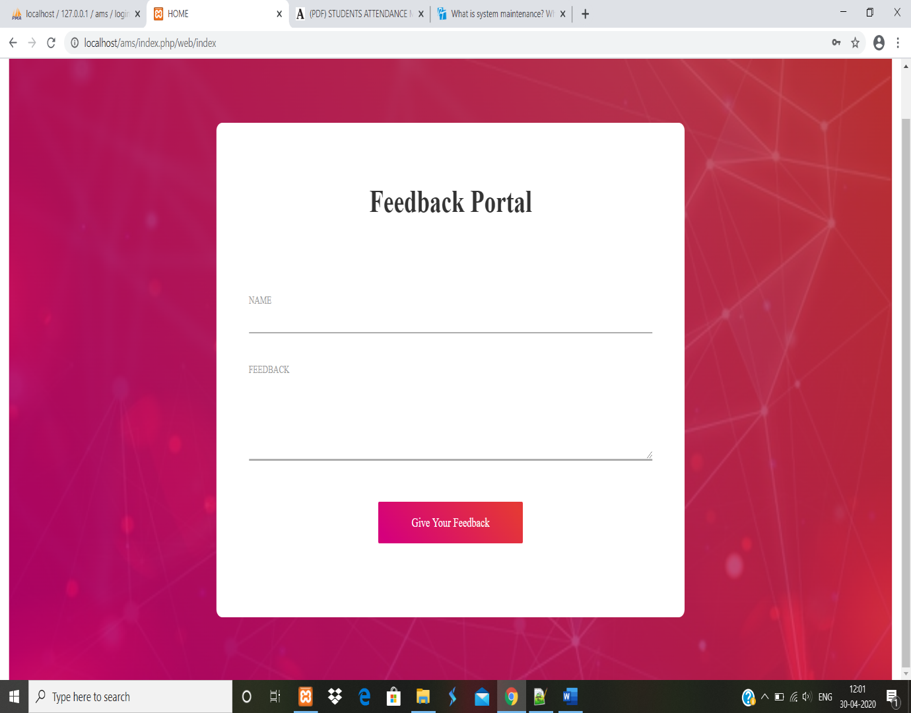

**PARENT PORTAL**

**PARENT HOMEPAGE**

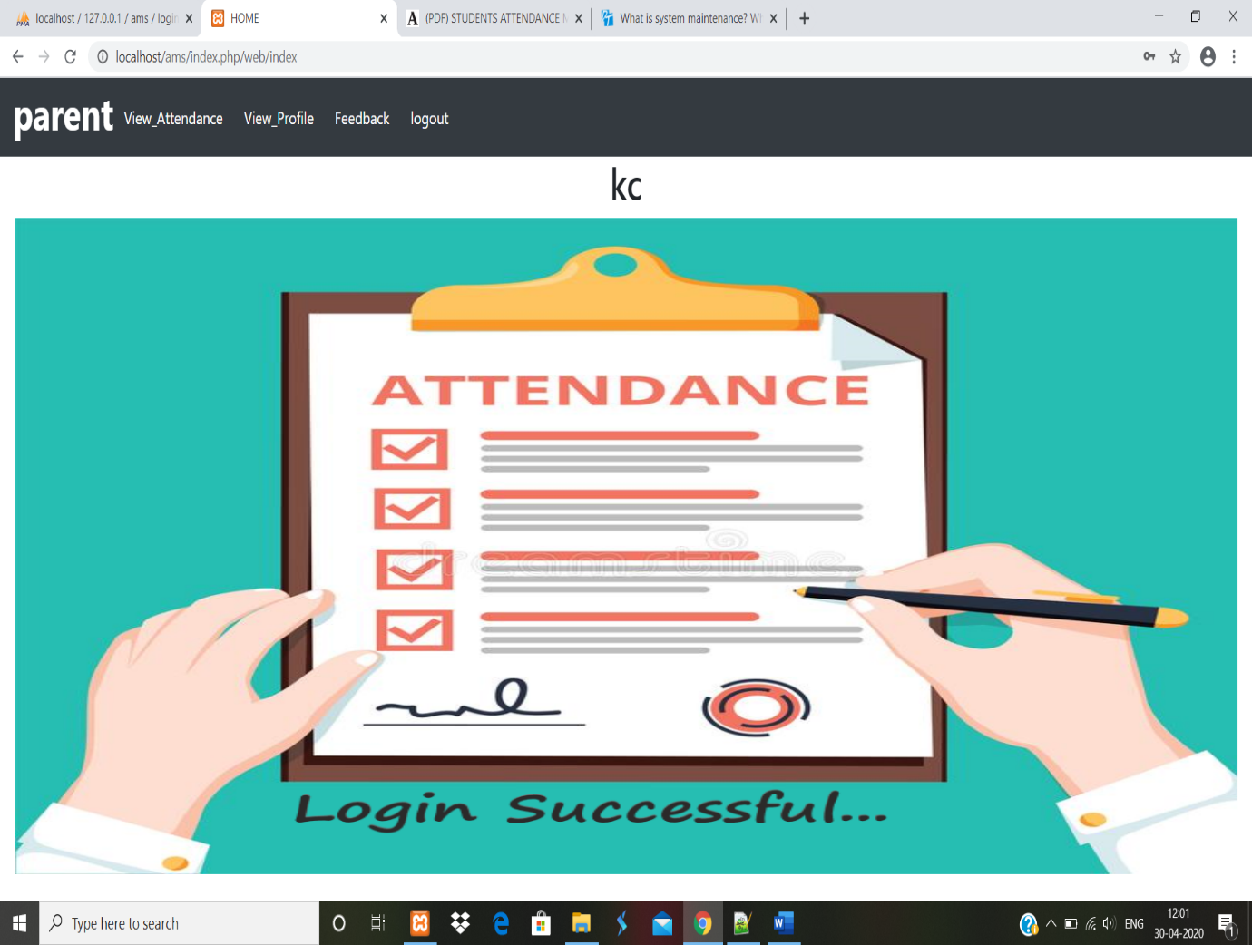

**VIEW ATTENDANCE**



**ATTENDANCE REPORT AFTER FILLING DETAILS**



**REPORT GENERATE AS PDF FORMAT**



**VIEW PROFILE**

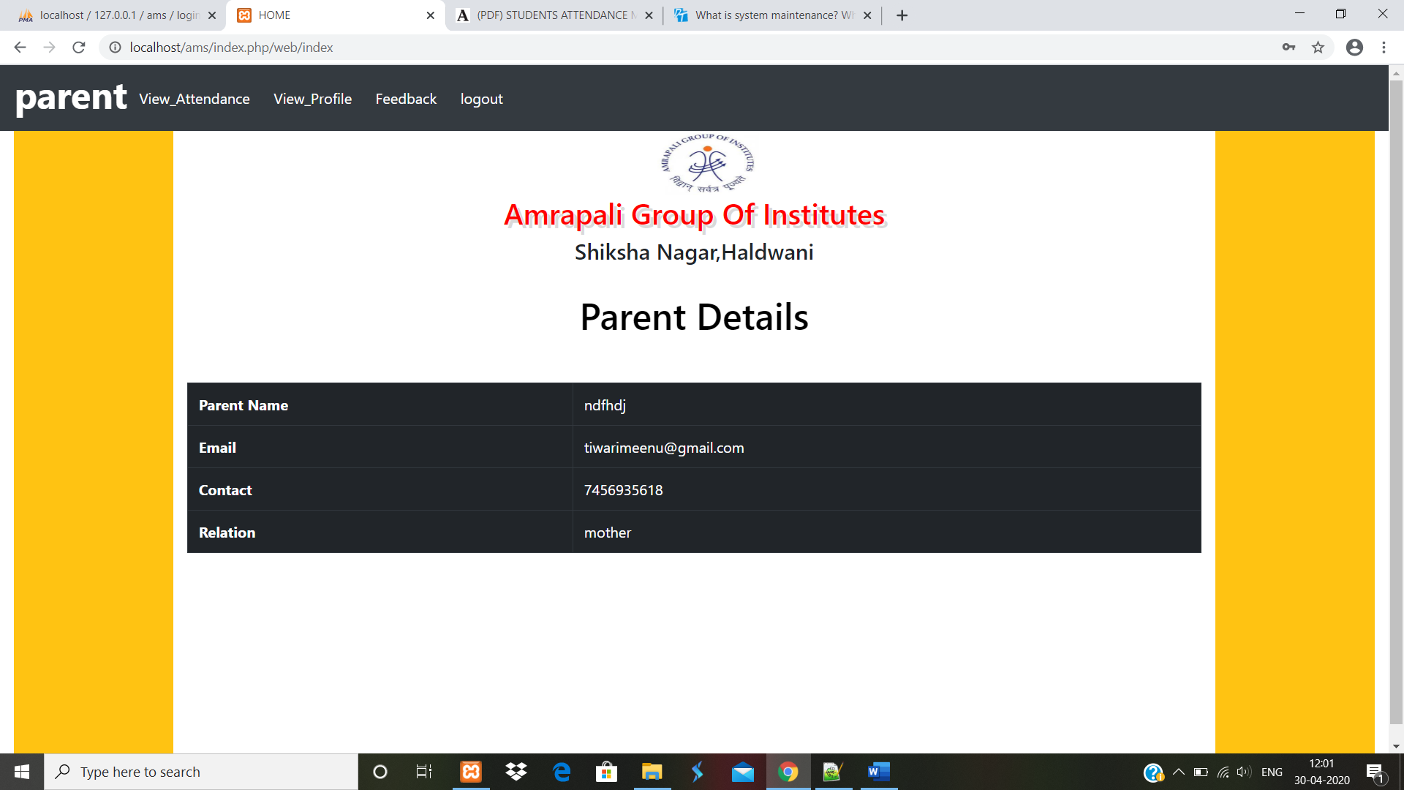

**GIVE FEEDBACK**



**Chapter 12 Coding**

**LOGIN PAGE**

<html>

<head>

<title> login </title>

<script src="http://ajax.googleapis.com/ajax/libs/jquery/1.11.1/jquery.min.js"></script>

<script src="https://ajax.googleapis.com/ajax/libs/jqueryui/1.8.11/jquery-ui.min.js"></script>

<link rel= “stylesheet” href = “http:// stackpath.bootstrapcdn.com/bootstrap/4.1.3/css/

Bootstrap.min.css”>

<link rel= “stylesheet” href = “https://use.fontawesome.com/releases/v5.3.1/css/all.css”>

<script src="https://maxcdn.bootstrapcdn.com/bootstrap/3.4.1/js/bootstrap.min.js"></script>

<link rel= “stylesheet” href = “https://maxcdn.bootstrapcdn.com/bootstrap/3.4.1/css/

Bootstrap.min.css”>

<link rel="stylesheet" href="<? php echo base_url ();?>ss/stylelogin.css">

</head>

<body>

<header><h1 id= “id1” style= “font-family: Segoe Script”><b> ATTENDANCE MANAGEMENT SYSTEM </b></h1></header>

<div class="container" >

<div class="d-flex justify-content-center h-100" >

<div class="card" >

<div class="card-header" id="dot">

<h3>LOGIN</h3>

<div class= “d-flex justify-content-end social_icon”>

<span><a href= “<?php echo site_url('authenticate/logout):?>”>

<i class="fas fa-home"></i></a></span>

<span><a href= “<?php echo site_url('web/contact);?>”>

<i class="fas fa-address-book"></i></a></span>

<span><a href="#"><i class="fas fa-info-circle"></i></a></span>

<span><a href="#"><i class="fab fa-facebook-square"></i></a></span>

<span><a href="#"><i class="fab fa-google-plus-square"></i></a></span>

<span><a href="#"><i class="fab fa-twitter-square"></i></a> </span>

</div>

</div>

<div class="card-body" >

<form method="post" id="form" action="<?php echo site_url (‘authenticate/checklogin’);? >">

<div class="input-group form-group">

<div class="input-group-prepend">

<span class="input-group-text"><i class="fas fa-user"></i></span>

<input type="text" class="form-control" placeholder="username" name="username">

</div>

</div>

<div class="input-group form-group">

<div class="input-group-prepend">

<span class="input-group-text"><i class="fas fa-key"></i></span>

<input type="password" class="form-control" placeholder="password" name="password">

</div>

</div>

<div class="form-group">

<button type="submit" class="btn float-center login_btn" id="btn"><i class="fas fa-lock-open"></i></button>

<button type="button" data-toggle="modal" data-target="#myModal" class="btn float-right login_btn" id="btn"><i class="fas fa-key"></i></button>

</div>

<div id="myModal" class="modal fade" role="dialog">

<div class="modal-dialog model-lg">

<div class="modal-content">

<div class="modal-header">

<h4 class="modal-title">Change Password</h4>

</div>

<div class="modal-body">

<div class="input-group form-group">

<div class="input-group-prepend">

<span class="input-group-text"><i class="fas fa-user"></i></span>

<input type="text" class="form-control" placeholder="username" id="user" name="user">

</div>

</div>

<div class="input-group form-group">

<div class="input-group-prepend">

<span class="input-group-text"><i class="fas fa-key"></i></span>

<input type="password" class="form-control" placeholder=" new password" id="pass" name="pass">

</div>

</div>

<button class="btn float-right login_btn" id="change">change</button>

<button type="reset" class="btn float-left login_btn">reset</button>

</div>

<div class="modal-footer">

<button type="button" id="but" class="btn btn-default" data-dismiss="modal">Close</button>

</div>

</div>

</div>

</div>

</form>

</div>

</div>

</div>

<header><h1 id="id2" style="font-family: Segoe Script"><b><center>ATTEND TODAY, ACHIEVE TOMORROW </center></b></h1></header>

<div class="text-center">

<h2 style="color: white"><b>Created By</b></h2>

<h1 id="meena" style="color: black; animation: slide-right; font-family: Comic Sans MS; font- weight: bold;">Meenakshi Tiwari</h1>

<h1 id="bhagu" style="color: black; font-family: Comic Sans MS; font-weight: bold;">Bhagwati Bora</h1>

</div>

</body>

</html>

<script>

$(document). ready (function () {

$("#btn"). click (function () {

$("#form"). submit ()

});

$("#dot"). hide ();

$("#dot"). slideDown('slow');

$('#change'). on ('click’, function () {

var user = $('#user'). val ();

var pass = $('#pass'). val ();

if (user! = '' && pass! = '')

{

$. ajax ({

url:"<?php echo site_url ('/web/change_password');?>",

method: " POST",

data: {user: user,

pass: pass},

success: function(res)

{

if (res == 1)

{

alert ('password changed successfully');

}

else {

alert ('username not exist');

}

}

});

}

else

{

alert ('fill out the fields');

}

return false; });

});

</script>

**Stylelogin.css**

@import url ('https://fonts.googleapis.com/css? family=Numans');

html, body {

background- image: url (http://localhost/ams/images/tech.jpg);

background-size: cover;

background-repeat: no-repeat;

background- attachment: fixed;

height: 85%;

font-family: ' Numans ', sans-serif;

}

.container-fluid {

height: 60%;

align-content: center;

position: fixed;

}

body header h1{

color: white;

font-family: verdana;

text-align: center;

padding-top:30px;

}

body header h2{

color: white;

font-family: verdana;

text-align: center;

}

. card {

height: 300px;

margin-top: 150px;

margin-bottom: auto;

width: 400px;

background-color: rgba (0,0,0,0.5);

}

. social_icon span {

font-size: 60px;

margin-left: 5px;

color: #FFC312;

}

. social_icon span a i{

color: #FFC312;

}

. social_icon span a i: hover {

color: white;

cursor: pointer;

}

. input-group-text i {

font-size:20px;

}

. card-header h3{

color: white;

}

. social_icon {

position: absolute;

right: 20px;

top: -45px;

}

. input-group-prepend span {

width: 50px;

background-color: #FFC312;

color: black;

border:0;

}

input: focus {

outline: 0 0 0 0;

box-shadow: 0 0 0 0;

}

. remember {

color: white;

}

. remember input

{

width: 40px;

height: 40px;

margin-left: 5px;

margin-right: 5px;

}

.login_btn {

color: black;

background-color: #FFC312;

width: 100px;

}

. login_btn: hover {

color: black;

background-color: white;

}

. links {

color: white;

}

. links a {

margin-left: 4px;

}

**CONTROLLER**

**Authenticate.php**

<?php

defined('BASEPATH') OR exit ('No direct script access allowed');

class Authenticate extends CI_Controller {

function __construct () {

parent: __construct ();

$this->load->model (‘my_model','mm’);

}

function login ()

{

$this->load->view('login');

}

function checklogin ()

{

$r = $this->mm->checklogin ();

if ($r == true)

{

echo "<script> window. location. href='http://localhost/ams/index.php/web/index';

alert ('login successful.’) ;</script>";

}

else

{

echo "<script> window. location. href='http://localhost/ams/index.php/authenticate/login';

alert('error’) ;</script>";

}

}

}

function change_password ()

{

$u = $this->input->post('user');

$p = $this->input->post('pass');

$r = $this->mm->ch_password ($u, $p);

if($r)

{

echo 1;

}

else

{

echo 0;

}

}?>

**MODEL**

**My_model.php**

<?php

defined('BASEPATH') OR exit ('No direct script access allowed');

class My_model extends CI_Model {

function checklogin ()

{

$this->db->where('sess_id',2020);

$this->db->where ('username', $this->input->post('username'));

$this->db->where ('password', $this->input->post('password'));

$this->db->select ('a. username, b. STATUS, b.pic');

$this->db->from ('login a');

$this->db->join ('user_status b', 'b. STID = a. STID');

$query = $this->db->get ();

if($query->num_rows ()! = 0) {

$r = $query->row ();

$this->session->set_userdata ('usr_', $r->username);

$this->session->set_userdata ('sts_', $r->STATUS);

$this->session->set_userdata ('pic_', $r->pic);

$bool_ = true;

}

else {

$bool_ = false;

}

return $bool_;

}

function ch_password ($u, $p)

{

$this->db->select ('a. username');

$this->db->from ('login a');

$query = $this->db->get ();

foreach ($query->result () as $x)

{

if ($u == $x->username)

{

$data= array (

'password' => $p

);

$this->db->where ('username’, $u);

$this->db->update ('login’, $data);

return 1;

}

}

}

?>

**CONTACT.PHP**

<link rel="stylesheet" href="https://use.fontawesome.com/releases/v5.3.1/css/all.css">

<link rel="stylesheet" type="text/css" href="<?php echo base_url ();?>css/util.css">

<link rel="stylesheet" type="text/css" href="<?php echo base_url ();?>css/main1.css">

<div class="container-contact100">

<div class="wrap-contact100">

<form class="contact100-form">

<span class="contact100-form-title">

CONTACT US

</span>

<div class="container-contact100-form-btn">

<span>

<button class="contact100-form-btn"><a style="color: white;" href="<?php echo site_url ('authenticate

/login');?>">

HOME

</a></button>

</span>

</div>

</form>

<div class="contact100-more flex-col-c-m" style="background-image: url('images/bg-01.jpg');">

<div class="flex-w size1 p-b-47">

<div class="txt1 p-r-25">

<span><i class="fas fa-map-marker-alt"></i></span>

</div>

<div class="flex-col size2">

<span class="txt1 p-b-20">

Address

</span>

<span class="txt2">

Amrapali Group of Institutes,

Shiksha Nagar, Lamachaur

Haldwani

</span>

</div>

</div>

<div class="dis-flex size1 p-b-47">

<div class="txt1 p-r-25">

<span><i class="fas fa-phone"></i></span>

</div>

<div class="flex-col size2">

<span class="txt1 p-b-20">

Let’s Talk

</span>

<span class="txt3">

7456935618

</span>

</div>

</div>

<div class="dis-flex size1 p-b-47">

<div class="txt1 p-r-25">

<span><i class="fas fa-envelope-square"></i></span>

</div>

<div class="flex-col size2">

<span class="txt1 p-b-20">

General Support

</span>

<span class="txt3">

tiwarimeenu593@gmail.com

</span>

</div>

</div>

</div>

</div>

</div>

**CONTROLLER**

function contact ()

{

$this->load->view('contact');

}

**HEADER (header.php)**

<html lang="en">

<head>

<title>HOME</title>

<meta charset="utf-8">

<meta name="viewport" content="width=device-width, initial-scale=1, shrink-to-fit=no">

<link rel="stylesheet" href="<?php echo base_url ();?>css/stylehome.css">

<link href='http://fonts.googleapis.com/css?family=Berkshire+Swash' rel='stylesheet' type='text/css'>

<script src="https://code.jquery.com/jquery-3.4.1.slim.min.js" integrity="sha384-J6qa4849blE2+poT4WnyKhv5vZF5SrPo0iEjwBvKU7imGFAV0wwj1yYfoRSJoZ+n" crossorigin="anonymous"></script>

<script src="https://cdn.jsdelivr.net/npm/popper.js@1.16.0/dist/umd/popper.min.js" integrity="sha384Q6E9RHvbIyZFJoft+2mJbHaEWldlvI9IOYy5n3zV9zzTtmI3UksdQRVvoxMfooAo" crossorigin="anonymous"></script>

<script src="https://stackpath.bootstrapcdn.com/bootstrap/4.4.1/js/bootstrap.min.js" integrity="sha384wfSDF2E50Y2D1uUdj0O3uMBJnjuUD4Ih7YwaYd1iqfktj0Uod8GCExl3Og8ifwB6" crossorigin="anonymous"></script>

<script src="https://kit.fontawesome.com/ada59038f7.js"></script>

<script src="http://ajax.googleapis.com/ajax/libs/jquery/1.11.1/jquery.min.js"></script>

<script type="text/javascript" src="https://ajax.googleapis.com/ajax/libs/jqueryui/1.8.11/jquery-ui.min.js"></script>

<link rel="stylesheet" href="https://stackpath.bootstrapcdn.com/bootstrap/4.1.3/css/bootstrap.min.css" >

<link rel="stylesheet" href="https://use.fontawesome.com/releases/v5.3.1/css/all.css">

</head>

**FOOTER (footer.php)**

</body>

</html>

**HOME PAGE (home.php)**

<style>

#img {

width:1500px;

height:600;

}

</style>

<nav class="navbar navbar-expand-lg navbar-dark bg-dark">

<button class="navbar-toggler" type="button" data-toggle="collapse" data-target="#navbarTogglerDemo03" aria-controls="navbarTogglerDemo03" aria-expanded="false" aria-label="Toggle navigation">

<span class="navbar-toggler-icon"></span>

</button>

<h1 style="color: white;"><b><?php echo $this->session->userdata('sts_');?></b></h1>

<div class="collapse navbar-collapse" id="navbarTogglerDemo03">

<ul class="navbar-nav mr-auto mt-2 mt-lg-0">

<?php foreach ($menu as $item) {?>

<li class="active">

<button style="color: white; text-decoration: none;" class="btn btn-link" id="<?php echo $item->item;?>"><?php echo $item->item;?></button>

</li>

<? php}?>

<a class="btn" style="color: white;" href="<?php echo site_url('authenticate/logout');?>" >logout</a>

</ul>

</div>

</nav>

<div id="pages" style="margin-top: auto "class="container-fluid">

<div class="text-center">

<h1><center><?php echo $this->session->userdata ('usr_');?></center></h1>

<img id="img" src="<?php echo base_url ();?>images/home.png" class="img-fluid" alt="Responsive image">

</div>

</div>

<script>

$(document). Ready (function () {

$('#img'). hide ();

$('#img'). slideToggle ('slow');

<?php foreach ($menu as $item) {?>

$("#<?php echo $item->item;?>"). Click (function () {

$("#pages"). load ('<?php echo site_url($item->path);?>');

});

<? Php}?>

});

</script>

**CONTROLLER (web.php)**

<?php

defined('BASEPATH') OR exit ('No direct script access allowed');

class Web extends CI_Controller {

function __construct () {

parent:: __construct ();

$this->load->model('my_model','mm');

}

function index ()

{

$this->load->view('header');

$id = $this->input->get('id');

$data['a'] = $this->mm->stdsubdata ($id);

$data['menu'] = $this->mm->get_menu ();

$this->load->view ('home', $data);

$this->load->view('footer');

}

}

?>

**MODEL (My_model.php)**

<?php

defined('BASEPATH') OR exit ('No direct script access allowed');

class My_model extends CI_Model {

function stdsubdata ()

{

$this->db->where ('semester_id', $this->session->userdata('sem_'));

$this->db->select ('a. subject_name');

$this->db->from ('subject a');

$query = $this->db->get ();

return $query->result ();

}

function get_menu ()

{

$this->db->where ('c. STATUS', $this->session->userdata('sts_'));

$this->db->select ('a. item, a. path');

$this->db->from ('menu a');

$this->db->join ('user_menu b', 'b. menu_id = a. menu_id', 'left');

$this->db->join ('user_status c', 'c. STID = b. STID', 'left');

$query=$this->db->get ();

return $query->result ();

}

}

?>

**MANAGE SESSION (manage_session.php)**

<style>

body

{

background- image: url (<?php echo base_url ('images/’ $this->session->userdata('pic_'));?>);

background-size: cover;

background-repeat: no-repeat;

}

.container

{

height: 450px;

margin-top: 150px;

margin-bottom: auto;

width: 500px;

background-color: rgba (0,0,0,0.5);

}

.c

{

color: white;

margin-top:10px;

font-size:20px;

}

. social_icon span

{

font-size: 70px;

}

. social_icon span a i

{

color: #FFC312;

}

. social_icon span a i:hover

{

color: blue;

cursor: pointer;

}

. btn

{

color: white;

}

</style>

<form id="myform" method="post" name="myform" role="form">

<div class="container" >

<div class="form-group">

<label for="session_id" class="c">Session Id:</label>

<input type="text" class="form-control" id="sess_id" name="id" >

</div>

<div class="form-group">

<label for="start" class="c">Start Date:</label>

<input type="date" class="form-control" id="start" name="start" >

</div>

<div class="form-group">

<label for="end" class="c"> End Date</label>

<input type="date" class="form-control" id="end" name="end">

</div>

<button id="btn" class="btn btn-primary float-right">submit</button>

<input id="rst" type="reset" class="btn btn-primary float-left">

</div>

</form>

<script>

$(document). ready (function () {

$("#myform"). hide ();

$("#myform"). slideDown ('slow');

$('#btn'). on ('click’, function () {

var sess_id = $('#sess_id'). val ();

var start = $('#start'). val ();

var end = $('#end'). val ();

if (sess_id! = '' && start! = '' && end != '')

{

jQuery. ajax ({

type: "POST",

url: "<?php echo site_url('/web/insert_session'); ?>",

dataType: 'html',

data: {sess_id: sess_id, start: start, end: end},

success: function(res)

{

if(res==1)

{

alert ('session created');

}

},

error: function ()

{

alert (' session exist');

}

});

}

else

{

alert ("pls fill all fields first");

}

return false;

});

});

</script>

**CONTROLLER (web.php)**

<?php

defined('BASEPATH') OR exit ('No direct script access allowed');

class Web extends CI_Controller {

function __construct () {

parent :: __construct ();

$this->load->model('my_model','mm');

}

function manage_session ()

{

$this->load->view('manage_session');

}

function insert_session ()

{

$data = array (

'sess_id' => $this->input->post('sess_id'),

'start_date'=>$this->input->post('start'),

'end_date'=>$this->input->post('end'),

'session_created'=>$this->input->post('start')

);

$result=$this->mm->insert_session($data);

if($result)

{

echo 1;

}

else

{

echo 0;

}

}

}

?>

**MODEL (My_model.php)**

<?php

defined('BASEPATH') OR exit ('No direct script access allowed');

class My_model extends CI_Model {

function insert_session($data)

{

if($this->db->insert ('session', $data))

{

return 1;

}

else

{

return 0;

}

}

}

?>

**ADD FACULTY (add_fac.php)**

<style>

body

{

background-image: url (<?php echo base_url ('images/’. $this->session->userdata('pic_’) );?>);

background-size: cover;

background-repeat: no-repeat;

}

h4{

color: white;

}

. card-header

{

color: white;

}

. input-group-prepend span

{

color: black;

font-weight: bold;

background-color: #FFC312;

}

.container

{

height: 70%;

margin-top: 100px;

margin-bottom: auto;

width: 500px;

background-color: rgba (0,0,0,0.5);

}

#btn

{

color: white;

width: 100px;

font-weight: bold;

}

#rst

{

color: white;

width: 100px;

font-weight: bold;

}

. btn

{

color: white;

margin-left:5px;

}

#btn: hover

{

color: black;

background-color: white;

}

#rst: hover

{

color: black;

background-color: white;

}

</style>

<div class="container">

<div class="card-header" id="dot">

<form id="form" method="post" role="form" name="form">

<h4>Login Details</h4>

<div class="md-form input-group input-group-sm mb-3">

<div class="input-group-prepend">

<span class="input-group-text " ><i class="fas fa-user"></i></span>

</div>

<input type="text" name="uername" class="form-control" placeholder="username" id="uername">

</div>

<div class="md-form input-group input-group-sm mb-3">

<div class="input-group-prepend">

<span class="input-group-text"><i class="fas fa-key"></i></span>

</div>

<input type="password" name="password" class="form-control" placeholder="password" id="password">

</div>

<h4>Personal Details</h4>

<div class="md-form input-group input-group-sm mb-3">

<div class="input-group-prepend">

<span class="input-group-text md-addon" ><i class="far fa-id-badge"></i></span>

</div>

<input type="number" name="fac_id" class="form-control" placeholder="Id" id="fac_id">

</div>

<div class="md-form input-group input-group-sm mb-3">

<div class="input-group-prepend">

<span class="input-group-text md-addon" ><i class="fas fa-at"></i></i></span>

</div>

<input type="email" name="email" class="form-control" placeholder="Email" id="email">

</div>

<div class="md-form input-group input-group-sm mb-3">

<div class="input-group-prepend">

<span class="input-group-text md-addon" ><i class="fas fa-chalkboard-teacher"></i></span>

</div>

<input type="text" name="name" class="form-control" placeholder="Faculty Name" id="name">

</div>

<div class="md-form input-group input-group-sm mb-3">

<div class="input-group-prepend">

<span class="input-group-text md-addon" ><i class="fas fa-address-book"></i></span>

</div>

<input type="number" name="contact" class="form-control" placeholder="contact" id="contact">

</div>

<div class="md-form input-group input-group-sm mb-3">

<div class="input-group-prepend">

<span class="input-group-text md-addon" ><i class="fas fa-university"></i></span>

</div>

<select class="form-control" name="dept" id="dept">

<?php foreach ($a as $item) {?>

<option><?php echo $item->dept_id;?></option>

<?php}?>

</select>

</div>

<div class="form-group">

<input id="rst" type="reset" class="btn btn-primary float-left">

<button id="btn" class="btn btn-primary float-left">submit</button>

</div>

<button id="delfac" class="btn btn-danger float-right">Delete Account</button>

</div>

</form><br>

<form id="form3" method="post" name="form3" role="form">

<h4>Delete Account</h4>

<div class="md-form input-group input-group-sm mb-3">

<div class="input-group-prepend">

<span class="input-group-text " ><i class="fas fa-user"></i></span>

</div>

<input type="text" name="usernamefac" class="form-control" placeholder="username" id="usernamefac">

</div>

<div class="md-form input-group input-group-sm mb-3">

<div class="input-group-prepend">

<span class="input-group-text " id="inputGroupMaterial-sizing-sm"><i class="far fa-id-badge"></i></span>

</div>

<input type="number" name="facid" class="form-control" placeholder="Id" id="facid">

</div>

<button id="deletefac" class="btn btn-danger float-right">Delete</button>

</form>

<div class="card-header" id="dot">

<button id="id2" class="btn btn-primary float-center">Add teaching details </button>

<form id="form2" method="post" name="form2" role="form">

<h4>teaching details</h4>

<div class="md-form input-group input-group-sm mb-3">

<div class="input-group-prepend">

<span class="input-group-text " id="inputGroupMaterial-sizing-sm"><i class="far fa-id-badge"></i></span>

</div>

<input type="number" name="id" class="form-control" placeholder="Id" id="id">

</div>

<div class="md-form input-group input-group-sm mb-3">

<div class="input-group-prepend">

<span class="input-group-text md-addon" ><i class="fas fa-book-reader"></i></span>

</div>

<select class="form-control" id="course" name="course">

<?php foreach ($d as $item) {?>

<option><?php echo $item->course_id;?></option>

<?php}?>

</select>

</div>

<div class="md-form input-group input-group-sm mb-3">

<div class="input-group-prepend">

<span class="input-group-text md-addon" ><i class="fas fa-book"></i></span>

</div>

<select class="form-control" name="subjectfac" id="subjectfac">

</select>

</div>

<div class="md-form input-group input-group-sm mb-3">

<div class="input-group-prepend">

<span class="input-group-text md-addon" ><i class="fas fa-building"></i></span>

</div>

<input type="text" name="cls" class="form-control" placeholder="class" id="cls">

</div>

<div class="form-group">

<button id="btn2" class="btn btn-primary float-right">submit</button>

<input id="rst" type="reset" class="btn btn-primary float-left">

</div>

</form>

</div>

</div>

<script>

$(document). ready (function () {

$("#form2"). hide ();

$('#form3'). hide ();

$('#id2'). on ('click', function () {

$("#form2"). slideDown ('slow');

$("#form"). hide ();

$("#id2"). hide ();

});

$('#course'). change (function () {

var course = $(this). val ();

$. ajax ({

url:"<?php echo site_url('/web/subjectadd');?>",

method: "POST",

data: {course: course},

dataType: "json",

success: function(res)

{

var sub = '';

var i;

for (i=0; i<res. length; i++)

{

sub+='<option value="'+res[i]. subject_code+'">'+res[i]. subject_code+

'</option>';

}

$('#subjectfac').html(sub);

}

});

});

$('#btn'). on ('click', function () {

var uername = $('#uername'). val ();

var password = $('#password'). val ();

var fac_id = $('#fac_id'). val ();

var email = $('#email'). val ();

var name = $('#name'). val ();

var contact = $('#contact'). val ();

var dept = $('#dept'). val ();

if (uername! = '' && password! = '' && fac_id! ='' && email! = '' && name! = '' && contact! = '' && dept! ='')

{

$. ajax ({

type: "POST",

url: "<?php echo site_url('/web/add_faculty'); ?>",

data: {

uername: uername,

password: password,

fac_id: fac_id,

email: email,

name: name,

contact: contact,

dept: dept

},

success: function(res)

{

if(res==1)

{

alert ('faculty added successfully');

}

else

{

alert('error');

}

},

error: function (xhr, status, error)

{

alert ('already exist');

}

});

}

else

{

alert ("pls fill all fields first");

}

return false;

});

$('#btn2'). On ('click', function () {

var id = $('#id'). val ();

var course = $('#course'). val ();

var subjectfac = $('#subjectfac'). val ();

var cls = $('#cls'). val ();

if (id! ='' && course! = '' && subjectfac! = '' && cls! = '')

{

$. ajax ({

type: "POST",

url: "<?php echo site_url('/web/add_subfaculty'); ?>",

data: {

id: id,

course: course,

subjectfac: subjectfac,

cls: cls,

},

success: function(res)

{

if(res==1)

{

alert ('acedamic details added');

}

else

{

alert('error');

}

},

error: function (xhr, status, error)

{

console.log (xhr. responseText);

}

});

}

else

{

alert ("pls fill all fields first");

}

return false;

});

$('#delfac'). On ('click', function () {

$('#form, #id2'). hide ();

$('#form2'). hide ();

$('#form3'). slideDown ('slow');

return false;

});

$('#deletefac'). On ('click', function () {

var usernamefac = $('#usernamefac'). val ();

var facid = $('#facid'). val ();

if (usernamefac! = '' && facid! = '')

{

$. ajax ({

type: "POST",

url: "<?php echo site_url('/web/delete_faculty'); ?>",

data: {

usernamefac: usernamefac,

facid: facid

},

success: function(res)

{

if (res == 1)

{

alert ('user deleted successfully...');

$("#pages"). load ('http://localhost/ams/index.php/web/add_fac');

}

else

{

alert ('user not exist');

}

}

});

}

else

{

alert('fill');

}

return false;

});

});

</script>

**CONTROLLER (web.php)**

<?php

defined('BASEPATH') OR exit ('No direct script access allowed');

class Web extends CI_Controller {

function __construct () {

parent::__construct ();

$this->load->model('my_model','mm');

}

function add_fac ()

{

$r['d’] = $this->mm->coursefac ();

$r['a'] = $this->mm->department ();

$this->load->view ('add_fac', $r);

}

function add_faculty ()

{

$u = $this->input->post('uername');

$p = $this->input->post('password');

$id = $this->input->post('fac_id');

$e = $this->input->post('email');

$n = $this->input->post('name');

$co = $this->input->post('contact');

$de = $this->input->post('dept');

$result=$this->mm->add_faculty ($u, $p, $id, $e, $n, $co, $de);

if($result)

{

echo 1;

}

else

{

echo 0;

}

}

function subjectadd ()

{

$id = $this->input->post('course');

$res = $this->mm->subjectadd($id);

echo json_encode($res);

}

function add_subfaculty ()

{

$i = $this->input->post('id');

$co = $this->input->post('course');

$s = $this->input->post('subjectfac');

$c = $this->input->post('cls');

$result=$this->mm->add_sufaculty ($i, $co, $s, $c);

if($result)

{

echo 1;

}

else

{

echo 0;

}

}

function delete_faculty ()

{

$id = $this->input->post('facid');

$name = $this->input->post('usernamefac');

$res = $this->mm->delete_fac ($id, $name);

if($res)

{

echo 1;

}

else

{

echo 0;

}

}

}

?>

**MODEL (My_model.php)**

<?php

defined('BASEPATH') OR exit ('No direct script access allowed');

class My_model extends CI_Model {

function department ()

{

$this->db->select ('a. dept_id, a. dept_name');

$this->db->from ('department a');

$query = $this->db->get ();

return $query->result ();

}

function coursefac ()

{

$this->db->select ('a. course_id');

$this->db->from ('course a');

$query = $this->db->get ();

return $query->result ();

}

function add_faculty ($u, $p, $id, $e, $n, $co, $de)

{

$this->db->select ('a. username');

$this->db->from ('login a');

$query = $this->db->get ();

$r = $query->row ();

if ($u! = $r->username)

{

$data1 = array (

'username'=> $u,

'password' => $p,

'STID' => 3,

'sess_id' => 2020

);

$data2 = array (

'faculty_id' => $id,

'faculty_name'=> $n,

'contact' => $co,

'email'=> $e,

'dept_id' => $de,

'sess_id' => 2020,

'username'=> $u

);

$this->db->insert ('login', $data1);

$this->db->insert ('faculty', $data2);

return 1;

}

else {

return 0;

}

}

function add_sufaculty ($i, $co, $s, $c)

{

$data3 = array (

'faculty_id'=> $i,

'subject_code' => $s,

'course_id'=> $co,

'class' => $c

);

$this->db->insert ('subfaculty', $data3);

return true;

}

function delete_fac ($id, $name)

{

$this->db->where('STID',3);

$this->db->select ('a. username');

$this->db->from ('login a');

$query = $this->db->get ();

foreach($query->result () as $i)

{

if ($name == $i->username)

{

$this->db->where ('faculty_id', $id);

$this->db->delete('subfaculty');

$this->db->where ('username', $name);

$this->db->delete('faculty');

$this->db->where ('username', $name);

$this->db->delete('login');

return 1;

}

}

}

}

?>

**ADD PARENT (add_par.php)**

<style>

body

{

background-image: url (<?php echo base_url ('images/’. $this->session->userdata('pic_’) );?>);

background-size: cover;

background-repeat: no-repeat;

}

. card-header {

color: white;

}

. input-group-prepend span

{

color: black;

font-weight: bold;

background-color: #FFC312;

}

.container

{

height: 65%;

margin-top: 100px;

margin-bottom: auto;

width: 500px;

background-color: rgba (0,0,0,0.5);

}

. btn

{

color: white;

}

#btn

{

margin-left:5px;

}

</style>

<div class="container">

<div class="card-header" id="dot">

<form id="form" method="post" name="form" role="form">

<h4 id="l">Login Details</h4>

<div id="d1" class="md-form input-group input-group-sm mb-3">

<div class="input-group-prepend">

<span class="input-group-text " ><i class="fas fa-user"></i></span>

</div>

<input id="username" type="text" name="username" class="form-control" placeholder="username" >

</div>

<div id="d2" class="md-form input-group input-group-sm mb-3">

<div class="input-group-prepend">

<span class="input-group-text " ><i class="fas fa-key"></i></span>

</div>

<input id="password" type="text" name="password" class="form-control" placeholder="password" >

</div>

<h4 id="p">Parent Details</h4>

<div class="md-form input-group input-group-sm mb-3">

<div class="input-group-prepend">

<span class="input-group-text " ><i class="fas fa-user"></i></span>

</div>

<input id="parent" type="text" name="parent" class="form-control" placeholder="Father/Mother Name" >

</div>

<div class="md-form input-group input-group-sm mb-3">

<div class="input-group-prepend">

<span class="input-group-text md-addon" ><i class="fas fa-at"></i></i></span>

</div>

<input id="fac_email" type="email" name="fac_email" class="form-control" placeholder="Email" >

</div>

<div class="md-form input-group input-group-sm mb-3">

<div class="input-group-prepend">

<span class="input-group-text md-addon" ><i class="fas fa-address-book"></i></span>

</div>

<input id="contact" type="number" name="contact" class="form-control" placeholder="contact" >

</div>

<div class="md-form input-group input-group-sm mb-3">

<div class="input-group-prepend">

<span class="input-group-text md-addon" >relation</span>

</div>

<select class="form-control" id="relation" name="relation">

<option>Other</option>

<option>Mother</option>

<option>Father</option>

</select>

</div>

<div class="md-form input-group input-group-sm mb-3">

<div class="input-group-prepend">

<span class="input-group-text " ><i class="fas fa-user"></i></span>

</div>

<input id="par" type="number" name="par" class="form-control" placeholder=" children enrollment" >

</div>

<div class="form-group">

<input id="rst" type="reset" class="btn btn-success float-left">

<button id="btn" class="btn btn-success float-left">submit</button>

<button id="deletepar" class="btn btn-danger float-right">Delete Account</button><br><br>

</div>

</form>

<form id="form1" method="post" name="form1" role="form">

<h4>Delete Account</h4>

<div class="md-form input-group input-group-sm mb-3">

<div class="input-group-prepend">

<span class="input-group-text " ><i class="fas fa-user"></i></span>

</div>

<input id="usernamepar" type="text" name="usernamepar" class="form-control" placeholder="username" >

</div>

<button id="delpar" class="btn btn-danger float-right">Delete</button>

</form>

</div>

</div>

<script>

$(document). ready (function () {

$("#form"). hide ();

$('#form1'). hide ();

$("#form"). slideDown ('slow');

$('#btn'). On ('click', function () {

var username = $('#username'). val ();

var password = $('#password'). val ();

var parent = $('#parent'). val ();

var fac_email = $('#fac_email'). val ();

var contact = $('#contact'). val ();

var relation = $('#relation'). val ();

var par = $(`#par`). val ();

if (username! = '' && password! = '' && parent! = '' && fac_email! = '' && contact! = '' && relation! = '')

{

$. ajax ({

type: "POST",

url: "<?php echo site_url('/web/add_parent'); ?>",

data: {

username: username,

password: password,

parent: parent,

fac_email: fac_email,

contact: contact,

par: par,

relation: relation

},

success: function(res)

{

if(res==1)

{

alert ('parent added successfully');

}

else

{

alert('error');

}

},

error: function (xhr, status, error)

{

alert ('already exist');

}

});

}

else

{

alert ("pls fill all fields first");

}

return false;

});

$('#deletepar'). On ('click', function () {

$("#form"). hide ();

$("#form1"). slideDown ('slow');

return false;

});

$('#delpar'). On ('click', function () {

var usernamepar = $('#usernamepar'). val ();

if (usernamepar! = '')

{

$. ajax ({

type: "POST",

url: "<?php echo site_url('/web/delete_parent'); ?>",

data: {

usernamepar: usernamepar },

success: function(res)

{

if (res == 1)

{

alert ('user deleted successfully...');

$("#pages"). load ('http://localhost/ams/index.php/web/add_par');

}

else

{

alert ('user not exist');

}

}

});

}

return false;

});

});

</script>

**CONTROLLER (web.php)**

<?php

defined('BASEPATH') OR exit ('No direct script access allowed');

class Web extends CI_Controller

{

function __construct ()

{

parent::__construct ()

$this->load->model('my_model','mm');

}

function add_par ()

{

$r['a'] = $this->mm->checkusr ();

$this->load->view ('add_par', $r);

}

function add_parent ()

{

$up = $this->input->post('username');

$p = $this->input->post('password');

$par = $this->input->post('parent');

$e = $this->input->post('fac_email');

$c = $this->input->post('contact');

$r = $this->input->post('relation');

$en = $this->input->post('par');

$result=$this->mm->add_parent ($up, $p, $par, $e, $c, $r, $en);

if($result)

{

echo 1;

}

else

{

echo 0;

}

}

function delete_parent ()

{

$upar = $this->input->post('usernamepar');

$res = $this->mm->delete_par($upar);

if($res)

{

echo 1;

}

else

{

echo 0;

}

}

**}**

**?>**

**MODEL (My_model.php)**

<?php

defined('BASEPATH') OR exit ('No direct script access allowed');

class My_model extends CI_Model {

function checkusr ()

{

$this->db->select ('a. username');

$this->db->from ('login a');

$query = $this->db->get ();

return $query->result ();

}

function add_parent ($up, $p, $par, $e, $c, $r, $en)

{

$this->db->select ('a. username');

$this->db->from ('login a');

$query = $this->db->get ();

$n = $query->row ();

if ($up! = $n->username)

{

$data3 = array (

'username' => $up,

'password' => $p,

'STID' => 2,

'sess_id' => 2020

);

$this->db->insert ('login', $data3);

$data4 = array (

'username' => $up,

'parent_name' => $par,

'email' => $e,

'contact' => $c,

'relation' => $r,

`enrollment_no`=> $en

'sess_id' => 2020

);

$this->db->insert('parent',$data4);

return 1;

}

else

{

return 0;

}

}

function delete_par($upar)

{

$this->db->where('sess_id',2020);

$this->db->where('STID',2);

$this->db->select ('a. username');

$this->db->from ('login a');

$query = $this->db->get ();

foreach($query->result () as $i)

{

if ($upar == $i->username)

{

$this->db->where ('username', $upar);

$this->db->delete('parent');

$this->db->where ('username', $upar);

$this->db->delete('login');

return 1;

}

}

}

}?>

**ADD STUDENT (student.php)**

<style>

body

{

background-image: url (<?php echo base_url ('images/'. $this->session->userdata('pic_’) );?>);

background-size: cover;

background-repeat: no-repeat;

}

.container

{

height: 85%;

margin-top: 100px;

margin-bottom: auto;

width: 500px;

background-color: rgba (0,0,0,0.5);

}

. card-header

{

color: white;

}

. input-group-prepend span

{

color: black;

font-weight: bold;

background-color: #FFC312;

}

#btn

{

margin-left:5px;

}

</style>

<div class="container">

<div class="card-header" id="dot">

<form id="form" method="post" name="form" role="form">

<h4>Login Details</h4>

<div class="md-form input-group input-group-sm mb-3">

<div class="input-group-prepend">

<span class="input-group-text " ><i class="fas fa-user"></i></span>

</div>

<input type="text" name="usrname" class="form-control" placeholder="username" id="usrname">

</div>

<div class="md-form input-group input-group-sm mb-3">

<div class="input-group-prepend">

<span class="input-group-text"><i class="fas fa-key"></i></span>

</div>

<input type="password" name="password" class="form-control" id="password" placeholder="password">

</div>

<h4>Academic Details</h4>

<div class="md-form input-group input-group-sm mb-3">

<div class="input-group-prepend">

<span class="input-group-text " >Enrollment No</span>

</div>

<input type="text" name="enroll" class="form-control" id="enroll">

</div>

<div class="md-form input-group input-group-sm mb-3">

<div class="input-group-prepend">

<span class="input-group-text " >Student Name</span>

</div>

<input type="text" name="name" class="form-control" id="name">

</div>

<div class="md-form input-group input-group-sm mb-3">

<div class="input-group-prepend">

<span class="input-group-text " >Roll No</span>

</div>

<input type="number" name="rollno" class="form-control" id="rollno">

</div>

<div class="md-form input-group input-group-sm mb-3">

<div class="input-group-prepend">

<span class="input-group-text " >contact</span>

</div>

<input type="number" name="contact" class="form-control" id="contact">

</div>

<div class="md-form input-group input-group-sm mb-3">

<div class="input-group-prepend">

<span class="input-group-text md-addon" >Email</span>

</div>

<input type="email" name="email" class="form-control" id="email">

</div>

<div class="md-form input-group input-group-sm mb-3">

<div class="input-group-prepend">

<span class="input-group-text md-addon" >Department</i></span>

</div>

<select class="form-control" name="department" id="department">

<?php foreach ($a as $item) {?>

<option value="<?php echo $item->dept_id;?>"><?php echo $item->dept_id;?></option>

<?php}?>

</select>

</div>

<div class="md-form input-group input-group-sm mb-3">

<div class="input-group-prepend">

<span class="input-group-text md-addon" >Course</span>

</div>

<select class="form-control" name="course" id="course">

</select>

</div>

<div class="md-form input-group input-group-sm mb-3">

<div class="input-group-prepend">

<span class="input-group-text md-addon" >semester</span>

</div>

<select class="form-control" name="semester" id="semester">

</select>

</div>

<input id="rst" type="reset" value="reset" class="btn btn-primary float-left">

<button id="btn" class="btn btn-primary float-right">submit</button>

</form>

</div>

</div>

<script>

$(document). ready (function () {

$("#form"). hide ();

$("#form"). slideDown ('slow');

$('#department'). change (function () {

var department = $(this). val ();

$. ajax ({

url:"<?php echo site_url('/web/course');?>",

method: "POST",

data: {department: department},

dataType: "json",

success: function(res)

{

var cor = '';

var i;

for (i=0; i<res. length; i++)

{

cor+='<option value="'+res[i]. course_id+'">'+res[i]. course_id+'</option>';

}

$('#course').html(cor);

}

});

});

$('#course'). change (function () {

var course = $("#course"). val ();

$. ajax ({

url:"<?php echo site_url('/web/semester');?>",

method: "POST",

data: {course: course},

dataType: "json",

success: function(res)

{

var sem = '';

var i;

for (i=0; i<res. length; i++)

{

sem+='<option value="'+res[i]. semester_id+'">'+res[i]. semester_id+'</option>';

}

$('#semester').html(sem);

}

});

});

$('#btn'). on ('click', function () {

var usrname = $('#usrname'). val ();

var password = $('#password'). val ();

var enroll = $('#enroll'). val ();

var name = $('#name'). val ();

var contact = $('#contact'). val ();

var rollno = $('#rollno'). val ();

var email = $('#email'). val ();

var department = $('#department'). val ();

var course = $('#course'). val ();

var semester = $('#semester'). val ();

if (usrname! = '' && password! = '' && enroll! = '' && name! = '' && contact! = '' && rollno! = '' && email! = '' && department! = '' && course! ='' && semester! = '')

{

$. ajax ({

type: "POST",

url: "<?php echo site_url('/web/add_student'); ?>",

data: {

usrname: usrname,

password: password,

enroll: enroll,

name: name,

contact: contact,

rollno: rollno,

email: email,

department: department,

course: course,

semester: semester

},

success: function(res)

{

if(res==1)

{

alert ('student added successfully');

}

else

{

alert('error');

}

},

error: function (xhr, status, error)

{

alert ('already exist');

}

});

}

else

{

alert ("pls fill all fields first");

}

return false;

});

});

</script>

**CONTROLLER (web.php)**

<?php

defined('BASEPATH') OR exit ('No direct script access allowed');

class Web extends CI_Controller {

function __construct () {

parent::__construct ();

$this->load->model('my_model','mm');

}

function addstudent ()

{

$r['a'] = $this->mm->department ();

$this->load->view ('student', $r);

}

function semester ()

{

$id = $this->input->post('course');

$res = $this->mm->semester($id);

echo json_encode($res);

}

function course ()

{

$id = $this->input->post('department');

$res = $this->mm->course($id);

echo json_encode($res);

}

function add_student ()

{

$us = $this->input->post('usrname');

$p = $this->input->post('password');

$std = $this->input->post('name');

$en = $this->input->post('enroll');

$r = $this->input->post('rollno');

$c = $this->input->post('contact');

$em = $this->input->post('email');

$de = $this->input->post('department');

$co = $this->input->post('course');

$sem = $this->input->post('semester');

$result = $this->mm->add_student ($us, $p, $std, $en, $r, $c, $em, $de, $co, $sem);

if($result)

{

echo 1;

}

else

{

echo 0;

}

}

}

?>

**MODEL (My_model.php)**

<?php

defined('BASEPATH') OR exit ('No direct script access allowed');

class My_model extends CI_Model

{

function department ()

{

$this->db->select ('a. dept_id, a. dept_name');

$this->db->from ('department a');

$query = $this->db->get ();

return $query->result ();

}

function course($id)

{

$this->db->where ('dept_id', $id);

$this->db->select ('a. course_id');

$this->db->from ('course a');

$query = $this->db->get ();

return $query->result ();

}

function semester($id)

{

$this->db->where ('course_id', $id);

$this->db->select ('a. semester_id');

$this->db->from ('semester a');

$query = $this->db->get ();

return $query->result ();

}

function add_student ($us, $p, $std, $en, $r, $c, $em, $de, $co, $sem)

{

$this->db->select ('a. username');

$this->db->from ('login a ');

$query = $this->db->get ();

$m = $query->row ();

if ($us! = $m->username)

{

$data1 = array (

'username' => $us,

'password' => $p,

'STID' => 4,

'sess_id' => 2020

);

$data2 = array (

'enrollment_no'=> $en,

'student_name' => $std,

'roll_no'=> $r,

'email' => $em,

'contact' => $c,

'username' => $us,

'dept_id' => $de,

'course_id' => $co,

'semester_id' => $sem,

'sess_id' => 2020

);

$this->db->insert ('login', $data1);

$this->db->insert ('student', $data2);

return 1;

}

else

{

return 0;

}

}

}

?>

**ADD SUBJECT (add_sub.php)**

<style>

body

{

background-image: url (<?php echo base_url ('images/'.$this->session->userdata('pic_'));?>);

background-size: cover;

background-repeat: no-repeat;

}

.container

{

height: 50%;

margin-top: 100px;

width: 500px;

background-color: rgba (0,0,0,0.5);

}

. btn

{

color: white;

}

. card-header

{

color: white;

}

.c

{

font-size:20px;

color: #FFC312;

}

</style>

<div class="container">

<div class="card-header">

<form id="form" method="post" name="form" role="form">

<h4>Add Subject</h4>

<div class="form-group">

<label class="c">Subject Name:</label>

<input type="text" class="form-control" id="subject" name="name" required>

</div>

<div class="form-group">

<label class="c">course:</label>

<select class="form-control" id="course" name="course">

<?php foreach ($b as $item) {?>

<option><?php echo $item->course_id;?></option>

<?php}?>

</select>

</div>

<div class="form-group">

<label class="c">Semester:</label>

<select class="form-control" id="semester" name="semester">

</select>

</div>

<button id="btn" type="submit" class="btn btn-primary float-right">submit</button>

<input id="rst" type="reset" class="btn btn-primary float-left">

</form>

</div>

</div>

<script>

$(document). ready (function () {

$('#course'). change (function () {

var course = $('#course'). val ();

jQuery. ajax ({

type: "POST",

url: "<?php echo site_url('/web/subjectsem'); ?>",

dataType: 'json',

data:

{course: course

},

success: function(res)

{

var sub = '';

var i;

for (i=0; i<res. length; i++)

{

sub+='<option value="'+res[i]. semester_id+'">'+res[i]. semester_id+'</option>';

}

$('#semester').html(sub);

},

error: function ()

{

alert ('oops something went wrong');

}

});

});

$("#form"). hide ();

$("#form"). slideDown ('slow');

$('#btn'). On ('click', function () {

var subject = $('#subject'). val ();

var course = $('#course'). val ();

var semester = $('#semester'). val ();

if (subject! = '' && semester! = '' && course! = '')

{

jQuery. ajax ({

type: "POST",

url: "<?php echo site_url('/web/add_subject'); ?>",

dataType: 'html',

data:

{

subject: subject,

semester: semester,

course: course

},

success: function(res)

{

if(res==1)

{

alert ('subject added successfully');

}

},

error: function ()

{

alert ('oops something went wrong');

}

});

}

else

{

alert ("pls fill all fields first");

}

return false;

});

});

</script>

**CONTROLLER (web.php)**

<?php

defined('BASEPATH') OR exit ('No direct script access allowed');

class Web extends CI_Controller {

function __construct () {

parent::__construct ();

$this->load->model('my_model','mm');

}

function add_sub ()

{

$r['b'] = $this->mm->coursefac ();

$this->load->view ('add_sub', $r);

}

function subjectsem ()

{

$a = $this->input->post('course');

$res=$this->mm->semestersub ($a);

echo json_encode($res);

}

function add_subject ()

{

$data = array (

'subject_code' => $this->input->post('subject'),

'subject_name' => $this->input->post('subject'),

'semester_id' => $this->input->post('semester'),

'course_id' => $this->input->post('course')

);

$result=$this->mm->add_subject($data);

if($result)

{

echo 1;

}

else

{

echo 0;

}

}

}

?>

**MODEL (My_model.php)**

<?php

defined('BASEPATH') OR exit ('No direct script access allowed');

class My_model extends CI_Model {

function coursefac ()

{

$this->db->select ('a. course_id');

$this->db->from ('course a');

$query = $this->db->get ();

return $query->result ();

}

function semestersub($a)

{

$this->db->where ('course_id', $a);

$this->db->select ('a. semester_id');

$this->db->from ('semester a');

$query = $this->db->get ();

return $query->result ();

}

function add_subject($data)

{

if($this->db->insert ('subject', $data))

{

return 1;

}

else

{

return 0;

}

}

**}**

**?>**

**VIEW ATTENDANCE (view_attend.php)**

<style>

. std1

{

height: auto;

background-color: white;

margin-top:0px;

}

. std

{

margin-top:0px;

height: auto;

background-color: #A98190;

}

h2

{

color: #A98190;

}

.img-fluid

{

width:10%;

height:10%;

margin-left:30px;

}

a

{

color: white;

}

a. hover

{

color: white;

}

#x {

font-size:20px;

}

#y {

font-size:20px;

}

#z {

font-size:20px;

}

. item {

width:400px;

height:100px;

}

</style>

<div class="container-fluid std">

<div class="container std1">

<div class="text-center">

<img src="<?php echo base_url ();?>images/amrapali1.png" class="img-fluid">

<div class="header">

<h2 id="top" style="color: red; text-shadow: 1px 1px 0px #ededed, 4px 4px 0px rgba (0,0,0,0.15);">Amrapali Group of Institutes</h2>

<h4>Shiksha Nagar, Haldwani</h4><br>

<h3><u><b>Attendance</b></u></h3>

</div>

</div>

<form id="viewall" name="viewall" method="post" type="form">

<div class="container item">

<div class="form-group">

<label id="x" for="enroll" class="col-2 col-form-label">Enrollment:</label>

<div class="col-10">

<input class="form-control" type="text" value="" id="enroll">

</div>

</div>

<div class="form-group">

<label id="y" for="start" class="col-2 col-form-label">Date From:</label>

<div class="col-10">

<input class="form-control" type="date" value="" id="start">

</div>

</div>

<div class="form-group">

<label for="end" id="z" class="col-2 col-form-label">Date to:</label>

<div class="col-10">

<input class="form-control" type="date" value="" id="end">

</div>

</div>

<div class="form-group">

<button value="submit" style="color: white;" id=" allattend" class="btn btn-success float-center">submit</button>

</div>

</div><br><br>

<div class="text-center">

<h1 id="matter" style="color: black; margin-top:250px; font-family: Segoe Script;"><p><b><i> "It Is So Important to Understand Your Good Attendance Ups Yours Chance of Graduating"</i></b></p><h1>

</div>

<div>

<b><h1 style="color: black;" id="name"></h1></b>

<h2 id="dept"></h2>

<h3 id="course"></h3>

<h4 id="semester"></h4>

</div>

<table id="tab" class="table table-dark" >

<thead>

<tr>

<th>Lecture Present</th>

<th>Lecture Absent</th>

<th> Total Class</th>

</tr>

</thead>

<tbody id="number">

</tbody>

</table><br>

<h3 id="a">Attendance Details</h3>

<table id="tab" class="table table-hover" >

<thead class="thead-dark">

<tr>

<th> Subject Name</th>

<th> Attendance</th>

<th> Date</th>

</tr>

</thead>

<tbody id="showstatus">

</tbody>

</table><br>

<div class="text-center">

<h3 id="avg"> Average Attendance</h3>

<h2 id="average"></h2>

</div>

<div class="p-3 mb-2 bg-success text-black answer" >

<div class="text-center">

<h1 id="answer"><h1>

</div>

</div>

</form>

<div class="text-center">

<button type="button" id="print" style="color: white;" class="btn btn-primary float-center" onclick=" $('#print').hide();window.print();$('#check,#print').slideDown('slow');">print</button>

<button value="submit" style="color: white;" id="check" class="btn btn-primary float-center"><a href="#top">check another</a></button>

</div>

</div>

</div>

<script>

$(document). ready (function () {

$('#tab, #avg, #a. answer'). hide ();

$('#check'). hide ();

$('#enroll'). change (function () {

var enroll = $('#enroll'). val ();

if (enroll! = '')

{

$. ajax ({

type: "POST",

url: "<?php echo site_url('/web/std_data');?>",

dataType: 'json',

data:

{

enroll: enroll

},

success: function(res)

{

var hey= '';

var i;

for (i=0; i< res. length; i++)

{

hey +='<tr>'+

'<td>'+res[i]. student_name+'</td>'+

'</tr>';

}

$('#name').html(hey);

var hey= '';

var i;

for (i=0; i< res. length; i++)

{

hey +='<tr>'+

'<td>'+res[i]. dept_name+'</td>'+

'</tr>';

}

$('#dept').html(hey);

var hey= '';

var i;

for (i=0; i< res. length; i++)

{

hey +='<tr>'+

'<td>'+res[i]. course_name+'</td>'+

'</tr>';

}

$('#course').html(hey);

var hey= '';

var i;

for (i=0; i< res. length; i++)

{

hey +='<tr>'+

'<td>'+res[i]. semester_name+'</td>'+

'</tr>';

}

$('#semester').html(hey);

$('#name, #dept, #course, #semester'). hide ();

}

});

}

return false;

});

$('#allattend'). on ('click', function () {

var enroll = $('#enroll'). val ();

var start = $('#start'). val ();

var end = $('#end'). val ();

if (enroll! = '' && start! ='' && end! ='')

{

$. ajax ({

type: "POST",

url: "<?php echo site_url('/web/all_attend');?>",

dataType: 'json',

data:

{

enroll: enroll,

start: start,

end: end

},

success: function(res)

{

if (res! = '')

{

var hey= '';

var i;

for (i=0; i< res. length; i++)

{

hey +='<tr>'+

'<td>'+res[i]. subject_name+'</td>'+

'<td>'+res[i]. status+'</td>'+

'<td>'+res[i]. date+'</td>'+

'</tr>';

}

$('#showstatus').html(hey);

var hey= '';

var i;

var x= '';

var l;

var a=0;

var p=0;

var t=0;

for (i=0; i< res. length; i++)

{

t++

if (res[i]. status == 'present')

{

p++

}

else

{

a++

}

}

l= p/t*100

x+='<tr>'+

'<td>'+(p)+'</td>'+

'<td>'+(a)+'</td>'+

'<td>'+(t)+'</td>'+

'</tr>';

$('#number').html(x);

$('#average').html(l);

$('#allattend, #enroll, #z'). hide ();

$('#start, #x'). hide ();

$('#end, #y'). hide ();

$('#matter'). hide ();

$('#tab, #avg, #a,. answer'). slideDown ('slow');

$('#name, #dept, #course, #semester'). slideDown ('slow');

var ans;

if (l >= 75)

{

ans = 'Excellent. <i class="fas fa-smile"></i>'

}

else {

ans = 'Improve your attendance. <i class="fas fa-frown"></i>'

}

$('#answer').html(ans);

$(‘. answer'). delay (5000). fadeOut ();

}

else

{

alert ('enrollment not exist');

}

}

});

}

else

{

alert ('fill all field first');

}

return false;

});

$('#check'). on ('click', function () {

$("#pages"). load ('http://localhost/ams/index.php/web/view_attend');

return false;

});

});

</script>

**CONTROLLER (web.php)**

<?php

defined('BASEPATH') OR exit ('No direct script access allowed');

class Web extends CI_Controller {

function __construct () {

parent::__construct ();

$this->load->model('my_model','mm');

}

function view_attend ()

{

$this->load->view('view_attend');

}

function std_data ()

{

$a = $this->input->post('enroll');

$res = $this->mm->get_data($a);

echo json_encode($res);

}

function all_attend ()

{

$a = $this->input->post('enroll');

$s = $this->input->post('start');

$e = $this->input->post('end');

$st = date ("d-m-Y", strtotime($s));

$en = date ("d-m-Y", strtotime($e));

$res = $this->mm->std_attend ($a, $st, $en);

if ($res! = '')

{

echo json_encode($res);

}

else

{

echo 0;

}

}

}

}

?>

**MODEL (My_model.php)**

<?php

defined('BASEPATH') OR exit ('No direct script access allowed');

class My_model extends CI_Model {

function std_attend ($a, $st, $en)

{

$this->db->select ('a. enrollment_no');

$this->db->from ('student a');

$query = $this->db->get ();

foreach($query->result () as $r)

{

if ($a == $r->enrollment_no)

{

$this->db->where('sess_id',2020);

$this->db->where ('enrollment_no', $a);

$this->db->where ('date >=', $st);

$this->db->where ('date <=', $en);

$this->db->select ('c. subject_name, a. status, a. date');

$this->db->from ('attendance a');

$this->db->join ('subject c', 'c. subject_code = a. subject_code');

$query1= $this->db->get ();

return $query1->result ();

}

}

}

function get_data($a)

{

$this->db->where('sess_id',2020);

$this->db->where ('enrollment_no', $a);

$this->db->select ('a. student_name, b. course_name, d. semester_name, c. dept_name');

$this->db->from ('student a');

$this->db->join ('course b', 'b. course_id = a. course_id');

$this->db->join ('department c', 'c. dept_id = a. dept_id');

$this->db->join ('semester d', 'd. semester_id = a. semester_id');

$query= $this->db->get ();

return $query->result ();

}

}

?>

**VIEW FEEDBACK (view_feedback.php)**

<style>

. table {

margin-top:50px;

}

.x {

font-size:20px;

}

</style>

<div class="container-fluid ">

<table class="table table-hover table-striped" >

<thead class="thead-dark">

<tr class="text-center" >

<th scope="col" class="x">Sr no</th>

<th scope="col" class="x">Name</th>

<th scope="col" class="x">Feedback</th>

<th scope="col" class="x">Delete feedback </th>

</tr>

</thead>

<tbody class="c" id="show_data">

</tbody >

</table>

<button value="submit" style="color: white;" id="check" class="btn btn-primary float-center">Refresh</button>

</div>

</body>

<script type="text/javascript">

$ (function () {

$('#check'). hide ();

$('#check'). on ('click', function () {

$("#pages"). load ('http://localhost/ams/index.php/web/index4');

});

view_feedback ();

function view_feedback () {

$. ajax ({

type: 'ajax',

url: "<?php echo site_url('web/view_feedback');?>",

async: false,

dataType: 'json',

success: function(data) {

var hey= '';

var i;

for (i=0; i< data. length; i++) {

hey += '<tr class="table-primary text-center">'+

'<td>'+(i+1) +'</td>'+

'<td>'+data[i].name+'</td>'+

'<td>'+data[i]. feedback +'</td>'+

'<td>'+'<button type="submit" class="btn btn-danger danger-item" id="'+data[i]. feedback_id +'" ><i class="fas fa-trash-alt" style="color: white;"></i></button>'+'</td>'+

'</tr>';

}

$('#show_data').html(hey);

},

error: function ()

{

alert('fail');

}

});

return false;

}

$(“. danger-item"). On ('click', function () {

var id = $(this). attr ('id');

if (confirm ('are you sure you want to delete?'))

{

$. ajax ({

url:"<?php echo site_url('/web/deletefeed');?>",

method: "POST",

data: {id: id},

success: function(res) {

if (res == 1)

{

alert ('deleted successfully...');

}

$('#check'). slideDown ('slow');

}

});

}

});

});

</script>

**CONTROLLER (web.php)**

<?php

defined('BASEPATH') OR exit ('No direct script access allowed');

class Web extends CI_Controller {

function __construct () {

parent::__construct ();

$this->load->model('my_model','mm');

}

function index4()

{

$this->load->view('view_feedback');

}

function view_feedback ()

{

$a = $this->mm->feedback ();

echo json_encode($a);

}

function deletefeed ()

{

$id = $this->input->post('id');

$res = $this->mm->deletefeed($id);

echo json_encode($res);

}

}

?>

**MODEL (My_model.php)**

<?php

defined('BASEPATH') OR exit ('No direct script access allowed');

class My_model extends CI_Model {

function feedback ()

{

$this->db->where('sess_id',2020);

$this->db->select ('a. feedback_id, a. name, a. feedback');

$this->db->from ('feedback a');

$query = $this->db->get ();

if($query->num_rows ()>0)

{

return $query->result ();

}

else

{

return false;

}

}

function deletefeed($id)

{

$this->db->where('sess_id',2020);

$this->db->where ('feedback_id', $id);

$this->db->delete('feedback');

return 1;

}

}

?>

**GIVE FEEDBACK (give_feedback.php)**

<link rel="stylesheet" type="text/css" href="<?php echo base_url ();?>css/main.css">

<div class="bg-contact2" style="background-image: url (<?php echo base_url('images/tech.jpg');?>);">

<div class="container-contact2">

<div class="wrap-contact2">

<form class="contact2-form validate-form">

<span class="contact2-form-title">

<b>Feedback Portal</b>

</span>

<div class="wrap-input2 validate-input" data-validate="Name is required">

<span class="focus-input2" data-placeholder="NAME"></span>

<input class="input2" type="text" name="name" id="name">

</div>

<div class="wrap-input2 validate-input" data-validate = "Message is required">

<span class="focus-input2" data-placeholder="FEEDBACK"></span>

< textarea class="input2" name="feed" id="feed" ></textarea>

</div>

<div class="container-contact2-form-btn">

<div class="wrap-contact2-form-btn">

<div class="contact2-form-bgbtn" ></div>

<button class="contact2-form-btn" id="btn">

Give Your Feedback

</button>

</div>

</div>

</form>

</div>

</div>

</div>

</body>

</html>

<script>

$(document). ready (function () {

$('#btn'). On ('click', function () {

var name = $('#name'). val ();

var feedback = $('#feed'). val ();

if (parent! = '' && feedback! ='')

{

jQuery. ajax ({

type: "POST",

url: "<?php echo site_url('/web/give_feedback');?>",

dataType: 'html',

data:

{name: name,

feedback: feedback

},

success: function(res)

{

if(res==1)

{

alert (' success');

$("#pages"). load ('http://localhost/ams/index.php/web/feedback');

}

},

error: function ()

{

alert('error');

}

});

}

else

{

alert ("pls fill all fields first");

}

return false;

});

});

</script>

**CONTROLLER (web.php)**

<?php

defined('BASEPATH') OR exit ('No direct script access allowed');

class Web extends CI_Controller {

function __construct () {

parent::__construct ();

$this->load->model('my_model','mm');

}

function feedback ()

{

$this->load->view('give_feedback');

}

function give_feedback ()

{

$data = array (

'name'=> $this->input->post('name'),

'feedback'=> $this->input->post('feedback'),

'sess_id'=> 2020

);

$result=$this->mm->give_feedback($data);

if($result)

{

echo 1;

}

else

{

echo 0;

}

}

}

?>

**MODEL (My_model.php)**

<?php

defined('BASEPATH') OR exit ('No direct script access allowed');

class My_model extends CI_Model {

function give_feedback($data)

{

if($this->db->insert ('feedback', $data))

{

return 1;

}

else

{

return 0;

}

}

}

?>

**MARK ATTENDANCE (mark_attendance.php)**

<style>

#tab {

margin-top:30px;

}

body

{

background-image: url (<?php echo base_url('images/tech.jpg');?>);

background-repeat: no-repeat;

background-size: cover;

}

label

{

color: white;

}

#attend

{

margin-left:5px;

}

.text-center {

margin-top:0px;

width:400px;

margin-left:350px;

}

#a {

font-size:20px;

}

#x {

font-size:20px;

}

#y {

font-size:20px;

}

#z {

font-size:20px;

}

#w {

font-size:20px;

}

. item {

width:400px;

height:100px;

}

</style>

<div class="container-fluid">

<div class="header">

<h1 style="color: white;"><center>Amrapali Attendance Portal</center></h1><br><br>

</div>

<form class="form-group" id="format" method="post" name="format" role="form" action="<?php echo site_url('web/insert_data');?>">

<div class="container">

<div class="container item">

<div class="form-group">

<label for="faculty_id" id="a">Faculty Id:</label>

<select class="form-control" name="faculty_id" id="faculty_id">

<?php foreach ($a as $item) {?>

<option value="<?php echo $item->faculty_id;?>"><?php echo $item->faculty_id;?></option>

<?php}?>

</select>

<button type="" style="margin-left:5px;" id="btn" class="btn btn-success float-right">submit</button><br>

</div>

<div class="form-group" >

<label for="course_id" id="x">Course:</label>

<select class="form-control" name="course" id="course">

</select>

</div>

<div class="form-group" >

<label for="subject" id="y">Subject:</label>

<select class="form-control" name="subject" id="subject">

</select>

<button type="" style="margin-left:5px;" id="btn1" class="btn btn-success float-right">submit</button><br>

<label for="subject" id="z">Semester:</label>

<select class="form-control" name="semester" id="semester">

</select>

<button type="" id="btn2" class="btn btn-success float-right">select student</button><br><br>

<label for="date" id="w">Date:</label>

<input type="text" class="form-control" name="date" id="date"><br><br>

</div>

</div>

</div></br>

<div class="table-responsive">

<table class="table table-hover" id="tab" >

<caption>List of student</caption>

<thead class="thead-dark">

<tr class="text-center">

<th scope="col">Roll No</th>

<th scope="col">Enrollment</th>

<th scope="col">Student Name</th>

<th scope="col">Status</th>

</tr>

</thead>

<tbody class="c" id="std_show">

</tbody>

</table>

<button type="button" style="color: white;" id="attend" class="btn btn-success float-right">Add Attendance</button>

</form>

</div>

<script>

$(document). ready (function () {

$('#tab, #attend'). hide ();

$('#btn'). On ('click', function () {

var faculty_id = $('#faculty_id'). val ();

if (faculty_id! = '' )

{

$. ajax ({

type: "POST",

url: "<?php echo site_url('/web/send_id'); ?>",

dataType: "json",

data: {

faculty_id: faculty_id

},

success: function(res)

{

var hey= '';

var i;

for (i=0; i< res. length; i++)

{

hey += '<option value='+res[i]. subject_code+'>'+res[i].subject_code+'</option>';

}

$('#subject').html(hey);

var he= '';

var i;

for (i=0; i< res. length; i++)

{

he += '<option value='+res[i]. course_id+'>'+res[i].course_id+'</option>';

}

$('#course').html(he);

}

});

}

else

{

alert('error');

}

return false;

});

$('#btn1'). On ('click', function () {

$('#btn'). hide ();

var subject = $('#subject'). val ();

if (subject! = '' )

{

$. ajax ({

type: "POST",

url: "<?php echo site_url('/web/sendsub'); ?>",

dataType: "json",

data:

{

subject: subject

},

success: function(res)

{

var html= '';

var i;

for (i=0; i< res. length; i++)

{

html += '<option value='+res[i]. semester_id+'>'+res[i].semester_id+'</option>';

}

$('#semester').html(html);

}

});

}

return false;

});

$('#btn2'). click (function(){

$('#btn1'). hide ();

var semester = $('#semester'). val ();

var course = $('#course'). val ();

$. ajax ({

type: "POST",

url: "<?php echo site_url('/web/take_student'); ?>",

dataType: "json",

data: {

semester: semester,

course: course

},

success: function(res)

{

var std= '';

var i;

for (i=0; i< res. length; i++)

{

std += '<tr class="table-primary text-center">'+

'<td>'+res[i]. roll_no +'</td>'+

'<td>'+res[i]. enrollment_no +'</td>'+

'<td>'+res[i]. student_name+'</td>'+

'<td>'+'<input type="checkbox" class="form-check-input" name="student []" value="'+res[i]. enrollment_no +'"> present'+

'</td>'+

'</tr>';

}

$('#std_show').html(std);

$('#tab, #attend'). slideDown ('fast');

$('#a, #w, #x, #y, #z'). hide ();

$('#faculty_id, #course, #semester, #subject'). hide ();

$("#date"). datepicker ({dateFormat: 'dd-mm-yy ' }). Datepicker ("setDate", new Date ());

}

});

$('#btn2'). hide ();

return false;

});

$('#attend'). on ('click',function(){

if (confirm ('do you like to submit...'))

{

$('#format'). submit ();

}

else

{

$("#pages"). load ('http://localhost/ams/index.php/web/mark_attendance');

}

});

return false;

});

</script>

**CONTROLLER (web.php)**

<?php

defined('BASEPATH') OR exit ('No direct script access allowed');

class Web extends CI_Controller {

function __construct () {

parent::__construct ();

$this->load->model('my_model','mm');

}

function mark_attendance ()

{

$r['a'] = $this->mm->choosefac ();

$this->load->view ('mark_attendance', $r);

}

function send_id ()

{

$id = $this->input->post('faculty_id');

$res = $this->mm->send_id($id);

echo json_encode($res);

}

function sendsub ()

{

$id = $this->input->post('subject');

$res = $this->mm->send_sem ($id);

echo json_encode($res);

}

function take_student ()

{

$id = $this->input->post('semester');

$res = $this->mm->take_std($id);

echo json_encode($res);

}

function insert_data ()

{

$a = $this->input->post('faculty_id');

$b = $this->input->post('course');

$c = $this->input->post('subject');

$d = $this->input->post('date');

$e = $this->input->post('semester');

$data = $this->input->post('student');

if($data>='' && $d! = '' )

{

$x = $this->mm->insert_data ($a, $b, $c, $d, $data, $e);

echo "<script> window. location. href='';

alert ('attendance added successfully.'); </script>";

}

else

{

redirect('web');

}

}

}

?>

**MODEL (My_model.php)**

<?php

defined('BASEPATH') OR exit ('No direct script access allowed');

class My_model extends CI_Model {

function choosefac ()

{

$this->db->where('sess_id',2020);

$this->db->where ('username', $this->session->userdata('usr_'));

$this->db->select ('a. faculty_id');

$this->db->from ('faculty a');

$query = $this->db->get ();

return $query->result ();

}

function send_id($id)

{

$this->db->where ('faculty_id', $id);

$this->db->select ('a. course_id, a. subject_code');

$this->db->from ('subfaculty a');

$query= $this->db->get ();

return $query->result ();

}

function send_sem($id)

{

$this->db->where ('subject_code', $id);

$this->db->select ('a. semester_id');

$this->db->from ('subject a');

$query= $this->db->get ();

return $query->result ();

}

function take_std($id)

{

$this->db->where ('semester_id', $id);

$this->db->select ('a. roll_no, a. student_name, a. enrollment_no');

$this->db->from ('student a');

$query= $this->db->get ();

return $query->result ();

}

function student ()

{

$this->db->where('sess_id',2020);

$this->db->where('semester_id','sembca1');

$this->db->select ('a. roll_no, a. student_name, a. enrollment_no');

$this->db->from ('student a');

$query= $this->db->get ();

return $query->result ();

}

function insert_data ($a, $b, $c, $d, $data, $e)

{

$this->db->where ('semester_id', $e);

$this->db->select ('a. enrollment_no');

$this->db->from ('student a');

$query= $this->db->get ();

if($data>=0)

{

foreach ($query->result () as $r)

{

$data1 = array (

'enrollment_no' => $r->enrollment_no,

'status'=> 'absent',

'sess_id'=>2020,

'course_id'=>$b,

'subject_code'=>$c,

'date'=>$d,

'faculty_id'=>$a

);

$this->db->insert ('attendance', $data1);

}

}

if($data>0)

{

for ($i=0; $i<count($data); $i++)

{

$data2= array

(

'status'=> 'present'

);

$this->db->where ('course_id', $b);

$this->db->where ('subject_code', $c);

$this->db->where ('date', $d);

$this->db->where ('enrollment_no', $data[$i]);

$this->db->update ('attendance', $data2);

}

}

return 1; }

}

?>

**UPDATE ATTENDANCE (update_attendance.php)**

<style>

# tab {

margin-top:30px;

}

body

{

background-image: url (<?php echo base_url('images/tech.jpg');?>);

background-repeat: no-repeat;

background-size: cover;

}

label

{

color: white;

}

#attend

{

margin-left:5px;

}

.text-center {

margin-top:0px;

width:400px;

margin-left:350px;

}

#a {

font-size:20px;

}

#x {

font-size:20px;

}

#y {

font-size:20px;

}

#z {

font-size:20px;

}

#w {

font-size:20px;

}

#ab

{

margin-left:10px;

}

. item {

width:400px;

height:100px;

}

</style>

<div class="container-fluid">

<div class="header">

<h1 style="color: white;"><center>Amrapali Update Attendance Portal</center></h1><br><br>

</div>

<form class="form-group" id="format" method="post" name="format" role="form" action="<?php echo site_url('web/update_data');?>">

<div class="container">

<div class="container item">

<div class="form-group">

<label for="faculty_id" id="a">Faculty Id:</label>

<select class="form-control" name="faculty_id" id="faculty_id">

<?php foreach ($a as $item) {?>

<option value="<?php echo $item->faculty_id;?>"><?php echo $item->faculty_id;?></option>

<?php}?>

</select>

<button type="" style="margin-left:5px;" id="btn" class="btn btn-success float-right">submit</button><br>

</div>

<div class="form-group" >

<label for="course_id" id="x">Course:</label>

<select class="form-control" name="course" id="course">

</select>

</div>

<div class="form-group" >

<label for="subject" id="y">Subject:</label>

<select class="form-control" name="subject" id="subject">

</select>

<button type="" style="margin-left:5px;" id="btn1" class="btn btn-success float-right">submit</button><br>

<label for="subject" id="z">Semester:</label>

<select class="form-control" name="semester" id="semester">

</select>

<button type="" id="btn2" class="btn btn-success float-right">select student</button><br><br>

<label for="date" id="w">Date:</label>

<input type="text" class="form-control" name="date" id="date"><br><br>

</div>

</div>

</div></br>

<div class="table-responsive">

<table class="table" id="tab" >

<caption>List of student</caption>

<thead class="thead-dark">

<tr class="text-center">

<th scope="col">Roll No</th>

<th scope="col">Enrollment</th>

<th scope="col">Student Name</th>

<th scope="col">Status</th>

</tr>

</thead>

<tbody class="c" id="std_show">

</tbody>

</table>

<button type="button" style="color: white;" id="attend" class="btn btn-success float-right">Update Attendance</button>

</form>

</div>

<script>

$(document). ready (function () {

$('#tab, #attend'). hide ();

$('#btn'). on ('click', function () {

var faculty_id = $('#faculty_id'). val ();

if (faculty_id! = '' )

{

$. ajax ({

type: "POST",

url: "<?php echo site_url('/web/send_id'); ?>",

dataType: "json",

data: {

faculty_id: faculty_id

},

success: function(res)

{

var hey= '';

var i;

for (i=0; i< res. length; i++)

{

hey += '<option value='+res[i]. subject_code+'>'+res[i].subject_code+'</option>';

}

$('#subject').html(hey);

var he= '';

var i;

for (i=0; i< res. length; i++)

{

he += '<option value='+res[i]. course_id+'>'+res[i]. course_id+'</option>';

}

$('#course').html(he);

}

});

}

else

{

alert('error');

}

return false;

});

$('#btn1'). On ('click', function () {

$('#btn'). hide ();

var subject = $('#subject'). val ();

if (subject! = ' ')

{

$. ajax ({

type: "POST",

url: "<?php echo site_url('/web/sendsub'); ?>",

dataType: "json",

data:

{

subject: subject

},

success: function(res)

{

var html= '';

var i;

for (i=0; i< res. length; i++)

{

html += '<option value='+res[i]. semester_id+'>'+res[i].semester_id+'</option>';

}

$('#semester').html(html);

}

});

}

return false;

});

$('#btn2'). click (function () {

$('#btn1'). hide ();

var semester = $('#semester'). val ();

var course = $('#course'). val ();

$. ajax ({

type: "POST",

url: "<?php echo site_url('/web/take_student'); ?>",

dataType: "json",

data: {

semester: semester,

course: course

},

success: function(res)

{

var std= '';

var i;

for (i=0; i< res. length; i++)

{

std += '<tr class="table-success text-center">'+

'<td>'+res[i]. roll_no +'</td>'+

'<td>'+res[i]. enrollment_no +'</td>'+

'<td>'+res[i]. student_name +'</td>'+

'<td>'+'<input type="checkbox" class="form-check-input" name="students []" value="'+res[i]. enrollment_no+ '" > <label>present</label></br>'+

'<input type="checkbox" class="form-check-input" name="student []" value="'+res[i]. enrollment_no +'"><label> absent</label><br>'+

'</td>'+

'</tr>';

}

$('#std_show').html(std);

$('#tab, #attend'). slideDown ('fast');

$('#a, #w, #x, #y, #z'). hide ();

$('#faculty_id, #course, #semester, #subject'). hide ();

$("#date"). datepicker ({dateFormat: 'dd-mm-yy'}). datepicker ("setDate", new Date ());

}

});

$('#btn2'). hide ();

return false;

});

$('#attend'). on ('click', function () {

if (confirm ('do you like to submit...'))

{

$('#format'). submit ();

}

else

{

$("#pages"). load ('http://localhost/ams/index.php/web/update_attend');

}

});

return false;

});

</script>

**CONTROLLER (web.php)**

<?php

defined('BASEPATH') OR exit ('No direct script access allowed');

class Web extends CI_Controller {

function __construct () {

parent::__construct ();

$this->load->model('my_model','mm');

}

function update_attend ()

{

$r['a'] = $this->mm->choosefac ();

$this->load->view ('update_attendance', $r);

}

function send_id ()

{

$id = $this->input->post('faculty_id');

$res = $this->mm->send_id($id);

echo json_encode($res);

}

function sendsub ()

{

$id = $this->input->post('subject');

$res = $this->mm->send_sem ($id);

echo json_encode($res);

}

function take_student ()

{

$id = $this->input->post('semester');

$res = $this->mm->take_std($id);

echo json_encode($res);

}

function update_data ()

{

$a = $this->input->post('faculty_id');

$b = $this->input->post('course');

$c = $this->input->post('subject');

$d = $this->input->post('date');

$e = $this->input->post('semester');

$pre = $this->input->post('student');

$abs = $this->input->post('students');

if($abs>'' && $pre>'' && $d! = '' )

{

$x = $this->mm->update_attend ($a, $b, $c, $d, $pre, $abs, $e);

echo "<script> window. location. href='';

alert ('attendance updated successfully...'); </script>";

}

else

{

redirect('web');

}

}

}

?>

**MODEL (My_model.php)**

<?php

defined('BASEPATH') OR exit ('No direct script access allowed');

class My_model extends CI_Model {

function choosefac ()

{

$this->db->where('sess_id',2020);

$this->db->where ('username', $this->session->userdata('usr_'));

$this->db->select ('a. faculty_id');

$this->db->from ('faculty a');

$query = $this->db->get ();

return $query->result ();

}

function send_id($id)

{

$this->db->where ('faculty_id', $id);

$this->db->select ('a. course_id, a. subject_code');

$this->db->from ('subfaculty a');

$query= $this->db->get ();

return $query->result ();

}

function send_sem($id)

{

$this->db->where ('subject_code', $id);

$this->db->select ('a. semester_id');

$this->db->from ('subject a');

$query= $this->db->get ();

return $query->result ();

}

function take_std($id)

{

$this->db->where ('semester_id', $id);

$this->db->select ('a. roll_no, a. student_name, a. enrollment_no');

$this->db->from ('student a');

$query= $this->db->get ();

return $query->result ();

}

function student ()

{

$this->db->where('sess_id',2020);

$this->db->where('semester_id','sembca1');

$this->db->select ('a. roll_no, a. student_name, a. enrollment_no');

$this->db->from ('student a');

$query= $this->db->get ();

return $query->result ();

}

function update_attend ($a, $b, $c, $d, $abs, $pre, $e)

{

if($pre>=0)

{

for ($i=0; $i<count($pre); $i++)

{

$this->db->where('sess_id',2020);

$this->db->where (‘enrollment_no', $pre[$i]);

$this->db->where ('subject_code', $c);

$this->db->where ('date', $d);

$this->db->select ('a. attend_id');

$this->db->from ('attendance a');

$query= $this->db->get ();

foreach($query->result () as $k)

{

$data2= array

(

'status'=> 'present'

);

$this->db->where ('attend_id', $k->attend_id);

$this->db->update ('attendance', $data2);

}

}

}

if($abs>=0)

{

for ($i=0; $i<count($abs); $i++)

{

$this->db->where('sess_id',2020);

$this->db->where ('enrollment_no', $abs[$i]);

$this->db->where ('subject_code', $c);

$this->db->where ('date', $d);

$this->db->select ('a. attend_ id');

$this->db->from ('attendance a');

$query1= $this->db->get ();

foreach($query1->result () as $j)

{

$data1= array

(

'status'=> 'absent'

);

$this->db->where ('attend_id', $j->attend_id);

$this->db->update ('attendance', $data1);

}

}

}

return 1;

}

}

?>

**VIEW ATTENDANCE (view_attend.php) for faculty, admin and parent**

<style>

. std1

{

height: auto;

background-color: white;

margin-top:0px;

}

. std

{

margin-top:0px;

height: auto;

background-color: #A98190;

}

h2

{

color: #A98190;

}

.img-fluid

{

width:10%;

height:10%;

margin-left:30px;

}

a

{

color: white;

}

a. hover

{

color: white;

}

#x {

font-size:20px;

}

#y {

font-size:20px;

}

#z {

font-size:20px;

}

. item {

width:400px;

height:100px;

}

</style>

<div class="container-fluid std">

<div class="container std1">

<div class="text-center">

<img src="<?php echo base_url ();?>images/amrapali1.png" class="img-fluid">

<div class="header">

<h2 id="top" style="color: red; text-shadow: 1px 1px 0px #ededed, 4px 4px 0px rgba (0,0,0,0.15);">Amrapali Group of Institutes</h2>

<h4>Shiksha Nagar, Haldwani</h4><br>

<h3><u><b>Attendance</b></u></h3>

</div>

</div>

<form id="viewall" name="viewall" method="post" type="form">

<div class="container item">

<div class="form-group">

<label id="x" for="enroll" class="col-2 col-form-label">Enrollment:</label>

<div class="col-10">

<input class="form-control" type="text" value="" id="enroll">

</div>

</div>

<div class="form-group">

<label id="y" for="start" class="col-2 col-form-label">Date From:</label>

<div class="col-10">

<input class="form-control" type="date" value="" id="start">

</div>

</div>

<div class="form-group">

<label for="end" id="z" class="col-2 col-form-label">Date to:</label>

<div class="col-10">

<input class="form-control" type="date" value="" id="end">

</div>

</div>

<div class="form-group">

<button value="submit" style="color: white;" id="allattend" class="btn btn-success float-center">submit</button>

</div>

</div><br><br>

<div class="text-center">

<h1 id="matter" style="color: black; margin-top:250px; font-family: Segoe Script;"><p><b><i> "It Is So Important to Understand Your Good Attendance Ups Yours Chance of Graduating"</i></b></p><h1>

</div>

<div>

<b><h1 style="color: black;" id="name"></h1></b>

<h2 id="dept"></h2>

<h3 id="course"></h3>

<h4 id="semester"></h4>

</div>

<table id="tab" class="table table-dark" >

<thead>

<tr>

<th>Lecture Present</th>

<th>Lecture Absent</th>

<th> Total Class</th>

</tr>

</thead>

<tbody id="number">

</tbody>

</table><br>

<h3 id="a">Attendance Details</h3>

<table id="tab" class="table table-hover" >

<thead class="thead-dark">

<tr>

<th> Subject Name</th>

<th> Attendance</th>

<th> Date</th>

</tr>

</thead>

<tbody id="showstatus">

</tbody>

</table><br>

<div class="text-center">

<h3 id="avg"> Average Attendance</h3>

<h2 id="average"></h2>

</div>

<div class="p-3 mb-2 bg-success text-black answer" >

<div class="text-center">

<h1 id="answer"><h1>

</div>

</div>

</form>

<div class="text-center">

<button type="button" id="print" style="color: white;" class="btn btn-primary float-center" onclick=" $('#print').hide();window.print();$('#check,#print').slideDown('slow');">print</button>

<button value="submit" style="color: white;" id="check" class="btn btn-primary float-center"><a href="#top">check another</a></button>

</div>

</div>

</div>

<script>

$(document). ready (function () {

$('#tab, #avg, #a. answer'). hide ();

$('#check'). hide ();

$('#enroll'). change (function () {

var enroll = $('#enroll'). val ();

if (enroll! = '')

{

$. ajax ({

type: "POST",

url: "<?php echo site_url('/web/std_data');?>",

dataType: 'json',

data:

{

enroll: enroll

},

success: function(res)

{

var hey= '';

var i;

for (i=0; i< res. length; i++)

{

hey +='<tr>'+

'<td>'+res[i]. student_name+'</td>'+

'</tr>';

}

$('#name').html(hey);

var hey= '';

var i;

for (i=0; i< res. length; i++)

{

hey +='<tr>'+

'<td>'+res[i]. dept_name +'</td>'+

'</tr>';

}

$('#dept').html(hey);

var hey= '';

var i;

for (i=0; i< res. length; i++)

{

hey +='<tr>'+

'<td>'+res[i]. course_name +'</td>'+

'</tr>';

}

$('#course').html(hey);

var hey= '';

var i;

for (i=0; i< res. length; i++)

{

hey +='<tr>'+

'<td>'+res[i]. semester_name +'</td>'+

'</tr>';

}

$('#semester').html(hey);

$('#name, #dept, #course, #semester'). hide ();

}

});

}

return false;

});

$('#allattend'). on ('click',function(){

var enroll = $('#enroll'). val ();

var start = $('#start'). val ();

var end = $('#end'). val ();

if (enroll! = '' && start! = '' && end! = '')

{

$. ajax ({

type: "POST",

url: "<?php echo site_url('/web/all_attend');?>",

dataType: 'json',

data:

{

enroll: enroll,

start: start,

end: end

},

success: function(res)

{

If (res! = '')

{

var hey= '';

var i;

for (i=0; i< res. length; i++)

{

hey +='<tr>'+

'<td>'+res[i]. subject_name +'</td>'+

'<td>'+res[i]. status +'</td>'+

'<td>'+res[i]. date +'</td>'+

'</tr>';

}

$('#showstatus').html(hey);

var hey= '';

var i;

var x= '';

var l;

var a=0;

var p=0;

var t=0;

for (i=0; i< res. length; i++)

{

t++

if (res[i]. status == 'present')

{

p++

}

else

{

a++

}

}

l= p/t*100

x+='<tr>'+

'<td>'+(p)+'</td>'+

'<td>'+(a)+'</td>'+

'<td>'+(t)+'</td>'+

'</tr>';

$('#number').html(x);

$('#average').html(l);

$('#allattend, #enroll, #z'). hide ();

$('#start, #x'). hide ();

$('#end, #y'). hide ();

$('#matter'). hide ();

$('#tab, #avg, #a,. answer'). slideDown ('slow');

$('#name, #dept, #course, #semester'). slideDown ('slow');

var ans;

if (l >= 75)

{

ans ='Excellent...<i class="fas fa-smile"></i>'

}

else {

ans = 'Improve your attendance. <i class="fas fa-frown"></i>'

}

$('#answer').html(ans);

$(‘. answer'). delay (5000). fadeOut ();

}

else

{

alert ('attendance not exist');

}

},

error: function ()

{

alert('yup');

}

});

}

else

{

alert ('fill all field first');

}

return false;

});

$('#check'). on ('click', function () {

$("#pages"). load ('http://localhost/ams/index.php/web/view_attend');

return false;

});

});

</script>

**CONTROLLER (web.php)**

<?php

defined('BASEPATH') OR exit ('No direct script access allowed');

class Web extends CI_Controller {

function __construct () {

parent::__construct ();

//redirect('authenticate/uc');

$this->load->model('my_model','mm');

}

function view_attend ()

{

$this->load->view('view_attend');

}

function all_attend ()

{

$a = $this->input->post('enroll');

$s = $this->input->post('start');

$e = $this->input->post('end');

$st = date ("d-m-Y", strtotime($s));

$en = date ("d-m-Y", strtotime($e));

$res = $this->mm->std_attend ($a, $st, $en);

if ($res! = '')

{

echo json_encode($res);

}

else

{

echo 0;

}

}

}

?>

**MODEL (My_model.php)**

<?php

defined('BASEPATH') OR exit ('No direct script access allowed');

class My_model extends CI_Model {

function std_attend ($a, $st, $en)

{

$this->db->select ('a. enrollment_no');

$this->db->from ('student a');

$query = $this->db->get ();

foreach($query->result () as $r)

{

if ($a == $r->enrollment_no)

{

$this->db->where('sess_id',2020);

$this->db->where ('enrollment_no', $a);

$this->db->where ('date >=', $st);

$this->db->where ('date <=', $en);

$this->db->select ('c. subject_name, a. status, a. date');

$this->db->from ('attendance a');

$this->db->join ('subject c', 'c. subject_code = a. subject_code');

$query1= $this->db->get ();

return $query1->result ();

}

}

}

}

?>

**VIEW ATTENDANCE (web.php) for student**

<style>

. std {

height: auto;

background-color: white;

margin-top:0px;

}

. std {

height: auto;

background-color: #900C3F;

}

.img-fluid {

width:10%;

height:10%;

}

h2{

color: red;

}

h2: hover

{

font-weight: bold;

}

#x {

font-size:20px;

}

#y {

font-size:20px;

}

. item {

width:400px;

height:100px;

}

</style>

<div class="container-fluid std">

<div class="container std1">

<div class="text-center">

<img src="<?php echo base_url ();?>images/amrapali1.png" class="img-fluid" alt="Responsive image">

<div class="header">

<h2 style="font-weight: bold; text-shadow: 1px 1px 0px #ededed, 4px 4px 0px rgba (0,0,0,0.15);">Amrapali Group of Institutes</h2>

<h4>Shiksha Nagar, Haldwani</h4><br>

<?php foreach ($a as $i) {?>

<h2 style="color: #900C3F;"> <?php echo $i->student_name;?></h2></br>

<?php}?>

</div>

</div>

<form id="viewatd" name="viewatd" method="post" type="form">

<div class="container item">

<div class="form-group">

<label id="x" for="start" class="col-2 col-form-label">Date From:</label>

<div class="col-10">

<input class="form-control" type="date" value="" id="start">

</div>

</div>

<div class="form-group">

<label for="end" id="y" class="col-2 col-form-label">Date to:</label>

<div class="col-10">

<input class="form-control" type="date" value="" id="end">

</div>

</div>

<div class="form-group">

<div class="col-10">

<button value="submit" style="color: white;" id="student" class="btn btn-success float-left">submit</button>

</div>

</div>

</div>

<div class="text-center">

<h1 id="matter" style="color: black; margin-top:250px; font-family: Segoe Script;"><p><b><i>"It Is So Important to Understand Your Good Attendance Ups Yours Chance of Graduating"</i></b></p><h1>

</div>

<table id="tab" class="table table-dark" >

<thead>

<tr>

<th>Lecture Present</th>

<th>Lecture Absent</th>

<th> Total classes</th>

</tr>

</thead>

<tbody id="number">

</tbody>

</table><br>

<h3 id="a">Attendance Details</h3>

<table id="tabl" class="table table-hover" >

<thead class="thead-dark">

<tr>

<th> Subject Name</th>

<th> Attendance</th>

<th> Date</th>

</tr>

</thead>

<tbody id="showstatus">

</tbody>

</table><br>

<div class="text-center">

<h3 id="avg"> Average Attendance</h3>

<h2 id="average"></h2>

<div class="p-3 mb-2 bg-success text-black answer" >

<div class="text-center">

<h1 id="answer"><h1>

</div>

</div>

<button type="button" id="print" style="color: white;" class="btn btn-primary float-center" onclick=" $('#print'). hide (); window. print();$('#print').slideDown('slow');">print</button>

</div>

</form>

</div>

</div>

<script>

$(document). ready (function () {

$('#tab, #tabl, #avg, #average, #a, answer '). hide ();

$('#student'). on ('click', function () {

var start = $('#start'). val ();

var end = $('#end'). val ();

$('#student'). hide ();

$('#start, #x'). hide ();

$('#end, #y'). hide ();

if (start! = 0 && end! = 0)

{

$. ajax ({

type: "POST",

url: "<?php echo site_url('/web/student_attend');?>",

dataType: 'json',

data:

{start: start,

end: end

},

success: function(res)

{

var hey= '';

var i;

for (i=0; i< res. length; i++)

{

hey +='<tr>'+

'<td>'+res[i]. subject_name +'</td>'+

'<td>'+res[i]. status +'</td>'+

'<td>'+res[i]. date +'</td>'+

'</tr>';

}

$('#showstatus').html(hey);

var hey= '';

var i;

var x= '';

var l;

var a=0;

var p=0;

var t=0;

for (i=0; i< res. length; i++)

{

t++

if (res [i]. status== 'present')

{

p++

}

else

{

a++

}

}

l= p/t*100

x+='<tr>'+

'<td>'+(p)+'</td>'+

'<td>'+(a)+'</td>'+

'<td>'+(t)+'</td>'+

'</tr>';

$('#number').html(x);

$('#average').html(l);

$('#allattend, #enroll, #z'). hide ();

$('#start, #x'). hide ();

$('#end, #y'). hide ();

$('#matter'). hide ();

$('#tab, #tabl, #avg, #average, #a. answer'). slideDown ('slow');

var ans;

if (l >= 75)

{

ans = 'Excellent. <i class="fas fa-smile"></i>'

}

else {

ans = 'Improve your attendance. <i class="fas fa-frown"></i>'

}

$('#answer').html(ans);

$(‘. answer'). delay (5000). fadeOut ();

}

});

}

return false;

});

});

</script>

**CONTROLLER (web.php)**

<?php

defined('BASEPATH') OR exit ('No direct script access allowed');

class Web extends CI_Controller {

function __construct () {

parent::__construct ();

$this->load->model('my_model','mm');

}

function std_view_attend ()

{

$r['b'] = $this->mm->stdsubdata ();

$r['a'] = $this->mm->getname ();

$this->load->view ('std_view_attend', $r);

}

function student_attend ()

{

$s = $this->input->post('start');

$e = $this->input->post('end');

$st = date ("d-m-Y", strtotime($s));

$en = date ("d-m-Y", strtotime($e));

$res = $this->mm->student_attend ($st, $en);

echo json_encode($res);

}

}

?>

**MODEL (My_model.php)**

<?php

defined('BASEPATH') OR exit ('No direct script access allowed');

class My_model extends CI_Model {

function stdsubdata ()

{

$this->db->where ('semester_id', $this->session->userdata('sem_'));

$this->db->select ('a. subject_name');

$this->db->from ('subject a');

$query = $this->db->get ();

return $query->result ();

}

function getname ()

{

$this->db->where('sess_id',2020);

$this->db->where ('username', $this->session->userdata('usr_'));

$this->db->select ('a. student_name');

$this->db->from ('student a');

$query= $this->db->get ();

return $query->result ();

}

function student_attend ($st, $en)

{

$this->db->where('sess_id',2020);

$this->db->where ('username', $this->session->userdata('usr_'));

$this->db->select ('a. enrollment_no');

$this->db->from ('student a');

$query= $this->db->get ();

$r = $query->row ();

$this->db->where ('enrollment_no', $r->enrollment_no);

$this->db->where ('date >=', $st);

$this->db->where ('date <=', $en);

$this->db->select ('c. subject_name, a. status, a. date');

$this->db->from ('attendance a');

$this->db->join ('subject c', 'c. subject_code = a. subject_code');

$this->db->order_by ('subject_name', 'asc');

$query1= $this->db->get ();

return $query1->result ();

}

}

?>

**VIEW PROFILE (view_profilepar.php) for parent**

<style>

. par {

height:700px;

background-color: white;

margin-top:0px;

}

. par {

height:700px;

background-color: #FFC312;

}

.img-fluid {

width:10%;

height:10%;

margin-left:30px;

}

h2{

text-shadow: 1px 1px 0px #ededed, 4px 4px 0px rgba (0,0,0,0.15);

color: red;

}

</style>

<div class="container-fluid par">

<div class="container par1">

<div class="text-center">

<img src="<?php echo base_url ();?>images/amrapali1.png" class="img-fluid" alt="Responsive image">

<div class="header">

<h2>Amrapali Group of Institutes</h2>

<h4>Shiksha Nagar, Haldwani</h4><br>

<h1 style="color: black">Parent Details</h1>

</div>

</div>

<div class="table-responsive-lg">

<table class="table table-dark table-bordered" style="margin-top:50px; height:150px;">

<tr id="showpar">

</tr>

<tr id="showem">

</tr>

<tr id="showcon">

</tr>

<tr id="showrel">

</tr>

<tr id="showname">

</tr>

</table>

</div>

</div>

</div>

</body>

<script>

$ (function () {

view_profilepar ();

function view_profilepar () {

$. ajax ({

type: 'ajax',

url:"<?php echo site_url('web/view_profiles');?>",

async: false,

dataType: 'json',

success: function(data) {

var hey= '';

var i;

for (i=0; i< data. length; i++) {

hey += '<th ">Parent Name</th>';

hey += '<td >'+data[i]. parent_name +'</td>';

$('#showpar').html(hey);

}

var em= '';

var i;

for (i=0; i< data. length; i++) {

em += '<th>Email</th>';

em += '<td>'+data[i]. email +'</td>';

$('#showem').html(em);

}

var em= '';

var i;

for (i=0; i< data. length; i++) {

em += '<th>Contact</th>';

em += '<td>'+data[i]. contact +'</td>';

$('#showcon').html(em);

}

var em= '';

var i;

for (i=0; i< data. length; i++) {

em += '<th>Relation</th>';

em += '<td>'+data[i]. relation +'</td>';

$('#showrel').html(em);

}

var em= '';

var i;

for (i=0; i< data. length; i++) {

em += '<th>children name</th>';

em += '<td>'+'<button type="submit" class="btn btn-primary primary-item" id="'+data[i]. parent_id +'" >click me</button>'+'</td>';

$('#showstd').html(em);

}

},

error: function ()

{

alert('fail');

}

});

}

$(". primary-item"). On ('click', function () {

var id = $(this). attr ('id');

$. ajax ({

url:"<?php echo site_url('/web/childpar');?>",

method: "POST",

data: {id: id},

dataType: "json",

success: function(res) {

var em= '';

var i;

for (i=0; i< res. length; i++) {

em += '<th>children name</th>';

em += '<td>'+res[i]. student_name+'</td>';

$('#showstd').html(em);

}

}

});

});

});

</script>

**CONTROLLER (web.php)**

<?php

defined('BASEPATH') OR exit ('No direct script access allowed');

class Web extends CI_Controller {

function __construct () {

parent::__construct ();

$this->load->model('my_model','mm');

}

function index1()

{

$this->load->view('view_profilepar');

}

function view_profiles ()

{

$r = $this->mm->view_profile ();

echo json_encode($r);

}

function childpar ()

{

$a = $this->input->post('id');

$res = $this->mm->childparent ($a);

echo json_encode($res);

}

}

?>

**MODEL (My_model.php)**

<?php

defined('BASEPATH') OR exit ('No direct script access allowed');

class My_model extends CI_Model {

function view_profile ()

{

$this->db->where('sess_id',2020);

$this->db->where ('username', $this->session->userdata('usr_'));

$this->db->select ('a. parent_name, a. parent_id, a. relation, a. email, a. contact');

$this->db->from ('parent a');

$query = $this->db->get ();

if($query->num_rows ()>0)

{

return $query->result ();

}

else

{

return false;

}

}

function childparent($a)

{

$this->db->where ('parent_id', $a);

$this->db->select ('b. student_name');

$this->db->from ('parent a');

$this->db->join ('student b', 'b. enrollment_no= a. enrollment_no');

$query = $this->db->get ();

return $query->result ();

}}

?>

**VIEW PROFILE (view_profilestd.php) for student**

<style>

. std {

height:800px;

background-color: white;

margin-top:0px;

}

. std {

height:800px;

background-color: #FF5733;

}

.img-fluid {

width:10%;

height:10%;

}

h2{

color: red;

text-shadow: 1px 1px 0px #ededed, 4px4px 0px rgba (0,0,0,0.15);

}

. c {

font_size:10px;

}

</style>

<div class="container-fluid std">

<div class="container std1">

<div class="text-center">

<img src="<?php echo base_url ();?>images/amrapali1.png" class="img-fluid" alt="Responsive image">

<div class="header">

<h2>Amrapali Group of Institutes</h2>

<h4>Shiksha Nagar, Haldwani</h4><br>

<h3>Student Details</h3>

</div>

</div>

<div class="table-responsive">

<table class="table table-dark" >

<tr id="showenroll">

</tr>

<tr id="showroll">

</tr>

<tr id="showname">

</tr>

<tr id="showema">

</tr>

<tr id="showpcon">

</tr>

<tr id="showdept">

</tr>

<tr id="showcou">

</tr>

<tr id="showsem">

</tr>

</table>

</div>

<div class="text-center">

<div class="header">

<h3>subject Details</h3>

</div>

</div>

<table class="table table-hover " >

<thead class="thead-dark">

<tr class="text-center">

<th scope="col">Subject</th>

</tr>

</thead>

<tbody class="c" id="showdata">

</tbody >

</table>

</div>

</div>

<script>

$ (function () {

view_profilestd ();

function view_profilestd () {

$. ajax ({

type: 'ajax',

url:"<?php echo site_url('web/view_profilestd');?>",

async: false,

dataType: 'json',

success: function(data) {

var hey= '';

var i;

for (i=0; i< data. length; i++) {

hey += '<th class="c">Enrollment No</th>';

hey += '<td>'+data[i]. enrollment_no +'</td>';

}

$('#showenroll').html(hey);

var hey= '';

var i;

for (i=0; i< data. length; i++) {

hey += '<th class="c">Roll No</th>';

hey += '<td>'+data[i]. roll_no +'</td>';

}

$('#showroll').html(hey);

var hey= '';

var i;

for (i=0; i< data. length; i++) {

hey += '<th class="c">Student Name</th>';

hey += '<td>'+data[i]. student_name +'</td>';

}

$('#showname').html(hey);

var hey= '';

var i;

for (i=0; i< data. length; i++) {

hey += '<th class="c">Email</th>';

hey += '<td>'+data[i]. email +'</td>';

}

$('#showema').html(hey);

var hey= '';

var i;

for (i=0; i< data. length; i++) {

hey += '<th class="c">Contact</th>';

hey += '<td>'+data[i]. contact +'</td>';

}

$('#showcon').html(hey);

var hey= '';

var i;

for (i=0; i< data. length; i++) {

hey += '<th class="c">Department</th>';

hey += '<td>'+data[i]. dept_name +'</td>';

}

$('#showdept').html(hey);

var hey= '';

var i;

for (i=0; i< data. length; i++) {

hey += '<th class="c">Course</th>';

hey += '<td>'+data[i]. course_name +'</td>';

}

$('#showcou').html(hey);

var hey= '';

var i;

for (i=0; i< data. length; i++) {

hey += '<th class="c">Semester</th>';

hey += '<td>'+data[i]. semester_name +'</td>';

}

$('#showsem').html(hey);

},

error: function ()

{

alert('fail');

}

});

}

view_profilestdsub ();

function view_profilestdsub () {

$. ajax ({

type: 'ajax',

url:"<?php echo site_url('web/view_stdsubdata');?>",

async: false,

dataType: 'json',

success: function(data) {

var hey= '';

var i;

for (i=0; i< data. length; i++) {

hey += '<tr class="text-center">'+

'<td>'+data[i]. subject_name +'</td>'+

'</td>'+

'</tr>';

}

$('#showdata').html(hey);

},

error: function ()

{

alert('fail');

}

});

}

});

</script>

**CONTROLLER (web.php)**

<?php

defined('BASEPATH') OR exit ('No direct script access allowed');

class Web extends CI_Controller {

function __construct () {

parent::__construct ();

$this->load->model('my_model','mm');

}

function index2()

{

$this->load->view('view_profilestd');

}

function view_profilestd ()

{

$r = $this->mm->view_profiles ();

echo json_encode($r);

}

function view_stdsubdata ()

{

$r = $this->mm->stdsubdata ();

echo json_encode($r);

}

}

?>

**MODEL (My_model.php)**

<?php

defined('BASEPATH') OR exit ('No direct script access allowed');

class My_model extends CI_Model {

function view_profiles ()

{

$this->db->where('sess_id',2020);

$this->db->where ('username', $this->session->userdata('usr_'));

$this->db->select ('a. enrollment_no, a. roll_no, b. course_name, d. semester_id, d. semester_name, a. student_name, a. email, a. contact, c. dept_name');

$this->db->from ('student a');

$this->db->join ('course b', 'b. course_id = a. course_id');

$this->db->join ('department c', 'c. dept_id = a. dept_id');

$this->db->join ('semester d', 'd. semester_id = a. semester_id');

$query = $this->db->get ();

if($query->num_rows ()>0)

{

$r = $query->row ();

$this->session->set_userdata ('sem_', $r->semester_id);

return $query->result ();

}

else {

return false;

}

}

function stdsubdata ()

{

$this->db->where ('semester_id', $this->session->userdata('sem_'));

$this->db->select ('a. subject_name');

$this->db->from ('subject a');

$query = $this->db->get ();

return $query->result ();

}

}

?>

**VIEW PROFILE (view_profilefac.php)**

<style>

.br

{

height:730;

background-color: white;

margin-top:0px;

}

. dr

{

height:730;

background-color: #FFC312;

}

.img-fluid

{

width:10%;

height:10%;

margin-left:30px;

}

h2

{

text-shadow: 1px 1px 0px #ededed, 4px 4px 0px rgba (0,0,0,0.15);

color: red;

}

</style>

<div class="container-fluid dr">

<div class="container br">

<div class="text-center">

<img src="http://localhost/ams/images/amrapali1.png" class="img-fluid" alt="Responsive image">

<div class="header">

<h2>Amrapali Group of Institutes</h2>

<h4>Shiksha Nagar, Haldwani</h4><br>

<h3>Faculty Details</h3>

</div>

</div>

<div class="table-responsive">

<table class="table table-dark" >

<tr id="shownamefac">

</tr>

<tr id="showconfac">

</tr>

<tr id="showemfac">

</tr>

<tr id="showdepfac">

</tr>

</div>

</table>

<div class="text-center">

<div class="header">

<h3 style="margin-top:130px;">Academic Teaching Details</h3>

</div>

</div>

<div class="table-responsive">

<table class="table table-dark" >

<thead class="thead-dark">

<tr class="text-center">

<th scope="col">Subject Name</th>

<th scope="col">Course</th>

<th scope="col"> class</th>

</tr>

</thead>

<tbody class="c" id="show_fac1">

</tbody >

</table>

</div>

</div>

</div>

</body>

<script>

$ (function () {

view_profilefac ();

function view_profilefac () {

$. ajax ({

type: 'ajax',

url:"<?php echo site_url('web/view_profilefac');?>",

async: false,

dataType: 'json',

success: function(data) {

var hey= '';

var i;

for (i=0; i< data. length; i++) {

hey += '<th>Faculty Name</th>';

hey += '<td>'+data[i]. faculty_name +'</td>';

}

$('#shownamefac').html(hey);

var hey= '';

var i;

for (i=0; i< data. length; i++) {

hey += '<th>Email</th>';

hey += '<td>'+data[i]. email +'</td>';

}

$('#showemfac').html(hey);

var hey= '';

var i;

for (i=0; i< data. length; i++) {

hey += '<th>Contact</th>';

hey += '<td>'+data[i]. contact +'</td>';

}

$('#showconfac').html(hey);

var hey= '';

var i;

for (i=0; i< data. length; i++) {

hey += '<th>Department</th>';

hey += '<td>'+data[i]. dept_name +'</td>';

}

$('#showdepfac').html(hey);

},

error: function ()

{

alert('fail');

}

});

}

view_profilefac1();

function view_profilefac1() {

$. ajax ({

type: 'ajax',

url:"<?php echo site_url('web/view_profilefac1');?>",

async: false,

dataType: 'json',

success: function(data) {

var hey= '';

var i;

for (i=0; i< data. length; i++) {

hey += '<tr class="table-primary text-center">'+

'<td>'+data[i]. subject_name +'</td>'+

'<td>'+data[i]. course_name+ '</td>'+

'<td>'+data[i].class+'</td>'+

'</td>'+

'</tr>';

}

$('#show_fac1').html(hey);

},

error: function ()

{

alert('fail');

}

});

}

});

</script>

**CONTROLLER (web.php)**

<?php

defined('BASEPATH') OR exit ('No direct script access allowed');

class Web extends CI_Controller {

function __construct () {

parent::__construct ();

$this->load->model('my_model','mm');

}

function index3()

{

$this->load->view('view_profilefac');

}

function view_profilefac ()

{

$r = $this->mm->view_profilefac ();

echo json_encode($r);

}

function view_profilefac1()

{

$r = $this->mm->view_profilefac1();

echo json_encode($r);

}

}

?>

**MODEL (My_model.php)**

<?php

defined('BASEPATH') OR exit ('No direct script access allowed');

class My_model extends CI_Model {

function view_profilefac ()

{

$this->db->where('sess_id',2020);

$this->db->where ('username', $this->session->userdata('usr_'));

$this->db->select ('a. faculty_id, a. faculty_name, a. contact, a. email, b. dept_name');

$this->db->from ('faculty a');

$this->db->join ('department b', 'b. dept_id = a. dept_id');

$query = $this->db->get ();

return $query->result ();

}

function view_profilefac1()

{

$this->db->where('sess_id',2020);

$this->db->where ('username', $this->session->userdata('usr_'));

$this->db->select ('c. subject_name, d. course_name, b. class');

$this->db->from ('faculty a');

$this->db->join ('subfaculty b', 'b. faculty_id = a. faculty_id');

$this->db->join ('subject c', 'c. subject_code = b. subject_code');

$this->db->join ('course d', 'd. course_id = b. course_id');

$query = $this->db->get ();

return $query->result ();

}

}

?>

**Chapter 13 References**

**BOOK**

C.J Date, an introduction to database system, Narosa pub

Web technology:

**WEBSITES**

[www.w3schools.com](http://www.w3schools.com)

[www.javapoint.com](http://www.javapoint.com)

[www.tutorialspoint.com](http://www.tutorialspoint.com)

[www.getbootstrap.com](http://www.getbootstrap.com)

[www.stackoverflow.com](http://www.stackoverflow.com)

www.youtube.com

Designing the database for attendance management system, knowing about the modules, implementation and much more.

Used for working with jQuery, ajax.